Transformation
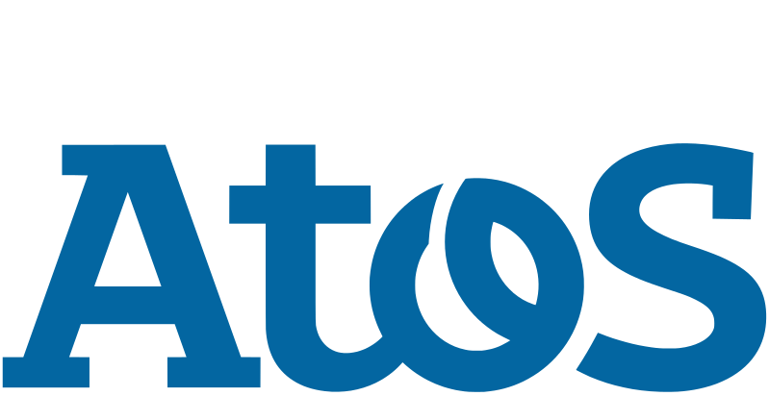
Plan

Nick van Oort, Max Post
& Arwen Voorn

2021

Document History

Revisions
Table 0-1 - Revisions
Version | Status | Date | Change
0.1 | Concept | 03-03-2021 | Written introduction (Including strategic change)
0.2 | Concept | 03-03-2021 | Made changes to the wording used on strategic change
0.3 | Concept | 12-03-2021 | Executed and documented strategic analysis
0.4 | Concept | 28-05-2021 | New version after feedback from client and teacher

Approval
This document requires the following approvals:
Table 0-2 - Approval
Version | Approval date | Name | Function | Initials
1.0 |  | Nick van Pelt
1.0 |  | Hans Kwaspen
1.0 |  | Bas Mommers
1.0 |  | Tom van der Hoff

Distribution
This document has been distributed to:
Table 0-3 - Distribution
Version | Distribution date | Name | Function
0.2 | 03-03-2021 | Tom van der Hoff | Teacher
0.3 | 12-03-2021 | Tom van der Hoff | Teacher
0.4 | 28-05-2021 | Tom van der Hoff | Teacher

Table of Contents
Management Summary 6
1 Preface 7
1.1 Strategic Change 7
1.2 What is Business & IT Alignment (BIA) and why is it important? 8
1.3 What is the Business Transformation Framework (BTF)? 9
1.4 Why is it a good framework for this project? 10
2 Phase 1: Strategic Analysis 11
2.1 Mission, Vision & Core Values 11
2.1.1 Mission 11
2.1.2 Vision 11
2.1.3 Core Values 12
2.1.4 Opinion students 12
2.2 Internal and External analysis, SWOT-Analysis & Confrontation Matrix 13
2.2.1 External Analysis 14
2.2.2 Internal Analysis 17
2.2.3 SWOT-Analysis 20
2.2.4 Confrontation Matrix 21
2.3 Critical Success Factors (CSF) & Key Performance Indicators (KPI) 23
2.3.1 CSF 23
2.3.2 KPI 23
3 Phase 2: Architecture Principles 24
3.1 Principles 24
3.2 Principle’s architecture 24
4 Phase 3: Architecture Sketches & ArchiMate 27
4.1 Sketch 27
4.1.1 IST Sketch 27
4.1.2 SOLL Sketch 27
4.2 ArchiMate 28
4.2.1 IST ArchiMate 29
4.2.2 SOLL ArchiMate 30
4.3 Architecture models 32
4.3.1 Business Function- and Informationmodel 32
4.3.2 Business Function model 33
4.3.3 Information Model 34
4.4 CRUD-Matrix 34
4.4.1 IST CRUD Matrix 35
4.4.2 SOLL CRUD-Matrix 36
4.5 Advice Architecture Methods 37
4.5.1 Architecture Methods 37
4.5.2 Advice 38
5 Phase 4/5: Change portfolio 39
5.1 Actions 39
5.2 Change Portfolio 41
5.2.1 Step 1: Clustering actions into candidate-projects 41
5.2.2 Step 2: Defining the projects that need prioritization 42
5.2.3 Step 3: Prioritizing projects 44
5.2.4 Step 4: Draw up change calendar 45
6 Bibliography 46
7 Annexes 49
7.1 Annex A – Architecture Methods 49
7.1.1 Dynamic Architecture – DYA 49
7.1.2 The Open Group Architecture Framework – TOGAF 52
7.1.3 Scaled Agile Framework – SAFe 55
7.2 Annex B – ArchiMate legend 57

Figures and Tables list
Figures
Figure 1-1 - Industry4.0, the digital transformation 8
Figure 1-2 - Intelligent Asset Management (IAM) 9
Figure 1-3 - Asset Intelligence Network (AIN) 9
Figure 1-4 - Business & IT Alignment 9
Figure 1-5 - Business Transformation Framework (BTF) (Stoop, Staffhorst, Bekker, & Hobma, 2016) 10
Figure 2-1 - Atos' core values (Atos, 2018) 13
Figure 2-2 - SWOT Example 14
Figure 2-3 - Scanning the environment: Pestel Analysis (Business 2 You, 2016) 15
Figure 2-4 - 2018 IT Services spend and growth 15
Figure 2-5 – Competitive Forces Model Porter 17
Figure 2-6 - Business Model Canvas (Atos, 2019) 19
Figure 2-7 - BCG Matrix (Atos, 2019) 20
Figure 2-8 - SWOT-Analysis 21
Figure 2-9 - Confrontation Matrix 22
Figure 3-1 – Architecture (Source: TU Delft SSC-ICT 2006, update 2013) 25
Figure 4-1 - Architecture Sketch IST 28
Figure 4-2 – Architecture Sketch SOLL 28
Figure 4-3 - Core Framework ArchiMate 29
Figure 4-4 - ArchiMate IST 30
Figure 4-5 - ArchiMate SOLL 31
Figure 4-6 – Business Function Model 34
Figure 4-7 – Information Model 35
Figure 4-8 - IST CRUD Matrix 36
Figure 4-9 - SOLL CRUD-matrix 37
Figure 4-10 - SAFe Model 39
Figure 5-1 - Change portfolio Roadmap 42
Figure 5-2 - Risk-importance-matrix for prioritization of projects 45
Figure 7-1 - Business & IT Alignment 50
Figure 7-2 - Theoretical model 51
Figure 7-3 - Maturity matrix 52
Figure 7-4 - Enterprise continuum 54
Figure 7-5 - SAFe model 56
Figure 7-6 - ArchiMate model 57
Figure 7-7 - Motivation layer legend 58
Figure 7-8 - Busienss layer legend 58
Figure 7-9 - Application layer legend 59
Figure 7-10 - Technology layer legend 59
Tables
Table 0-1 - Revisions 2
Table 0-2 - Approval 2
Table 0-3 - Distribution 2
Table 3-1 - Principles 25
Table 5-5-1 - Change portfolio actions 41
Table 5-2 - Action point clusters 43

Management Summary

Preface
This document argues which strategic change comes forth from the current project (‘Designing the bridge between Siemens Teamcenter & SAP AIN & IoT’) and how to deal with such strategic change in a way that provides the right direction.
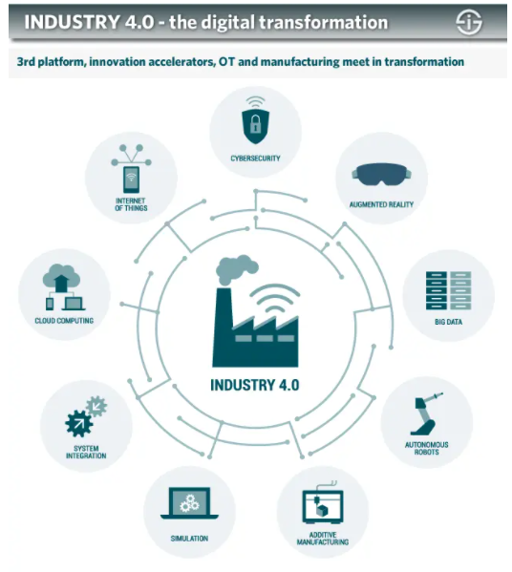
Figure 1-1 - Industry4.0, the digital transformation
Import to understand is what Industry4.0 is. Industry4.0 is the digital transformation of manufacturing/production and related industries and value creation processes. Cyber-physical systems form the basis by using modern control systems, embedded software systems and they can be addressed through the Internet of Things.

Strategic Change
The strategic change that Atos is currently facing must do mostly with innovation and more specifically with the switch to Industry4.0, where Atos’ goal is to offer innovative technology, products, and services for discrete manufacturing organizations. (Persberichten, 2020)

Currently, Atos offers amongst others, products from Siemens and SAP, these currently do not have a connection with each other or with the ‘Internet of Things’ (IoT). The goal is to make a connection between the IoT and (intelligent) systems, resulting in less time needed for maintenance and reparations. This change would result in, amongst other things:
- Products that are almost at the end of their life can be automatically ordered. This is done by using data from sensors (IoT) and making predictions on whether the product is still okay to use;
- The operator will have less work searching for the right documentation because the software can provide these more easily. Another advantage of this is that the systems can automatically recommend other products with the same specifications to ensure the machine will remain in service;
- The operator / (service) engineer gets real-time overviews about whether and where reparations and/or maintenance is necessary. This data is gathered by sensors, which are connected to the IoT, and of which software like Siemens Teamcenter and Sap IAM & AIN can give recommendations.

The current project, a connection between Siemens Teamcenter (Product Lifecycle Management) and SAP IAM & AIN (Intelligence Asset Management & Asset Intelligence Network) and sensors (Internet of Things), is the start for further development in this area, where Atos’ goal is to become and remain a frontrunner. Would they not take this step, then the risk would be that competitors will develop Industry4.0 software and products and that Atos will slowly lose market share.

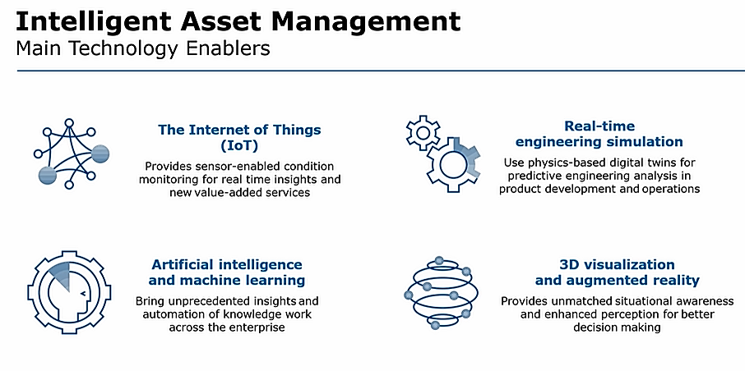
Figure 1-2 - Intelligent Asset Management (IAM)
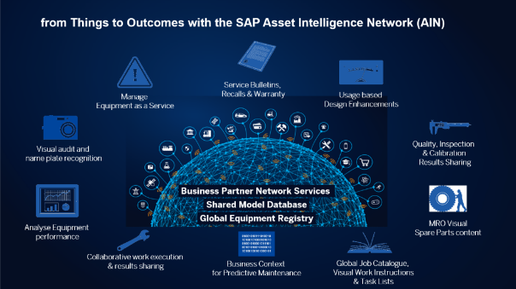
Figure 1-3 - Asset Intelligence Network (AIN)

What is Business & IT Alignment (BIA) and why is it important?
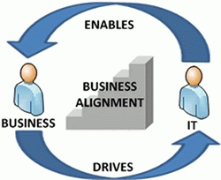
Business IT Alignment is a process in which a business uses information techniques to achieve business goals. Here, "Alignment" refers to the connection between the organization and the information techniques that are used to reach the full potential for the goals at hand.
Figuur 1.1 - Business & IT Alignment
Figure 1-4 - Business & IT Alignment

This balance is achieved by realizing a positive relationship between information technology and the business side. This positive relationship can be described as having the same goals and objectives. This allows IT to develop the necessary metrics and communicate about these metrics in the right (business) terms. There is a (large) gap between information technology (IT) and business in many companies. This gap means that expensive IT systems do not provide a sufficient return on investment.

What is the Business Transformation Framework (BTF)?
These days, companies must be flexible to changes, critical customers, competitors, or even legislation that forces a company to adapt. In addition to these continuous changes, there is an opportunity for growth and improvement. In addition to external change factors, there are also internal factors; after all, an organization is a partnership between people for a specific purpose. In short, organizational change is difficult. There are many statistics online about change initiatives whose success rates are often between 50% and 70%. There is a tool to help simplify the difficult task of organizational change. This is where the Business Transformation Framework (BTF) comes into place.
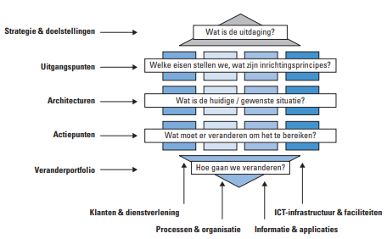
With help from the BTF, an organization can get a better understanding of how to create a Business Transformation Plan. This plan is used when an organization wants to implement a (major) change. The BTF is particularly helpful when combining a change of the 1st and 2nd order combined. When it comes to 3rd order changes, the BTF is often used as one of many tools to guide the change.
Figuur 1.2 - Business Transformation Framework (BTF) (Stoop, Staffhorst, Bekker, & Hobma, 2016)
Figure 1-5 - Business Transformation Framework (BTF) (Stoop, Staffhorst, Bekker, & Hobma, 2016)
Entering an organizational change using the BTF (see Figure 4), always make sure that enough thought has been put into the various aspects of the change. To do this, the BTF has five steps (vertical) to go through and four perspectives (horizontal) to approach the change from and consider when making certain decisions.

A couple of points where the BTF can be helpful:

- BTF helps to translate strategy into concrete action: The BTF ensures vision-driven change to bridge the gap between strategy and implementation. This is partly because BTF is highly action-oriented; the goal is ultimately to obtain a collection of action points that can be clustered into programs.
- BTF makes the coherence in organizations manageable: BTF brings together different functions in an organization and increases mutual understanding.
- BTF explicitly takes the existing into account: By including bottlenecks and areas for improvement from the existing situation in the design phase of the change, the desired change can be achieved.
- BTF promotes collaboration and creates support: The BTF provides a structured approach that allows people and organizations to change themselves.
- BTF provides greater directionality during changes: Through a well-established portfolio management process, "change the business" and "run the business" are combined.
- BTF is in line with the Novius Architecture Method: In the BTF the goal is to establish a basis for consistent business design, with sufficient insight and overview to be able to make the right choices. The details of the business design are only added during the execution of programs and projects, which are part of the business architecture. A much-used method is the Novius Architecture Method, which is exactly the reason why BTF seamlessly connects to it.

Why is it a good framework for this project?
Atos is making the switch to Industry4.0 technology, products, and services within the manufacturing industry. To make this possible across the board, numerous projects and programs are needed, in which (new) possibilities must be investigated, links must be made, teams must be set up, etc. Because of this reason, it is important to write a business transformation plan, with the Business Transformation Framework providing the right tools to set the change in motion in a structured way.

The BTF provides a practical application where continuous change is made while looking at feedback from inside/outside. This creates mutual understanding between different functions in the organization and everything needs to be captured in a change portfolio. For a gigantic end goal like achieving Industry4.0, the BTF will provide the necessary guidance.

Phase 1: Strategic Analysis
In the BTF model the first step is to do a strategic analysis of the company. Looking at the values of a company and the overarching view, gives an indication in which direction Atos is heading.
Making this strategic analysis the following model was used for the structure. First looking at the mission and vision of Atos. Then going more in depth on the core values of the company and the success factors/Key performance indicators. Before making a swot analysis first the internal and external analysis have been made. These analyses are added together for the final swot analysis.
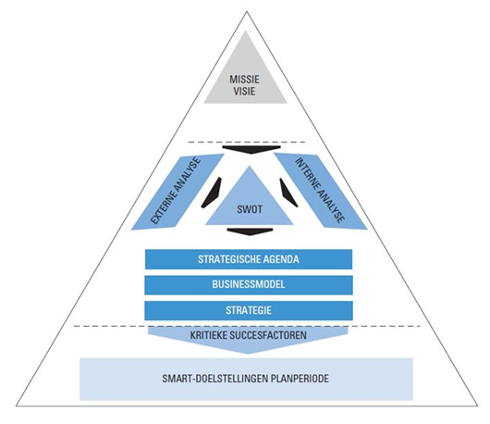

Mission, Vision & Core Values

Mission
“At Atos, our mission is to help design the future of the information technology space.”

Our expertise and services support the development of knowledge, education as well as multicultural and pluralistic approaches to research that contribute to scientific and technological excellence.

Across the world, we enable our customers, employees and collaborators, and members of societies at large to live, work and develop sustainably and confidently in the information technology space.” (Atos, 2019)

Vision
Atos does not clearly state one vision on their website. So, we have chosen to combine three visions into one large vision, thus resulting in an all-encompassing vision.
“At Atos, we actively help our clients stay one step ahead. We share our vision and innovative thinking on the emerging trends and technologies that will shape businesses and our society in the future. (Atos, 2019) Atos is embarking on its new three-year strategic plan, Advance 2021, which is strongly focused on clients’ needs and aspirations, and will see innovation, technology and the creation of long-term sustainable value drive the company forward towards further growth and greater profitability, doing this by applying the best soothed technologies and excessive industry knowledge.” (Atos, 2018)

Core Values
Atos had seven core values, which are depicted in figure 2-1.
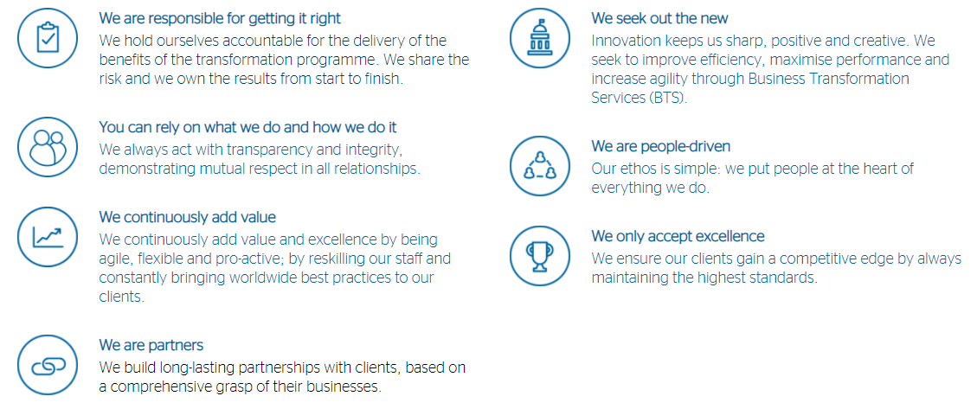
Figure 2-1 - Atos' core values (Atos, 2018)

Opinion students
The mission is a short but meaningful sentence, which is a broad view of which landscape Atos is operating in. Atos gives with their mission the view that it wants to be a frontrunner in information technology. The students that are assigned to Atos finds this mission good formulated, impactful, and compact.
The vision was not clearly stated anywhere, which isn’t good in our opinion. For the vision three different statements were taken and combined to get a concrete overview of what Atos vision entails. Core values are defined clearly, but these values should be extracted from the vision. A vision should be the view on how to achieve the mission. There isn’t a clear connection between the mission and vision of Atos.

Internal and External analysis, SWOT-Analysis & Confrontation Matrix
A Swot analysis is a tool to determine the strategy of a company. This model can be made when there has been an internal and external analysis made. Swot analysis can be useful to map the current situation of a company, based on the internal factors and external factors.
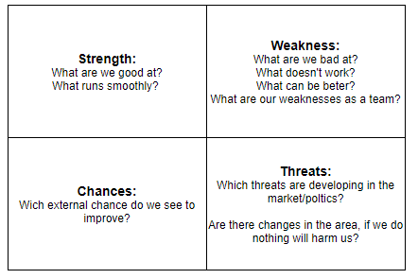
Figure 2-2 - SWOT Example
The confrontation matrix is made to see confrontations between:
- Strengths with opportunities;
- Strengths with threats;
- Weaknesses with opportunities;
- Weaknesses with threats.
By assessing the cross points in the matrix, an organization can see what the main options are that can be weighed against each other. Three of each part of the SWOT-analyses will be used in the confrontation matrix. If there are more than three, than needs to be decided which points are the most important. In figure 2-9 is the confrontation matrix based on the SWOT-analysis depicted.

External Analysis
PESTEL Analysis
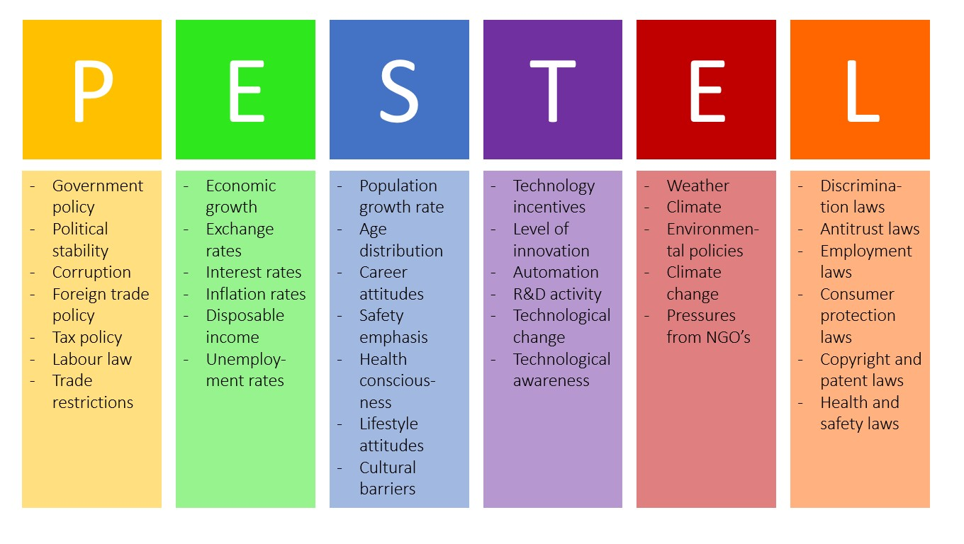
Before finishing the Swot analysis, a good start is to first make a Pestel analysis. P stands for ‘political’, e for ‘economic, s for ‘social’, t for ‘technological’, e for environmental and finally l for ‘legal’. A good framework is shown on the image below (Business 2 You, 2016).
Figure 2-3 - Scanning the environment: Pestel Analysis (Business 2 You, 2016)
  - Political factors:
A few political factors to note are:
    - The UK left the European Union, which could make international work (temporarily) harder;
    - Tension in the middle east is high;
    - The USA got a new president who invests more in ‘green-companies’, this could be a benefit for Atos, who aims to be green;
    - Tension in Asia-pacific is rising because of China.
  - Economic factors:
    - This has two sided. First, due to the coronavirus digitalization got a boost. This gives IT companies, like Atos, more work. However, long-term effect could mean that organizations will go bankrupt, resulting in less IT projects needed and thus their market would shrink. Note that this is only a possibility, not a prediction. The current consensus is that, because vaccines have been developed, the economy will continue to grow and get back on pre-corona levels by the end of the year / beginning of 2022.
    - IT is becoming more and more important for all organizations around the world. This results in more spending worldwide. The table below shows the growth in 2018:
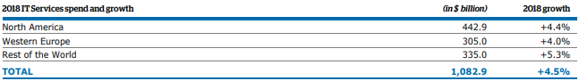
Figure 2-4 - 2018 IT Services spend and growth
  - Social factors:
There is still a global shortage in trained IT personnel. However, if we look at the big picture, we can see that the global level of education is steadily growing. This could result in more IT personnel (this would only have the long-term effect, though).
  - Technological factors:
There are a few technological factors to keep in mind:
    - Digital transformation momentum accelerates;
    - Demand for hybrid cloud infrastructures rise;
    - Real time business processes are highly sought after;
    - Artificial intelligence and IoT are developing rapidly;
    - A cashless world is rapidly emerging.
  - Environmental factors;
Atos has datacenters and offices in 73 countries, so it is necessary to look at ecological factors like natural disasters. They mitigate risks by having implemented processes to monitor these datacenters and offices and by making sure all datacenters have a back-up somewhere else.
  - Legal
    - IP leak threats because of cybercrime;
    - New security laws in Europe;
    - More legal punishment for failing to comply to regulations;
    - Some countries that have datacenters don’t have anti-corruption laws.

External Competitor Analysis
Next to the PESTEL-analysis, an external competitor analysis has been executed.
To perform this external analysis, the competitive-forces model from Porter will be used (Knoot, 2021). This method will be used because it’s important for Atos to stay ahead of their competition and this method is useful for analyzing competitors. The model from Porter allows a company to assess five forces in terms of competition. For each force will be looked at the position Atos is in.
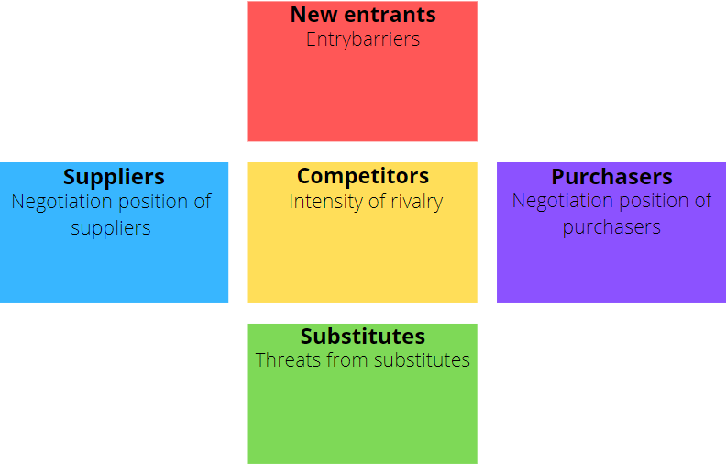
Figure 2-5 – Competitive Forces Model Porter

Potential entrants & Competitiveness of market players among themselves
Atos is a global leader in digital transformation. Based on the list of competitors from Atos, it’s safe to say that it would be hard to establish a new and thriving business in the same industry with companies like Atos, Accenture, Capgemini, CGI, IBM etc. All these companies have integrated themselves in the market and if a new company doesn’t do an extensive competitor analysis it is highly likely that a new company cannot compete with the existing companies (Owler, 2021).

Power of substitutions
Talking about products and services and the customers/clients who buy them from Atos, it is probably not a (big) concern for Atos. Since Atos is a global leader and ranks high in customer satisfaction as IT organization. Also, because Atos has ‘Trust’ as one of their core values, Atos won’t substitute good products with not fully functional or bad products. (Atos, 2020)

Supplier strength & Purchasing power
Because Atos is a global player, they also have alliances with other global players. These can either be customers or suppliers to Atos. Alliances with companies such as Microsoft, Amazon, Dell, Google, SAP, Siemens etc. make it so that Atos possesses the strength to purchase great products and solutions from their alliances and sell great new inventions and services to their alliances (Atos, 2021).

Internal Analysis
Internal Competitor Analysis
With the look into competitors (external analysis) done, there is in insight created into rival companies of Atos. What remains is why Atos can stay ahead of their competition and what they do to keep it that way. An internal analysis is required to find this out. To stay within the competitor bubble, the value chain of Porter will be used for the internal analysis (Eelants, 2021).
According to Atos themselves, they have both business insight and IT expertise like no other system integrator in the market has. This gives Atos the edge over their competition and they want to create new innovative products and services to stay ahead of the competition and remain a global leader in digital transformation. Here is how Atos explains their perspective:
“Atos brings a partner ecosystem built to deliver superior business value based on best-in-class technology.
We work together with selected world-class organizations in software applications, infrastructure, and consulting to strengthen our own unique portfolio in consulting, solutions, and services. Leveraging the abilities of these industry leaders allows us to concentrate on our goal of adding growth to our customers’ businesses. Through comprehensive, intelligent integration of partner product-based solutions and services we underpin and complement our own key strengths to maximize your productivity.
We have both business insight and IT expertise like no system integrator in the market.” (Atos, 2021).
Atos is currently ranked number 10 in the world in the IT services market and has been assessed by external organizations on capabilities and is positioned as follows:
Atos is a:
- Global leader in IT outsourcing;
- Global leader in private cloud and European leader in hybrid cloud;
- Global leader in SAP HANA and European leader in SAP services;
- Visionary provider in analytics;
- Global leader in IoT services;
- Global leader in digital workplace;
- Major player and visionary in unified communications & collaboration;
- Major player and European leader in security. (Atos, 2018)

Financial Analysis
Making a Financial analysis can give detailed information about the state of business. Comparing 2020 with 2019, you can see a drop of 3% (rounded), this is due the covid-19 crisis.

Atos made a large amount of revenue with cloud/digitalization projects in 2020. Their objectives for 2021 is having a revenue growth of +3,5% to 4,0% and a free cash flow of €550m to €600m (Atos, 2021).
These promises where not enough for the investors, Atos dropped with 5% at the Paris stock index (Petitjean, 2021).

Business Model Canvas
The business model canvas exists of nine parts. It includes each aspect of the company, intern and extern aspects like organization, value proposition, customers, suppliers, costs, and revenue. This model highlights the weaknesses and strengths of a company.

The value proposition indicates what the powers of distinction are of a company compared with the competitors.
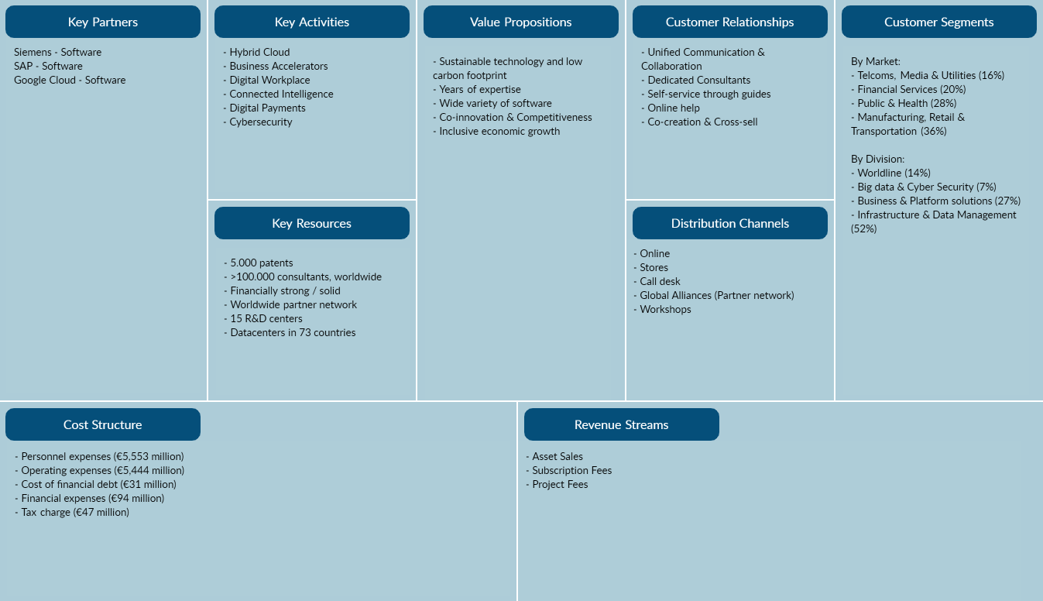
Figure 2-6 - Business Model Canvas (Atos, 2019)

BCG Matrix
The BCG Matrix is a well-known management model for analyzing a company's product portfolio.
The BCG matrix contains the following four components:

- Stars
- Cash cows
- Dogs
- Question marks

In the BCG matrix, market growth and market share of the products (or service) of a company are compared to each other. This allows a company to determine whether they should invest in a product or whether they should de-invest, or even stop the product altogether. View a BCG matrix example below. (Calltheone, 2019)
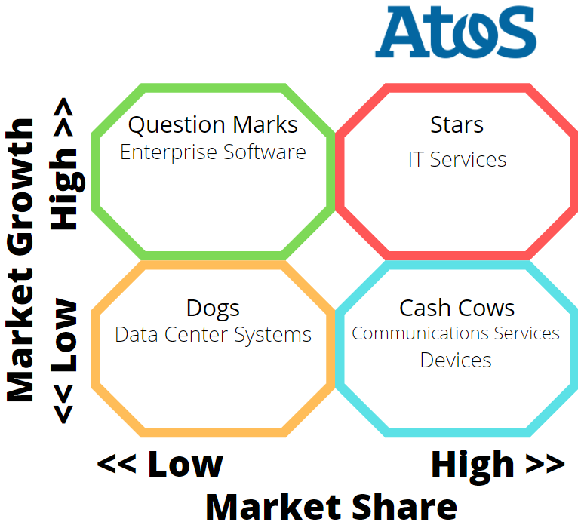
Figure 2-7 - BCG Matrix (Atos, 2019)

SWOT-Analysis
Figure 2-8 show the SWOT-analysis of Atos. This is based on previous analysis in this document (like the internal and external analysis).
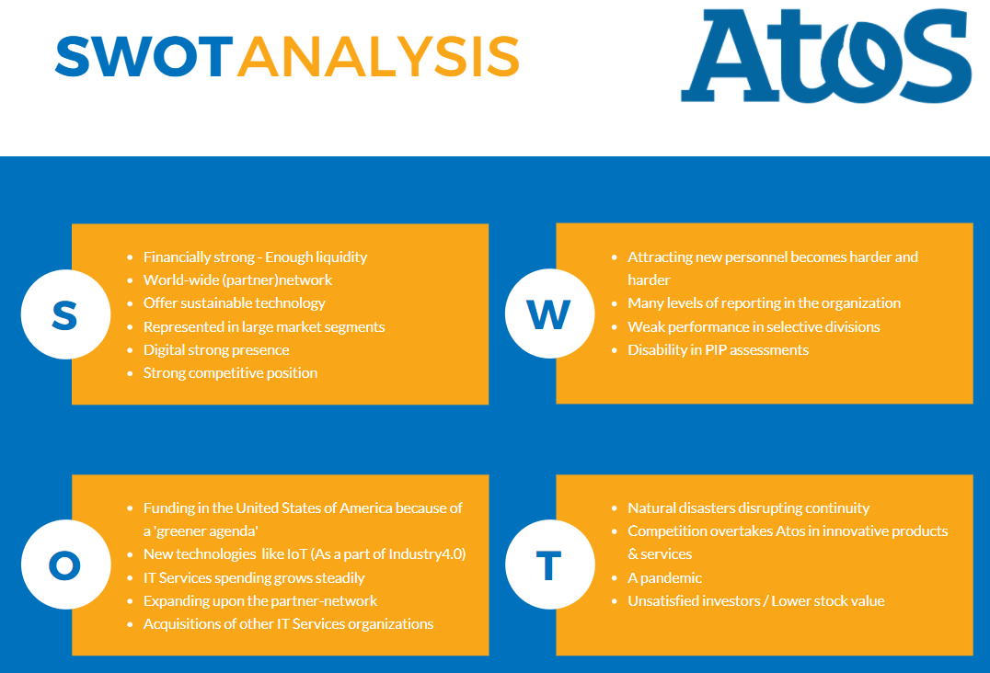
Figure 2-8 - SWOT-Analysis

Confrontation Matrix
The confrontation matrix exists of the three main points for each Swot part. In a professional Swot analysis, the results based on the stakeholders filling in a survey to decide which score each cell receives. (Strategischemarketingplan.com, 2014).
This confrontation matrix is filled in of the Atos group 1 own interpretation what the scores would be.
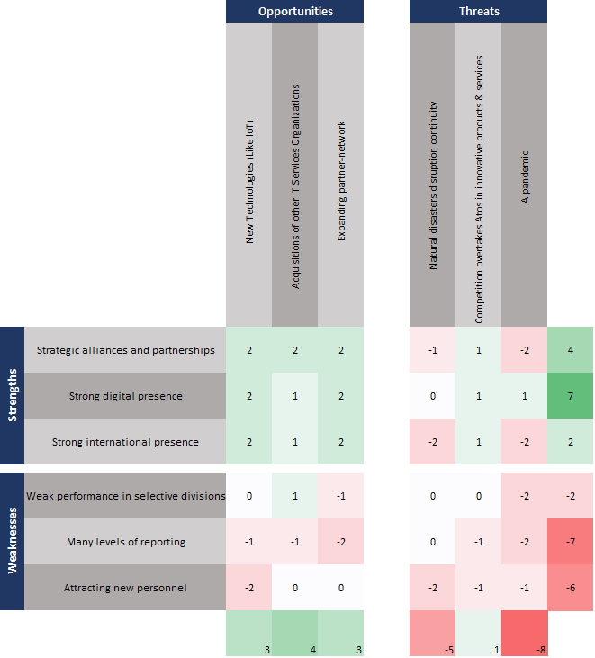
Figure 2-9 - Confrontation Matrix

Conclusion
The top-priorities that come forth from the confrontation matrix are:
- Having a strong digital presence (7) – Atos is mainly an information communication organization, so strong digital presence helps them cement a good foundation for IT activities.
- Having a focus on environmental change (-5) – Atos already does this by making sure datacenters are backed-up at other data centers and by monitoring areas near offices.
- Having strong alliances and partnerships (4) – Atos focusses on strong partnerships. On one side these binds customers to Atos and on the other side it makes sure Atos is aware of global needs in IT services.
- Remaining frontrunner in innovations (1) – There are currently rapid technological developments. Innovating and remaining a frontrunner is a must in order not to lose valuable market-share.

Critical Success Factors (CSF) & Key Performance Indicators (KPI)
Another important part of, and to complete, the strategic definition of a company are Critical Success Factors (CSF) and the Key Performance Indicators (KPI).

CSF
Critical Success Factors are simply the goals of a company. Atos embarked themselves in a new three-year plan to create new innovations, technology, and long-term sustainable value drivers (Atos, 2018). Atos did not classify their goals as plain and simple as ‘goals’ but wanted to show that they work in a three-year goal by calling it their ‘Strategic outlook’.

KPI
Atos had divided their goals/ values and KPI’s into five segments, which are:
- Finance
  - Organic growth revenue;
  - Operating margin rate;
  - An operating margin conversation rate to free cash flow;
- People
  - Great Place to Work Trust Index;
- Business & Innovation
  - Net Promoter Score;
  - Digital Transformation Factory Revenue;
- Ethics & Governance
  - Code of Ethics;
  - Suppliers;
- Environment
  - Global footprint.
These KPI’s are shown in four different years starting from 2016 and ending at the present with aim towards future years (Atos, 2021).

Phase 2: Architecture Principles

Principles
Based on the output of the mission, vision, CSF’s and KPI’s, the following architecture principles have been made (Stoop, Staffhorst, Bekker, & Hobma, 2016). These principles are also connected with the innovation Atos project with Fontys applied university of Information communication techniques. To help define these architecture principles on information provision the following source was used (HORA2 wiki, 2019)
Table 3-1 - Principles
Customers & services | Processes & organization | Information & applications | ICT infrastructure & facilities
Helping across sectors with customers digital business activities. | Automating maintenance processes by achieving Industry4.0. | Extracting and connecting useful information from different sources/processes. | Making supporting infrastructures to run the digital business activities on.
Having impact on the digital transformation factory revenue. | Clear documentation on each process. | Receiving notifications when a part should be replaced. | Complying with the GDPR legislation.
Achieving a high net promoter score in collaboration with customers. | Using excessive industry knowledge to map clear processes. | Picking the best soothed technologies to solve each problem. | Choosing the most durable option during developments.

Principle’s architecture
Architecture principles are defined assumptions for company strategies. The goal of these architecture principles is to make choices. The most important architecture principles are defined in detail. This was done for one principle for each category of the Business Transformation Framework. So, the most important principles for ‘Customers & services’, ’Processes & organization’ etc. In the table above is the previously made architecture principles reorganized from most to least important.
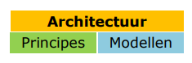
Figure 3-1 – Architecture (Source: TU Delft SSC-ICT 2006, update 2013)

Title: Cross-sector support
Statement
Helping across sectors with customers digital business activities.
Rational
Atos is a trusted partner for business transformation. Only providing services in industries that are related to information technology and in which Atos is active. (Financial services & insurance, Healthcare & Life sciences, Manufacturing, Public sector & Defence, Resources & services, and Telecommunications & media. (Atos, 2021))
Implications
That a company that can meet collaboration requirements and fits in one of these industries can have a trusted partner in Atos.
Exceptions
Companies that can’t meet collaboration requirements.

Title: Industry4.0
Statement
Automating maintenance processes by achieving Industry4.0.
Rational
Industry4.0 automates and makes process more insightful. While automating maintenance processes is one of the key parts for achieving Industry4.0.
Implications
- Industry4.0 is in the innovation stage;
- Needs a lot of implementation time until it is fully functional.
Exceptions
Only possible for certain companies that are active in manufacturing industry.

Title: Connecting the business
Statement
Extracting and connecting useful information from different sources/processes.
Rational
Working with multiple partners to combine their tools with our own to generate new (innovative) ideas/expand current solutions and gain new information.
Implications
Companies need to be partners.
Exceptions
A partner needs to have tools such as ERP in place to be able to collaborate.

Title: Support digital business
Statement
Making supporting infrastructures to run the digital business activities on.
Rational
As the business can be more digitalized by the year, there need to be new ways to do so. By creating supporting infrastructures, the next step in a digitalized business can be realized.
Implications
Risks of developing new ways for digital business need to be well thought through.
Exceptions
A company needs to be open to the idea of providing access to the current infrastructure to progress to a newer infrastructure.

Phase 3: Architecture Sketches & ArchiMate

Sketch
Based on the architecture principles a sketch has been made of the current situation and the desired situation. Following the guidelines of the BTF report as shown below to make the sketch. The sketches are formed from the principal perspectives of the BTF. (Stoop, Staffhorst, Bekker, & Hobma, 2016)
- Architectures of the desired layout demonstrably comply with the strategy and the formulated starting points.
- Architectures make design choices clearly visible.
- Architectures together form an integral whole over all aspects of business operations.
- Architectures are relatively stable.
- Architectures have come about because of collaboration between management, specialists, and subject matter experts from different parts of the organization.
All the systems and equipment that are used in this project are already there in the current situation, except for the fact that the systems (Siemens Teamcenter & SAP AIN) do not have a connection yet. This needs to be established in the desired situation. The sketches of the IST and SOLL situation are displayed in the following two paragraphs. Besides the sketches there is also a figure that displays the IST and SOLL situation in the modelling language ArchiMate.

IST Sketch
Figure 4-1 is a sketch that depicts the current situation of this project.
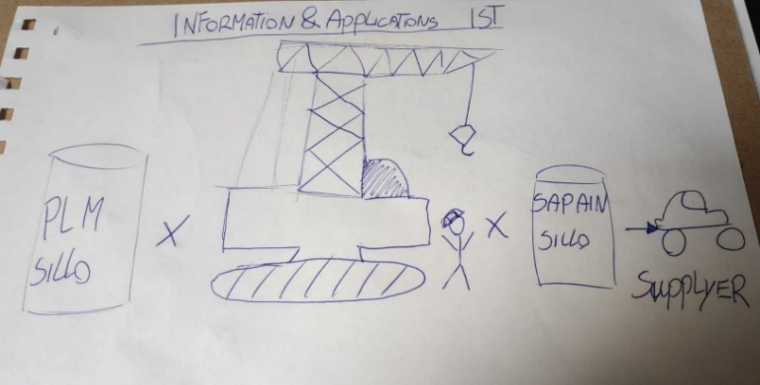
Figure 4-1 - Architecture Sketch IST

SOLL Sketch
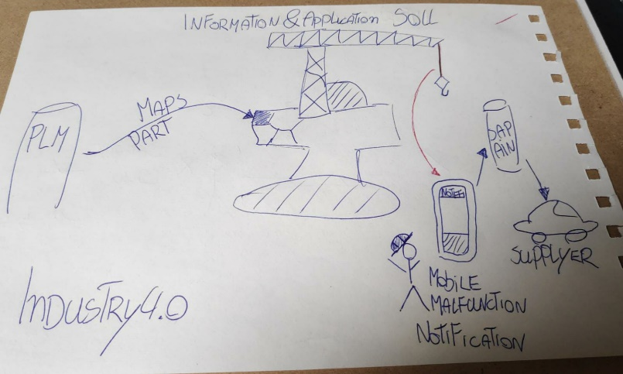
Figure 4-2 is a sketch that depicts the desired situation of this project.
Figure 4-2 – Architecture Sketch SOLL

ArchiMate
Core Framework
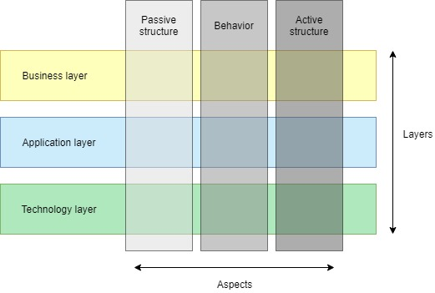
The main concepts and elements of the ArchiMate language are being presented as ArchiMate Core
Figure 4-3 - Core Framework ArchiMate
Framework. It consists of three layers and three aspects. This creates a matrix of combinations. Every layer has its Passive structure, Behaviour and Active structure aspects.

Layers
ArchiMate has a layered and service-oriented look on architectural models. The higher layers make use of services that are provided by the lower layers. Although, at an abstract level, the concepts that are used within each layer are similar, we define more concrete concepts that are specific for a certain layer. In this context, we distinguish three main layers:
- The Business layer is about business processes, services, functions, and events of business units. This layer "offers products and services to external customers, which are realized in the organization by business processes performed by business actors and roles".
- The Application layer is about software applications that "support the components in the business with application services".
- The Technology layer deals "with the hardware and communication infrastructure to support the Application Layer. This layer offers infrastructural services needed to run applications, realized by computer and communication hardware and system software". (ArchiMate Framework, 2021)

ArchiMate legend
Paragraphs 4.2.1 and 4.2.2 show the IST and SOLL situation in the Archi language. To understand the symbols, icons, and boxes better, Annex B – ArchiMate legend gives an overview of the elements of the ArchiMate plates. The overview shows the image of an element with the explanation of the element.

IST ArchiMate
Figure 4-4 depicts the current situation of this project in ArchiMate:
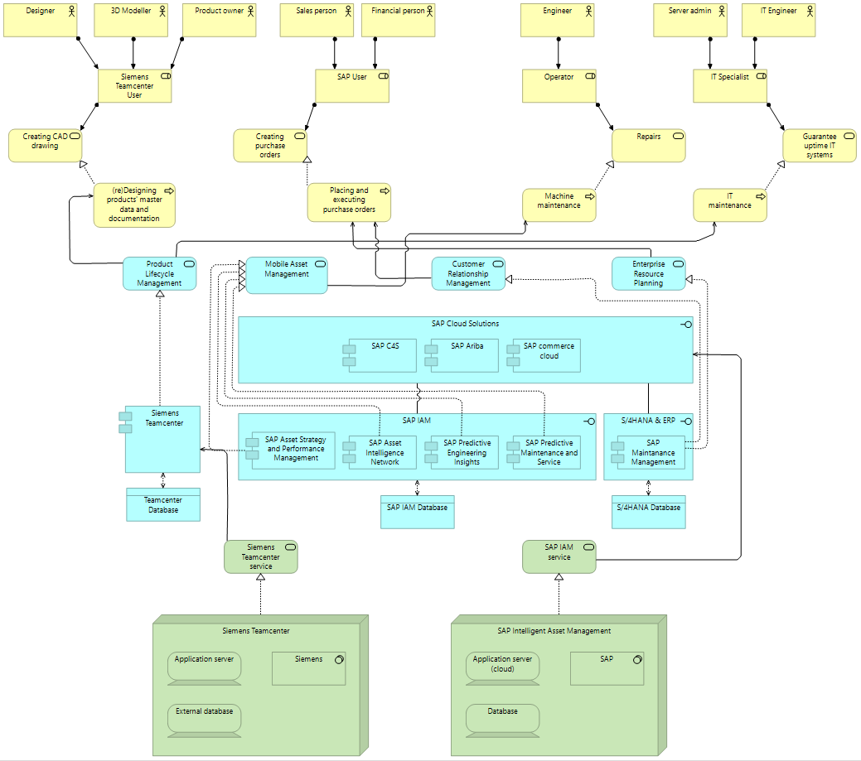
Figure 4-4 - ArchiMate IST
In the IST situation, there is still no connection between SAP (IAM) and Siemens Teamcenter, nor is there any use of the internet of things. As a result, the processes (that have a connection to this project) are not directly connected to each other thus reducing overall efficiency of the business.

SOLL ArchiMate
Figure 4-5 depicts the desired situation of this project in ArchiMate:
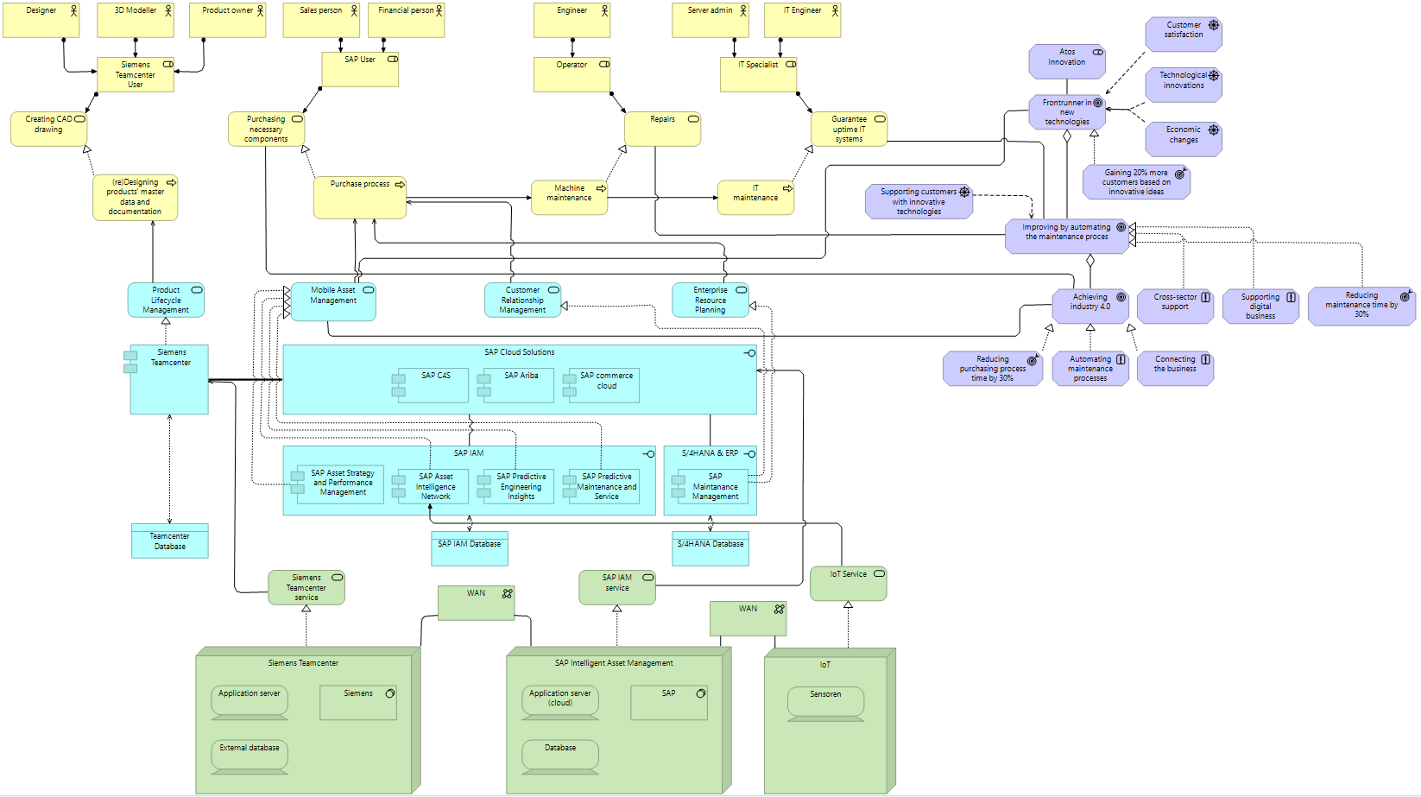
Figure 4-5 - ArchiMate SOLL

In the SOLL situation, a connection has been made between SAP (Cloud Solutions) and Siemens Teamcenter. This connection shows that there is (possible) data transfer between the two systems.
Because all systems are (indirectly) connected in the SOLL situation, a more streamlined process walkthrough is possible, which is indicated by the arrows connecting the business processes (Business processes are the yellow squares with an arrow inside). This more streamlined process walkthrough is possible because of the following changes:
- In the bottom right, in the technology layer ‘IoT’ has been added. The IoT is input for SAP and finally results in a more automated purchasing process, where data supplied by sensors (IoT) is the trigger for SAP to automatically create purchase requisition items. This automation results in shorter purchase process times.
- Automatic purchase requisition items are possible because Siemens Teamcenter is connected to SAP. Because of this connection SAP IAN ‘knows’ what part to order.
- The connected systems make it possible for operators and engineers to acquire necessary documentation more easily for maintenance and repairs.

Architecture models
The Business Function Model and Information Model are used to link together different models and can be used as general anchor points to start discussions on organization- and IT-design. This could for example be a strategic discussion on what distinctive and nondistinctive core competencies are within the organization which could provide insight in opportunities for the right outsourcing.

Business Function Model
A Business Function Model is a model of all the business functions within an organization. It describes what an organization does independent of how it is executed. It looks at the organization as a collection of activities which are executed and clusters these activities into logical units that need similar knowledge and competencies.

Since organizations most of the time remain executing the same activities over time, the Business Function Model is a stable model. Changes mostly happen on the process level which means changes only happen sub-function. (HORA, 2018)

Information Model
The Information Model is derived from the Business Function Model and describes the data that Atos manages. Other names for the Information Model are ‘Organization Object Model’ and ‘Data model’. An important aspect to keep in mind with the Information Model is that it is not a logical data model. The model describes the bigger units of data in a language that is understandable company wide.

A similarity between the Information Model and the Business Function Model is that the Information Model is also stable by nature. The Information Model uses, even more than the Business Function Model, unambiguous language, and words to describe data to eliminate uncertainties. (HORA, 2019)

Business Function- and Informationmodel
Figure 4.6 provides an overview of the Business Function Model of the IST-situation for the Atos project. The Business Function Model contains four categories:
- Steering
- Research
- Valorisation
- Business Operations
These categories are the same for both the Business Function Model and the Information model because the information model is built from the Business Function Model and therefore consists of the same categories. Both models need to be created to create a CRUD-matrix. This matrix shows the function model on the y-axis and the informationmodel on the x-axis. Each category from the models is contrasted and then filled in with the letters CRUD to see which function can Create, Read, Update and Delete which information part. The CRUD-matrix is shown in figure 4-8.

Business Function model
Since Atos is an innovation project, the only difference between the current and desired situation for the business function model is de ‘Innovation research’ element. This means that figure 4-6 an overview provides of the SOLL business function model of the Atos project. The SOLL element is highlighted with a red square for visual clarification.
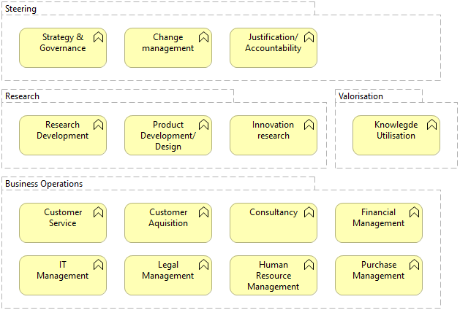
Figure 4-6 – Business Function Model

Information Model
The one element difference between the IST and SOLL situation for the business function model, also counts for the information model. Figure 4-7 provides an overview of the information model of the Atos project. The (SOLL) element is highlighted with a red square for visual clarification.
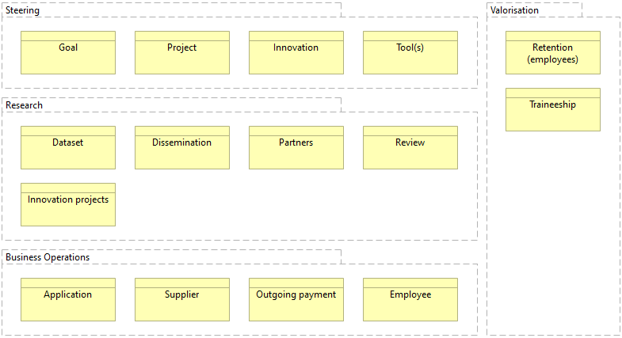
Figure 4-7 – Information Model

CRUD-Matrix
CRUD is an acronym that refers to the following actions on an object (typically a data entity):
- Create - to create and store new data;
- Read - to retrieve and read data;
- Update - to change or modify then store the data;
- Delete - to delete or remove the data.

There are two types of CRUD matrices in the BPM:

- A process/data CRUD matrix that is available from the Data CRUD matrix command in the Tools menu. It shows the links between a process and a data, and the type of operation the process performs on the data.
- A process/resource CRUD matrix that is available from the Resource CRUD matrix command in the Tools menu. It shows the links between a process and a resource using resource flows, and the type of operation the process performs on the resource. (Sybase, 2007)

IST CRUD Matrix
Figure 4-8 shows the CRUD-Matrix for the current situation of the Atos innovation project.
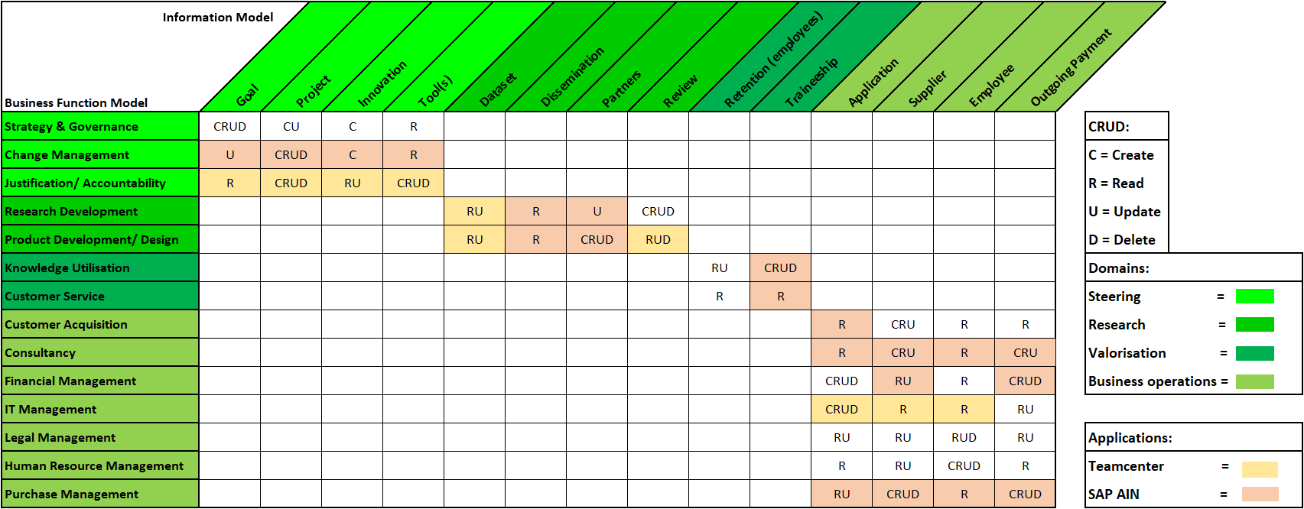
Figure 4-8 - IST CRUD Matrix

SOLL CRUD-Matrix
Figure 4-9 shows the CRUD-Matrix for the desired situation of the Atos innovation project.
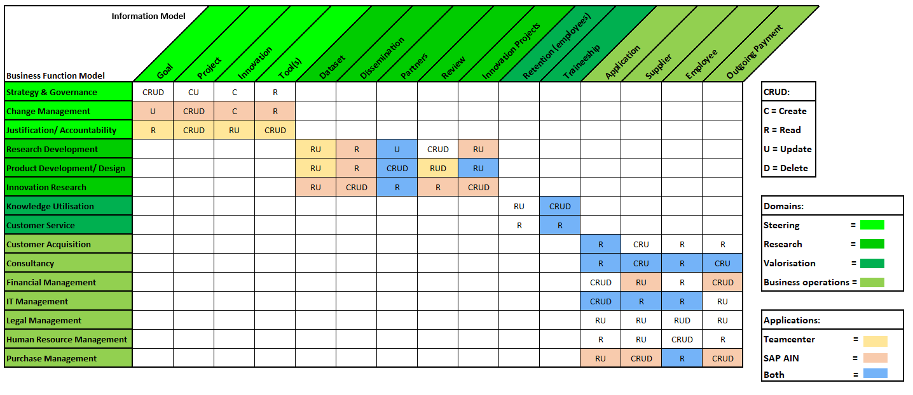
Figure 4-9 - SOLL CRUD-matrix

Advice Architecture Methods
The previous paragraphs have shown multiple tools and models (like the ArchiMate plates, business models, CRUD matrix, etc.) to get insight in the current and desired situation of Atos. All of these models can help the organization get a clear insight in their architecture. However, it is not much worth if this is not based on a structured way to reach a solid enterprise architecture. To reach that, there are several methods to help guide an organization to their enterprise architecture. In this paragraph, three architecture methods will be brought to life. Each of them will be introduced with some global information about the method (full version of the methods can be found in Annex A – Architecture Methods).
This paragraph will conclude with an advice towards Atos about the architecture method that best suites for them to reach a solid enterprise architecture in a structured way.

Architecture Methods

Dynamic Architecture – DYA
Dynamic Architecture (DYA) is a goal-oriented, pragmatic approach to architecture (Sogeti, 2021). The description makes it clear for which companies (depending on the branch) DYA is a useful method, as depending on the type of company, one architecture method may suit the company better or less than the other. Below are the most important points of DYA:
- DYA focuses more on the process to an architecture, rather than a good architecture as a result;
- DYA points out that the architecture should be shaped to the way the business works and makes decisions, not the other way around. The architecture must change, not the organization itself;
- DYA is known as the ‘just enough’ or ‘just-in-time’ architecture;
- For DYA, clear communication between the business and IT should be central (see figure 1).
More information on DYA can be found in Annex A (8.1.1).

The Open Group Architecture Framework – TOGAF
The Open Group is a global partnership whose mission is to achieve business goals by establishing technology standards. Their vision a "boundless flow of information through global interoperability in a secure, reliable and timely manner" (TheOpenGroup, 2021). TOGAF wants to map each process, business, data, application, and technology to make an enterprise architecture.
More information on TOGAF can be found in Annex A (8.1.2).

Scaled Agile Framework – SAFe
SAFe is based on Lean and Agile working. It provides patterns, principles, and tools to successfully develop large-scale products. The goal of SAFe is to ensure that problems arising from having multiple teams can be overcome.

SAFe aims to promote the following:
- Alignment between Business and IT;
Collaboration;
- Communication and delivery between multiple Agile teams.
- This is achieved by focusing on agile software development, lean product development and systems thinking.

More information on SAFe can be found in Annex A (8.1.3).

Advice
For the Atos innovation project, the Scaled Agile Framework (SAFe) is advised. SAFe is based on the Lean and Agile working method, this is great for software development where a strategic change is at the basis. In this innovation project using this working method in cooperation with the ArchiMate model. SAFe has four configurations; Essential, portfolio, large solution and full.

The reason why SAFe is advised upon for this project is because it deals with a large solution. SAFe focusses on collaboration between multiple ‘programs’. In the case of Atos, it would deal with SAP and Teamcenter and the multiple agile teams that work on each of these programs. Whereas TOGAF focusses more on work that happens in a large organisation regardless of whether it is executed as part of a framework. As for DYA, DYA does not make use of models such as ArchiMate which for a company the size of Atos it is hard to work without models to have a clear insight in the architecture of Atos. Therefore. SAFe is advised towards Atos.

The framework upkeeps a portfolio that takes in strategy, investments, and lean governance. It’s essential that the changes the innovation will bring are documented in a portfolio.

Below is an overview of SAFe:
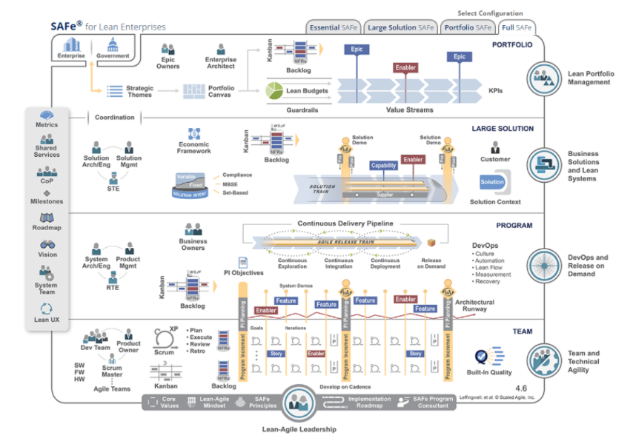
Figure 4-10 - SAFe Model
Figure 4-10 shows the SAFe model. The model shows how multiple levels in an organization work together and what their responsibilities are and how communications between different (agile) groups add value to product development.

Phase 4/5: Change portfolio
Short recap, in the introduction chapter of the BTF report show the relation between business IT alignment and the business transformation plan. It argues what the strategic change is and in phase 1 is that argument substantiated. Phase 2 is the theory part about architecture, why it’s used and what the goal is. This chapter shows some sketches of the desired situation. Then phase 3 the core of this document, uses the theory of the previous chapter to make a clear IST & SOLL Archimate model. This model is used to make a more specific model on certain parts by using the ‘business function model’ & ‘information model. Using those models to extract information for the CRUD matrix that gives insights on which parts of a enterprise have certain levels of access to specific applications. Having gained all these insights, what is this ‘change portfolio’ all about?

Phase 4/5 is about acting and reflecting on the results. Making action punts based on the information of the previous chapters, clustering those points, and prioritizing which project to do first. Having topics and goals to strive for the wanted results, but also keeping a change portfolio which will document the actual outcome.

Actions
Actions are derived from the ArchiMate models, the Business Function Model, the Information Model, and the CRUD-Matrices (Chapter 4).

To get an inventory of the possible projects, a list of actions is first created. These actions describe all small steps necessary to accomplish the strategic change. From this list of actions, a portfolio of projects is then created which together form the change portfolio.

On the next page there is an overview of the actions that need to be taken (Table 6-1) and describes the following:
- Action – A description of the action needed to be taken. The action is formulated as unambiguously as possible.
- Object of Change – Where the action needs to be taken. For example, a change in the Order process of the Financial department.
- Type – Describes what type of action it is. For example, a preliminary investigation, realisation, or a decision that has yet to be made.

Table 5-1 - Change portfolio actions
ID | Action point | Object of change | Type
AP1 | Using a recommendation system to reduce order time | SAP AIN | Realization
AP2 | Making it possible for operators to scan machines to get PLM details | SAP AIN | Realization
AP3 | Setting up SAP Asset Management to provide operators fast access to blueprints | SAP Asset Management | Realization
AP4 | Grouping and storing feedback to validate the results/issues | Product team manager | Review
AP5 | Lowering machine downtime by using SAP predictive maintenance and service application | SAP Predictive Maintenance | (preliminary) Research
AP6 | Protecting the data transfer using cryptography | Siemens & SAP connection | (preliminary) Research
AP7 | Making information transportation policies and procedures between SAP & Teamcenter data transfer | Policy Management | Realization
AP8 | Extracting technical information to understand how the data can be restructured | Siemens Teamcenter (PLM) | (preliminary) Research
AP9 | Create a use case to get an idea of how the result must look like | Innovation team | Realization
AP10 | Operators must sign confidentiality or non-disclosure agreements before receiving blueprint information | Legal department | Realization
AP11 | Separating user access on the SAP/Teamcenter applications | Authorization Access Management | Realization
AP12 | Educating a few employees by using the SAP & Teamcenter courses | Training department | Education
AP13 | Improving market position by connecting SAP & Teamcenter functionalities | Innovation team | (preliminary) Research
AP14 | Improving relations between SAP/Siemens by connecting and promoting their services | CRM system | Realization
AP15 | Automating order maintenance processes to reduce employees time spending on repetitive tasks | HR department | (preliminary) Research
AP16 | Using SAP Asset Management & automatic prediction software to give operators live data insights | SAP AIN | Realization
AP17 | Using IoT to get accurate data for the SAP IAM system | SAP AIN | Realization
AP18 | Using a concept like Process Mining to gain insight in bottlenecks of the order process | Application | (preliminary) Research
AP19 | Weekly reports providing insights on the production progress with information such as machine status | Reporting server | Making decision
AP20 | Conducting useful business cases, to show potential customers what the impact is | Sales department | Realization

Change Portfolio
The final step is to make a change portfolio of all the actions described in chapter 6.1. This is done according to the following roadmap:
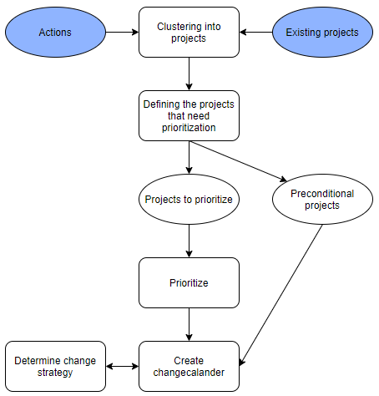
Figure 5-1 - Change portfolio Roadmap

Step 1: Clustering actions into candidate-projects
The first step is to cluster all actions into candidate-projects. This is done in the following areas:
- Topic – For example the implementation of a new application, which also requires changes to other processes.
- Object of change – For example the same product, process, business unit etcetera.
- Area of focus – This is often because of the ultimate responsibility of a manager.
- Goal(s) – This is the case if actions relate to the organizational goals that have been established.
Below is an overview of all goals, as defined in the ArchiMate Model, chapter 4.2.2:
- Frontrunner in new technologies;
  - Customer satisfaction;
  - Technological innovations;
  - Economic changes;
  - Gaining 20% more customers based on innovative ideas.
- Improving by automating the maintenance process;
  - Achieving Industry4.0;
    - Reducing purchasing process time by 30%;
    - Automating maintenance processes;
    - Connecting the business.
  - Cross-sector support;
  - Supporting digital business;
  - Reducing the maintenance time by 30%;
  - Supporting customers with innovative technologies.

Actionpoint clustering
With a lot of action points, it is hard to keep a structured overview. Therefore, table 5-2 provides an overview of the action point divided into different projects. The projects are based on a cluster. A project can be based on:
- Topic
- Object of change
- Area of focus
- Goal(s)
Table 5-2 - Action point clusters
Cluster on | Project | Action points
Topic | SAP | AP1, AP2, AP3, AP5, AP16 & AP17
 | Teamcenter | AP8
Object of change | Secure data transfer | AP6, AP10
Area of focus | Managing services | AP7, AP11, AP15
 | Customer relationships | AP14
 | Innovation/research | AP4, AP9, AP13, AP18
 | Education | AP12
Goal(s) | Progress reports | AP19
 | Customer acquisition | AP20

Step 2: Defining the projects that need prioritization
In this step the candidate-projects get a more detailed definition. Every candidate-project gets the following information (on max. 1 A4):
- Project name and description;
- Status;
- Project phases;
- Responsible manager;
- Intended goals and results;
- Relations to other projects;
- Expected throughput times;
- Budgeted costs and investments;
- Needed capacity;
- Risks.
One example is worked out on the following page. Other projects need to be defined by managers and other stakeholders.

Improving operational efficiency with SAP AIN
Description: SAP AIN can be used to improve operational efficiency by relieving operators and other supporting personnel of administrative work and automating processes.
Status: Currently in research phase
Project Phases: 1. Idea phase 2. Research phase 3. Proof-of-concept Phase 4. Implementation Phase
Responsible Manager: Hans Kwaspen – Innovation Team
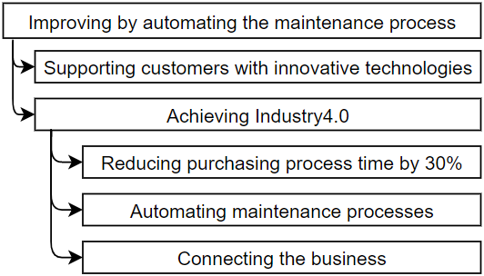
Intended Goals & Results: See below:

Relations to other projects: Part of a broader innovation. This project is connected to:
- SAP Asset Management - Siemens Teamcenter & SAP Connection
- SAP Predictive Maintenance
Expected throughput times: Since the project runs simultaneously with the projects mentioned above, the throughput times are spacious. The total throughput time is estimated to be 2 years, starting on 01-02-2021. The phasing is divided as follows:
1. Idea Phase: 01-02-2021 – 01-03-2021
2. Research Phase: 01-03-2021 – 01-07-2022
3. Proof-of-concept Phase: 01-01-2022 – 01-07-2022
4. Implementation Phase: 01-07-2022 – 01-02-2023
Budgeted costs and investment: Atos are already partnered with both Siemens (For Teamcenter) and SAP. This means there is no new investment needed for this project. Costs consist of capacity planned in for the project which is estimated to be around €1.000.000,- over the course of two years.
Needed Capacity: All capacity will be sourced in-house and from the innovation team.
The total needed capacity is 2.000 working days. (That translates to about 5 FTE for two years).
Risks:
Atos currently has little knowledge and experience for SAP IAM and AIN.
The project is highly dependent on other projects and other projects are highly dependent on this project.
The project requires a high dedication from a team of 5 people for 2 years. Someone leaving the team would mean a set-back on project throughput times.
Needed investments may come in to play if launching customers require a life-size proof-of-concept to be built.
As of now it is not clear if customers are waiting for this type of innovation since initial investments are high and ROI is not yet clear since it is different for each customer.

Step 3: Prioritizing projects
Note: This step and the next step (draw up change calendar) need to be executed by Atos themselves. This can only be done with stakeholders and managers and is not part of the scope of this Business Transformation Plan.
Before projects can be prioritized, the preconditional projects need to be filtered out. The reason for this is that preconditional projects often only create indirect value for an organization and thus score low on prioritization. However, these projects are the basis for other projects to succeed and that means they need to be executed.
After preconditional projects have been defined, the prioritization of the other projects starts. This is done according to figure 6-2 and takes the following parameters into account:
- Size – In both cost of throughput time;
- (Technical) Complexity;
- Number of stakeholders;
- Knowledge and experience within the organization;
- Project scope and -goals.
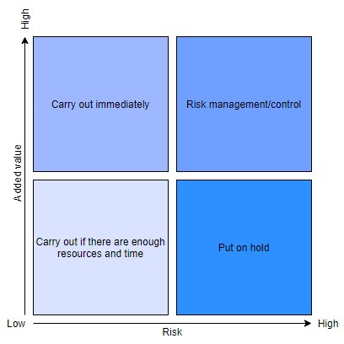
Figure 5-2 - Risk-importance-matrix for prioritization of projects

Step 4: Draw up change calendar
The change calendar can be drawn up on the basis of the prioritized projects. Drawing up the change calendar is a responsibility of managers, managing board and other (important) stakeholders.
For every project a start- and end date will be specified in a timetable. Next to that a plan needs to be constructed considering the necessary competencies, capacity and needed financial resources. Keep in mind that the project cards, made in chapter 5.2.2 can be used to create this timetable and that the timetable is often created on a quarterly or monthly basis. This is done because it spans across multiple years.
As already stated, projects will firstly be put in the change calendar on the basis of prioritization:
- Preconditional projects are planned in depending on when they are needed. For example for laws and regulations that means Atos can calculate back from the mandatory entry date.
- Projects that have a high added value and a low risk are planned in first (Low hanging fruit).
- Then projects that score high on risk management are planned in. This is to make sure risks are in control.
- Lastly projects with low risk and low added value are planned in.
Next to the basic prioritization, Atos needs to keep in mind mutual dependencies between the projects. If a project has low added value and a low risk but is necessary to even start on a high added value and low risk project, then that means the project needs to be executed first or simultaneously. In order to understand which projects depend on one another, a matrix can be constructed showing dependencies.

Bibliography
ArchiMate Framework. (2021, 2 12). Retrieved from Wikipedia: https://en.wikipedia.org/wiki/ArchiMate
Atos. (2018). Atos Integrated Report 2018. Eindhoven: Atos.
Atos. (2018). Atos Integrated Report 2018 - Financial Highlights. Paris: Atos.
Atos. (2018). Atos Integrated Report 2018 - Our vision and ambition. Paris: Atos.
Atos. (2018). Atos Integrated Report 2018 - Strategy Outlook. Paris: Atos.
Atos. (2018). Atos Registration Document 2018. Paris: Atos.
Atos. (2018, 01 01). Atos Strategic Outlook. Retrieved from Atos.net: https://atos.net/en/lp/integrated-report-2018/strategy-outlook
Atos. (2019, 08 01). Atos Business Transformation Services (BTS) - Our Values. Retrieved from Atos: https://atos.net/en-gb/united-kingdom/solutions-uk/atos-business-transformation-services-bts-uk/our-values-bts-uk
Atos. (2019, August 1). Our Values - BTS. Retrieved from Atos Web site: http://atos.lhsgroup.it/9-Profilo_Aziendale/48-Corporate_Values
Atos. (2020, February 27). ranked first overall in Whitelane’s 2020 IT Outsourcing Study for Belgium and Luxembourg. Retrieved from Atos Website: https://atos.net/en-be/belgium/atos-ranked-first-overall-in-whitelanes-2020-it-outsourcing-study-for-belgium-and-luxembourg
Atos. (2021, 02 18). 2020 annual results. Retrieved from Atos.net: https://atos.net/en/2021/press-release_2021_02_18/2020-annual-results
Atos. (2021, 01 01). atos industries. Retrieved from Atos.net: https://atos.net/en/industries
Atos. (2021, March 4). Partners and Alliances. Retrieved from Atos: https://atos.net/en/about-us/partners-and-alliances
Business 2 You. (2016, 09 18). Scanning the Environment: PESTEL Analysis. Retrieved from Business-to-you: https://www.business-to-you.com/scanning-the-environment-pestel-analysis/
CallTheOne. (2019, 03 25). Create BCG Matrix. Example & explanation about the BCG Matrix! Retrieved from CallTheOne: https://www.calltheone.com/en/consultants/bcg-matrix
CeoPedia. (n.d.). Examples of weaknesses. Retrieved from CeoPedia: https://ceopedia.org/index.php/Examples_of_weaknesses
Eelants, M. (2021, March 10). Value chain Porter | Waardeketen volgens Michael Porter. Retrieved from Strategischmarketingplan.com: https://www.strategischmarketingplan.com/marketingmodellen/value-chain-porter/
FrogDog Marketing. (2019, 11 18). Analyzing Your Strengths and Weaknesses to Achieve Growth. Retrieved from Frog-Dog: https://www.frog-dog.com/magazine/analyzing-strengths-weaknesses-achieve-growth
Google Books. (2021, mei 24). Dynamic Enterprise Architecture. Retrieved from Google Books: https://books.google.nl/books?hl=en&lr=&id=2ziKYfrwyhIC&oi=fnd&pg=PR3&dq=info:wyIDE9vHp3QJ:scholar.google.com&ots=L3p2SZ9XuN&sig=zD2Cmz9IYNA8-zh34JgqwnpZhkc&redir_esc=y#v=onepage&q&f=false
HORA. (2018, 11 6). Bedrijfsfunctiemodel HORA2. Retrieved from Bedrijfsfunctiemodel HORA2: https://hora.surf.nl/index.php/Bedrijfsfunctiemodel
HORA. (2019, 9 15). Informatiemodel HORA2. Retrieved from Informatiemodel HORA2: https://hora.surf.nl/index.php/Informatiemodel
HORA2 wiki. (2019, 09 15). Principes voor informatievoorziening. Retrieved from Hora: https://hora.surf.nl/index.php/Principes_voor_informatievoorziening#:~:text=Architectuurprincipes%20zijn%20richtinggevende%20uitspraken%20die,van%20organisatie%2C%20processen%20en%20informatievoorziening.
Knoot, J. (2021, March 10). Vijfkrachtenmodel volgens Porter en concurrentieanalyse. Retrieved from Strategischmarketingplan Website: https://www.strategischmarketingplan.com/marketingmodellen/vijf-krachten-model-porter/
Mahru, M. (2020, September 4). Atos SWOT & PESTLE Analysis. Retrieved from SWOT & PESTLE.com: https://www.swotandpestle.com/atos/
Nouwens, H. (2021, mei 24). In 5 stappen naar een architectuurpraktijk in Agile organisaties. Retrieved from Sogeti: https://www.sogeti.nl/nieuws/dya/blogs/5-stappen-naar-een-architectuurpraktijk-agile-organisaties
Owler. (2021, March 10). Attention Required! | Cloudflare. Retrieved from Owler Website: https://www.owler.com/company/atos#competitors
Persberichten. (2020, 07 15). Siemens en SAP werken samen aan het versnellen van industriële transformatie. Retrieved from Persberichten: https://www.persberichten.com/persbericht/98434/Siemens-en-SAP-werken-samen-aan-het-versnellen-van-industriele-transformatie
Petitjean, F. (2021, 02 18). Atos draaide minder omzet in 2020. Retrieved from Computable: https://www.computable.be/artikel/nieuws/management/7139029/5440850/atos-draaide-minder-omzet-in-2020.html
Roser, M. (2016, 08 31). Global Education. Retrieved from Our World In Data: https://ourworldindata.org/global-education
Sogeti. (2021, mei 20). DYA. Retrieved from Sogeti website: https://www.sogeti.nl/expertises/methodes/dya
Stoop, J., Staffhorst, S., Bekker, R., & Hobma, T. (2016). Business Transformatie Framework - een raamwerk voor organisatieverbetering. 's-Hertogenbosch: Van Haren Publishing.
Strategischemarketingplan.com (Director). (2014). SWOT en confrontatiematrix in 3 minuten [Motion Picture]. Retrieved from https://www.youtube.com/watch?v=qxCwbFygluc&ab_channel=Strategischmarketingplan.com
Sybase. (2007, 1 1). Sybase CRUD. Retrieved from Sybase CRUD: http://infocenter-archive.sybase.com/help/index.jsp?topic=/com.sybase.stf.powerdesigner.docs_12.5.0/html/bpug/bpugp91.htm
The Open Group. (2021, 01 01). The TOGAF standard version 9.2. Retrieved from opengroup.org: https://pubs.opengroup.org/architecture/togaf9-doc/arch/
TheOpenGroup. (2021, 01 01). About us - what we do. Retrieved from Opengroup.org: https://www.opengroup.org/about-us/what-we-do
Van Haren. (2018, oktober 23). DYA®. Retrieved from Van Haren Publishing | Corporate: https://www.vanharen.net/nl/blog/dya/

Annexes

Annex A – Architecture Methods

Dynamic Architecture – DYA
DYnamic Architecture (DYA) is a goal-oriented, pragmatic approach to architecture (Sogeti, 2021). This document describes what Dynamic Architecture is and why it is a useful architectural method to apply in a company. In addition, the description makes it clear for which companies (depending on the branch) DYA is a useful method, as depending on the type of company, one architecture method may suit the company better or less than the other. Below are the most important points of DYA:
- DYA focuses more on the process to an architecture, rather than a good architecture as a result;
- DYA points out that the architecture should be shaped to the way the business works and makes decisions, not the other way around. The architecture must change, not the organization itself;
- DYA is known as the ‘just enough’ or ‘just-in-time’ architecture;
- For DYA, clear communication between the business and IT should be central (see figure 1).
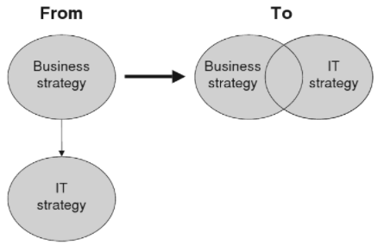
Figure 7-1 - Business & IT Alignment
Thinking
DYA consists of two parts, the theoretical and the application models (Google Books, 2021, pp. 56, 57). This chapter explains the theoretical model (also called ‘thinking model’)
Figure 2 depicts the theoretical model of DYA. The outer ring of figure 2 represents the entire organization, whereas the inner ring represents the IT department. It clearly shows that DYA strives to have clear communication between the organization and IT. Furthermore, figure 2 shows all the stakeholders of the organization, with each stakeholder defending their interests. They do this by making demands on the organization’s vision, strategy, and goals. For example, the customer expects (demands) good services, whereas the employee demands a good salary.
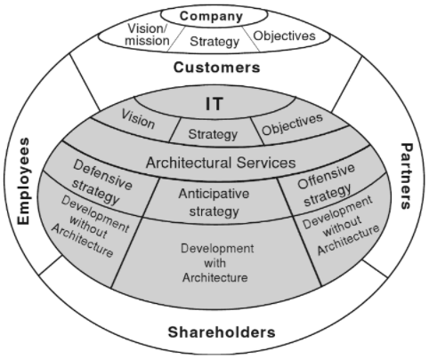
Figure 7-2 - Theoretical model
Method
As mentioned in the Thinking section, it is known that there is a theoretical model for DYA. There are also products to help get started with implementation. However, there is no working method with techniques that result in models (Van Haren, 2018). To work by several steps towards a dynamic architecture in an agile work environment, Sogeti’s steps are a good starting point. According to (Nouwens, 2021) the following steps are a recalibration to make an effective contribution to the architecture:
- Identify the context in which decisions must be made;
- Determine by whom decisions are made;
- Determine when decisions are made;
- Determine how architecture should be communicated;
- Redefine the vision of architecture in the organization.
Method of use
There are now more than fifty companies that use DYA, particularly in the Netherlands since Sogeti is the owner of the method. Because there is no modeling technique for DYA, there is no specific order of implementation. Most organizations start with the ‘project start architecture’ and then build out using various tools and templates, such as the maturity matrix (see figure 3). Because Sogeti is the owner of DYA, they also ensure that extensions to DYA are made regularly. It is therefore wise to keep an eye on Sogeti should an organization opt for a dynamic architecture.
Support mode
Every organization runs into sudden threats and opportunities where the organization has too little time available to implement adequate solutions. This applies to both an organization with fully implemented Dynamic Architecture, as well as a company without DYA. Therefore, within the DYA model, there are alternative strategies to deal with such a situation. In this regard, the following alternatives are discussed:
- Defensive strategy; and
- Offensive strategy.
The defensive strategy focuses on sudden events that threaten the continuity of the organization. In contrast, the offensive strategy focuses on opportunities that require immediate action from the organization (Google Books, 2021, p. 59).
When an organization uses either strategy, it is referred to as ‘development without architecture’.
Modeling mode
DYA has several templates that help implement DYA, such as the project start architecture. However, there is no specific tooling available for DYA, partly because DYA does not focus on modeling. To still be able to proceed with the implementation, the maturity matrix can be used. Figure 3 provides an example of such a matrix.
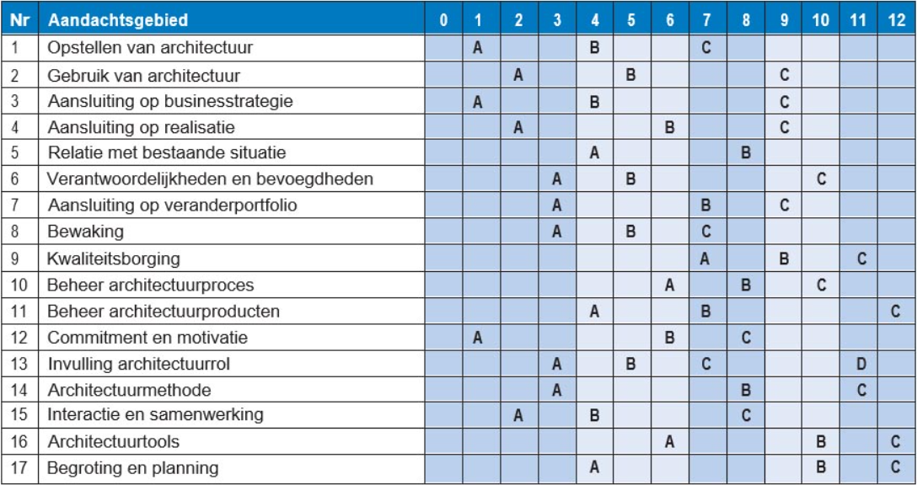
Figure 7-3 - Maturity matrix

The Open Group Architecture Framework – TOGAF
The Open Group is a global partnership whose mission is to achieve business goals by establishing technology standards. Their vision a "boundless flow of information through global interoperability in a secure, reliable and timely manner" (TheOpenGroup, 2021). What I take from this is that it wants to map all information systems so it can connect each system with each other.
Thought process
To understand the TOGAF framework, a definition must first be established, "Enterprise" is a collection of organizations with a corresponding purpose. Enterprise architecture is designed to capture all the different facets such as business activities, information and technology. (The Open Group, 2021)
Why is an Enterprise Architecture necessary?
Integrate, connect and change, the goal of an Enterprise architecture is to optimize the enterprise. Digital transformation today is a big factor in achieving business success, having the enterprise mapped is essential for this.

Principles of Enterprise Architecture:
- More effective and efficient business operations
- More effective and efficient digital transformation and IT operations
- Better return on existing investments, reduced risk for future investments
- Faster, easier and cheaper procurement
Work process
The TOGAF architecture standard typically includes the following four areas.
- The Business architecture, defines business strategy, governance, organization and main business processes.
- The Data architecture, describes the structure of an organizations logical, physical data resources and data management products.
- The Application architecture, is a blueprint for the individual applications to be implemented, their interactions and their relationships with the organization's core business processes.
- The Technology architecture, describes the software and hardware capabilities required to support the implementation at the business, data and application layer.
These are broadly the four areas that must be mapped and interconnected.

Use method
The TOGAF Architecture Development Method (ADM) is a method for developing architectures. This is a continuous process in which the architecture definition and realization is adjusted. As mentioned in the guest lecture by Johan Theunissen, for a large enterprise the work is divided into phases, each phase is assigned an architect. The different phases are:
- Phase A: Architecture vision describes the initial phase of an architecture development cycle. This incorporates information such as the mission, vision, scope etc.
- Phase B: Business Architecture describes the development of a business architecture in support of the agreed architecture vision
- Phase C: Information Systems Architecture describes the development of information systems to support the agreed architectural vision
- Phase D: Technology Architecture describes the development of technology to support the agreed architectural vision
- Phase E: Opportunities & Solutions performs initial implementation planning and delivery vehicle identification for the architecture defined in the previous phases
- Phase F: Migration Planning outlines how to move from the baseline to the target architectures by completing a detailed implementation and migration plan
- Phase G: Implementation Governance provides an architectural overview of the implementation
- Phase H: Architecture Change Management establishes procedures for managing changes to the new architecture
- Requirements Management examines the process of managing architecture requirements throughout the ADM
Supporting method
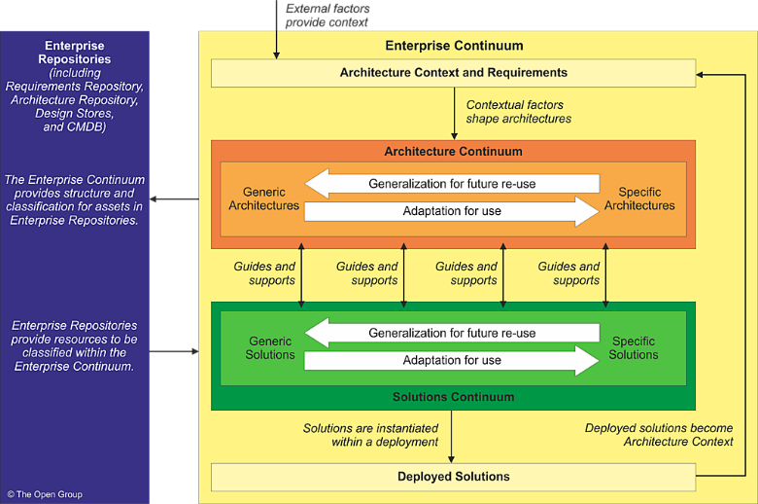
The enterprise continuum provides methods for classifying architecture and models, both internal and external to the architecture repository (think git). As the enterprise evolves and changes, the fundamental models are captured in a version control. The Enterprise Continuum includes more documentation of requirements, designs and CMDB.
Figure 7-4 - Enterprise continuum
Modeling method
Archimate is the modeling tool for modeling enterprise architecture. It is the standard when developing an enterprise architecture, with fixed icons, functions, views and much more. Archimate is always developed in consultation with enterprise stakeholders.

Scaled Agile Framework – SAFe
SAFe - Scaled Agile Framework
SAFe is based on Lean and Agile working.. It provides patterns, principles and tools to successfully develop large-scale products. The goal of SAFe is to ensure that problems arising from having multiple teams can be overcome.

SAFe aims to promote the following:
- Alignment between Business and IT;
Collaboration;
- Communication and delivery between multiple Agile teams.
- This is achieved by focusing on agile software development, lean product development and systems thinking.

Way of thinking
SAFe has since evolved into SAFe 5.0 and has four configurations: Essential, Portfolio, Large Solution and Full.

- Essential SAFe is the most stripped-down version. It describes the most critical elements required and is intended to provide the greatest benefits of the framework.
- Portfolio SAFe also takes strategy, investments and lean governance.
- Large Solution SAFe takes essentials as its foundation, focusing more on collaboration between multiple 'programs'.
- Full SAFe is a combination of the three above.
Figure 7-5 - SAFe model

Work and use
SAFe has 10 basic principles:
1. Take an economic view;
2. Apply systems thinking;
3. Assume variability; preserve options;
4. Build incrementally with fast integrated learning cycles;
5. Base milestones on objective evaluation of working systems;
6. Visualize and limit work-in-progress, reduce batch sizes, and manage queue lengths;
7. Apply cadence (timing), synchronize with cross-domain planning;
8. Unlock the intrinsic motivation of knowledge workers;
9. Decentralize decision-making;
10. Organize around value;

Modelling Method
SAFe uses ArchiMate to model. Within SAFe this happens top-down. This means that first large strategic models are made, on which subsequently models can be built that go further into detail.

An example:
A bank's strategic theme is to massively increase their revenue among millennials. To do so, they want to become the number 1 in terms of User Experience and that requires several resources. Below is a simple model of this.
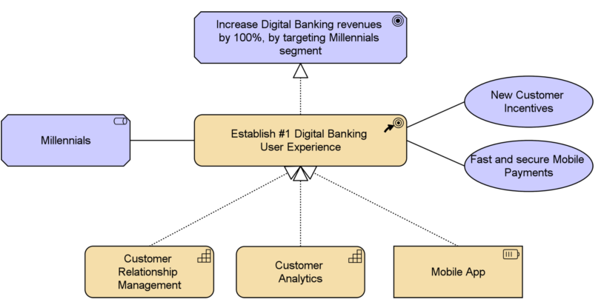
Figure 7-6 - ArchiMate model

This is the high-level plate. From here you could zoom in on the mobile app and what services it needs exactly. This would be a more detailed model derived from the strategic model.

By working this way, the right information is delivered to the right group, who can then direct the development process within their own specialization.

Annex B – ArchiMate legend
Motivation layer
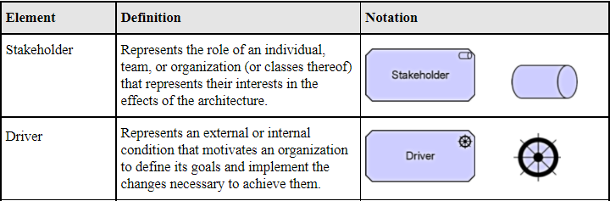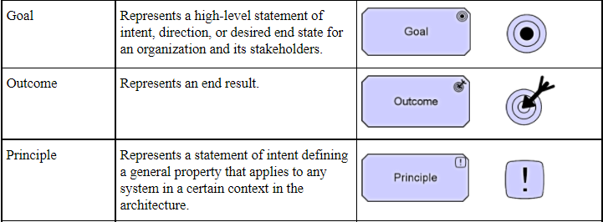
Figure 7-7 - Motivation layer legend
Business layer
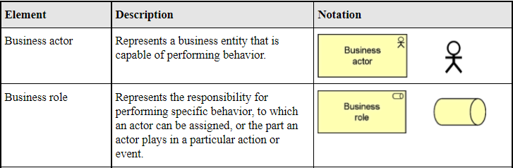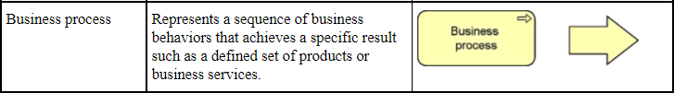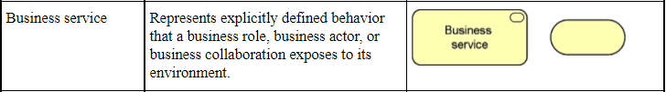
Figure 7-8 - Busienss layer legend
Application layer
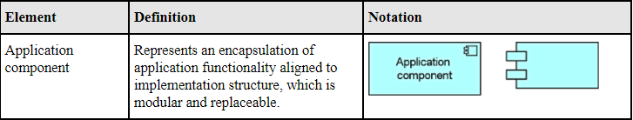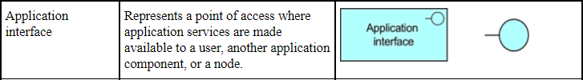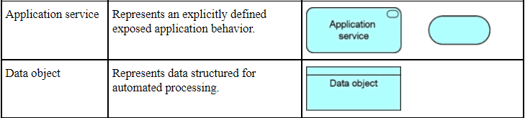
Figure 7-9 - Application layer legend
Technology layer
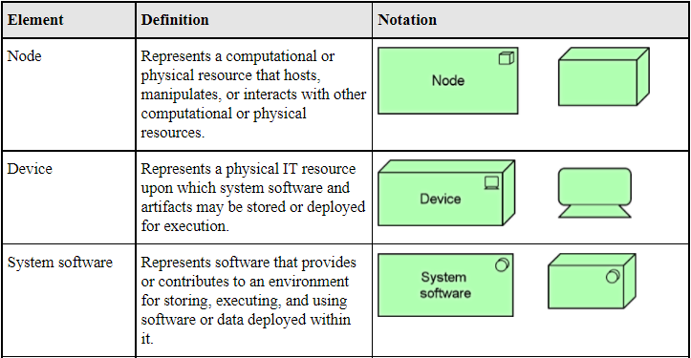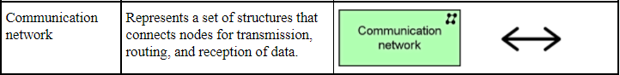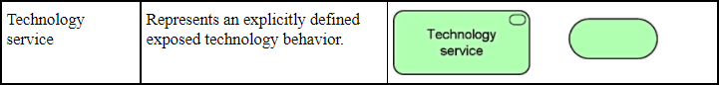
Figure 7-10 - Technology layer legend

