Advice report

Elevate
-
Nick van Oort, Max Post
& Arwen Voorn

2021

Document History

Revisions
Table 0-1 - Revisions
Version | Status | Date | Change
0.1 | Concept | 09-04-2021 | Start of the document.
0.2 | Concept | 23-04-2021 | Feedback Manon Penning processed.  - Added Appendix A & B  - Version 1 of chapter 3.1 & 3.2
0.3 | Concept | 10-06-2021 | All research questions written.  Conclusion written.  Advice written.
1.0 | Final | 11-06-2021 | Removed Appendix B – This was not used anywhere and is a separate document  Written introduction  Written management summary  Edited sub question 4.

Approval
This document requires the following approvals:
Table 0-2 - Approval
Version | Approval date | Name | Function | Initials

Distribution
This document has been distributed to:
Table 0-3 - Distribution
Version | Distribution date | Name | Function
0.1 | 14-04-2021 | Manon Penning | Project Assurance
0.3 | 10-06-2021 | Hans Kwaspen | Client
0.3 | 10-06-2021 | Nick van Pelt | Client
1.0 | 11-06-2021 | Manon Penning | Project Assurance

Management Summary (EN)
This research is set-up to investigate the possibilities of creating a bridge (a connection) between Siemens Teamcenter and SAP AIN based on the news that Siemens and SAP started cooperating since June 2020. Atos wants to implement this solution to provide it to their customers in the future. To investigate how this bridge can be created, the following research question was formulated:
“How to design a bridge between Siemens Teamcenter, SAP AIN and the Internet of Things so that Atos can define the concepts for the implementation of this type of solution for their customers?”
Several results were reached by working on answering the research question. The most important result was finding out about the T4S4 Gateway. This stands for ‘Teamcenter for S/4HANA’ gateway and is available in the Siemens Teamcenter application (PLM system) since 2018. This due to a takeover of Tesis PLMware by Siemens in 2013. This takeover made it possible for Teamcenter to connect to other business applications such as an ERP, MES, SCM, and CRM system. The T4S4 gateway enable a company to send information such as a document, a material, a bill of material, and more to from Teamcenter to S/4HANA (ERP system).
However, this is not the answer to the research question. The link to SAP AIN is still missing. Due to further research, there is a possibility to connect S/4HANA to SAP AIN by using a rest API or the SAP Cloud Integration Services as can be read in paragraph 3.4.
Knowing this, the conclusion can be made that this can be a possible way to connect Teamcenter to SAP AIN (with an extra connection in-between). However, finding out if a connection between S/4HANA and SAP AIN is not part of this research, it would be recommended to Atos to investigate this as part of the next research. The assumption is that since both systems are from SAP, that it should be possible to connect S/4HANA to SAP AIN using a rest API or SAP Cloud Integration Services.

Managementsamenvatting (NL)
Dit onderzoek is opgezet om de mogelijkheden te onderzoeken om een brug (een verbinding) te maken tussen Siemens Teamcenter en SAP AIN op basis van het nieuws dat Siemens en SAP sinds juni 2020 zijn gaan samenwerken. Atos wil deze oplossing implementeren om het in de toekomst aan hun klanten aan te bieden. Om te onderzoeken hoe deze brug kan worden gemaakt, werd de volgende onderzoeksvraag geformuleerd:
"Hoe kan een brug worden ontworpen tussen Siemens Teamcenter, SAP AIN en het Internet of Things, zodat Atos de concepten kan definiëren voor de implementatie van dit soort oplossingen voor hun klanten?"
Door te werken aan het beantwoorden van de onderzoeksvraag werden verschillende resultaten bereikt. Het belangrijkste resultaat was het leren over de T4S4 Gateway. Dit staat voor 'Teamcenter for S/4HANA' gateway en is sinds 2018 beschikbaar in de Siemens Teamcenter applicatie (PLM systeem). Dit als gevolg van een overname van Tesis PLMware door Siemens in 2013. Deze overname maakte het mogelijk voor Teamcenter om verbinding te maken met andere bedrijfsapplicaties zoals een ERP-, MES-, SCM- en CRM-systeem. De T4S4 gateway stelt een bedrijf in staat om informatie zoals een document, een materiaal, een materiaallijst en meer te sturen naar van Teamcenter naar S/4HANA (ERP-systeem).
Dit is echter niet het antwoord op de onderzoeksvraag. De koppeling met SAP AIN ontbreekt nog. Door verder onderzoek is er een mogelijkheid om S/4HANA te koppelen aan SAP AIN door gebruik te maken van een rest API of de SAP Cloud Integration Services zoals te lezen is in paragraaf 3.4.
Dit wetende kan geconcludeerd worden dat dit een mogelijke manier kan zijn om Teamcenter aan SAP AIN te koppelen (met een extra verbinding ertussen). Echter, het achterhalen van een koppeling tussen S/4HANA en SAP AIN is geen onderdeel van dit onderzoek, het zou Atos aan te bevelen zijn om dit te onderzoeken als onderdeel van het volgende onderzoek. De veronderstelling is dat aangezien beide systemen van SAP zijn, het mogelijk moet zijn om S/4HANA met SAP AIN te verbinden via een rest API of SAP Cloud Integration Services.

Table of contents
Management Summary (EN) 3
Managementsamenvatting (NL) 4
1. Introduction 7
2 Research 8
2.1 Sub question 1: Technical Information 9
2.2 Sub question 2: Bottlenecks and Problems 10
2.3 Sub question 3: Data Security 11
2.4 Sub question 4: Use Case 12
3 Results 13
3.1 Sub question 1: Technical Information 13
3.3 Sub question 3: Data Security 19
3.4 Sub question 4: Use Case 20
3.4.1 Example use case 22
4 Conclusion 23
5 Advice 24
6 Bibliography 25
Appendix 27
A. Sub-Question 1: Expert Interview 27
B. ArchiMate Legend 29

List of tables and figures
Tables
Table 0-1 - Revisions 2
Table 0-2 - Approval 2
Table 0-3 - Distribution 2
Figures
Figure 2-1 - Methods sub question 1 9
Figure 2-2 - Methods sub question 2 10
Figure 2-3 - Methods sub question 3 11
Figure 2-4 - Methods sub question 4 12
Figure 3-1 - SAP HANA Cloud blogpost 13
Figure 3-2 - Domain model 14
Figure 3-3 - SWOT Analysis 15
Figure 3-4 - Confrontation Matrix 16
Figure 3-5 - ArchiMate Atos IST 17
Figure 3-6 - ArchiMate Atos SOLL 18
Figure 3-7 - Risk Assessment 19
Figure 3-8 - SAP AIN to S/4HANA 20
Figure 3-9 - Flow of the connection between Teamcenter and S/4HANA 21
Figure 3-10 - Overview of the file formats 21
Figure 3-11 - Folder structure 22
Figure 3-12 - PLM Lego diagram 22
Figure 3-13 - Data table information example 22
Figure 3-14 - Example ERD between Teamcenter & SAP 23

Introduction
This research is set-up to investigate the possibilities of creating a bridge (a connection) between Siemens Teamcenter and SAP AIN based on the news that Siemens and SAP started cooperating since June 2020. Atos wants to implement this solution to provide it to their customers in the future.
Because this is an innovation project, it is a bit more difficult to explain the core issue as reason to start this project. However, the following can be described as issue to tackle with this research:
“How to create a bridge between Siemens Teamcenter and SAP AIN to achieve a next step in Industry4.0, to define and implement this to Atos’ customers”.
The goal to be reached with this research is as followed (also, based on the issue):
“Within a timeframe of five months, an information architecture will be designed to help achieve Industry4.0 in the future, using SAP AIN as the main framework, and researching possible future bottlenecks.”
To approach the issue in a structured way, this research will be performed using the DOT-Framework. This framework helps answering the research questions using research strategies and methods to achieve triangulation. This means that an answer is based on information, observation, etc. from multiple perspectives to reach a reliable and valid research.
Before starting to read the entire research, here follows a small overview of the chapters that this document contains. After this introduction chapter 2 shows the research questions and this chapter continues by explaining which research strategies and methods are chosen to get the best answer to a research question. Chapter 3 continues with showing the results that have been reached for each research question. This document will finish with a conclusion in chapter 4 and an advice towards Atos in chapter 5.

Research
The research described in this document tries to answer the following question:
“How to design a bridge between Siemens Teamcenter, SAP AIN and the Internet of Things so that Atos can define the concepts for the implementation of this type of solution for their customers?”
To be able to answer this question as thoroughly as possible, sub questions have been formulated:
- Technical Information: Which technical information needs to be extracted and how does this need to be restructured to be useful for the ‘real world’?
- Bottlenecks and Problems: How to ascertain what bottlenecks/problems will possibly arise from the change to the proposed Industry4.0 scope in our project?
- Data Security: How to assure the data security of the information architecture?
- Use Case: How to set up a use case so it can be shown to (potential) customers?
To answer the main question on how to design a connection between two systems, the technical information of SAP AIN and Teamcenter needs to be researched.
This chapter is about all the research (Methods) that have been used and the results that have come forth from it. The main question will be answered in chapter 3 (Conclusion).
To be able to answer the research question three or more methods will be used, for example: Document analysis, expert interview, and domain modelling. For each sub question an illustration is included that shows the correlation between the three or more methods. The reason why three or more methods are used is because it will result in triangulation which benefits the validity of the research.

Sub question 1: Technical Information
Which technical information needs to be extracted and how does this need to be restructured to be useful for the ‘real world’?
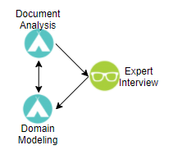
Figure 2-1 - Methods sub question 1
Document analysis
Document analysis will give insights on the technical information of the existing systems. Without doubt questions will arise from the document analysis, which are going to be asked during the expert interview.
Expert Interview
With the knowledge of the document analysis the expert interviews are being prepared to answer remaining questions.
Domain modelling
With input from the document analysis and the expert interview the domain can be modelled. The modelled domain should correspond to technical information found during the document analysis.

Sub question 2: Bottlenecks and Problems
How to ascertain what bottlenecks/problems will possibly arise from the change to the proposed Industry4.0 scope in our project?
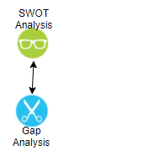
Figure 2-2 - Methods sub question 2
SWOT Analysis
By carrying out an internal and external analysis, a SWOT analysis can be made. This SWOT analysis gives a clear overview of possible bottlenecks and problems. The results from the SWOT analysis are further put into a confrontation matrix. By assessing the cross points in the matrix, an organization can see what the main options are that can be weighed against each other. Three of each part of the SWOT-analyses will be used in the confrontation matrix. If there are more than three, than needs to be decided which points are the most important.
Gap Analysis
Comparing the actual situation to the desired situation. This comparison is used to better understand what gaps there are. The gap analysis is then used to further improve upon the SWOT analysis as identified gaps are opportunities in a SWOT analysis.

Sub question 3: Data Security
How to assure the data security of the information architecture?
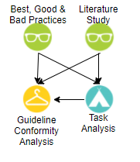
Figure 2-3 - Methods sub question 3
Best, Good & Bad Practices
Looking at the best IT audit cases, good cases and even failed IT audit cases. Using this information to improve the advice for an IT-Audit for Atos.
Literature Study
Doing a literature study on the selected framework for the IT audit to gain the necessary knowledge to make a well substantiated advice.
Task Analysis
Looking at the tasks of the employees that are key in the process. What input do they have and what are the risks of the actions they carry out. How to determine which employees have certain permissions in the tools.
Guideline Conformity Analysis
Setting up an IT auditing advice based on the current guidelines and with feedback from prestige auditing firms.

Sub question 4: Use Case
How to set up a use case so it can be shown to (potential) customers?
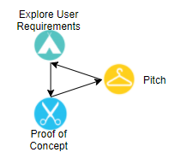
Figure 2-4 - Methods sub question 4
Explore User Requirements
To demonstrate the use of the new connection, between Siemens Teamcenter and SAP AIN, a use case can be created. To ensure the use case consists of the necessary steps, actions, and information it is useful to gather the user requirements from the stakeholders.
Proof of Concept
A proof of concept will be created for the use case to showcase the connection between Siemens Teamcenter and SAP IAM to the stakeholders.
Pitch
When the requirements are gathered and processed into the proof of concept, then the concept will be shown to the stakeholders in the form of a pitch. If the pitch is well received, it proves that the exploration of the user requirements has been done correctly.

Results
In the previous chapter is explained which research questions will be answered and how they will be answered by explaining the research methods. This chapter will focus on the results that have been achieved via those methods.

Sub question 1: Technical Information
Document analysis & Expert interview
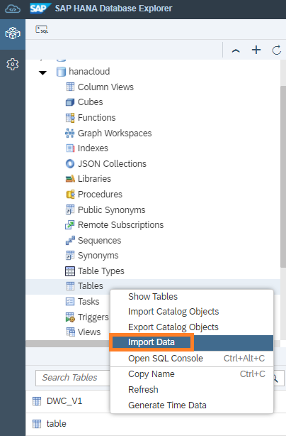
Reading up on the SAP IAM integration documentation supplied by the IAM expert. A few things became clear, there is a connection layer in which the integration must be made in order to connect with SAP ERP or S/4HANA system (Scheiba, 2021). This connection layer is called the ‘Asset Central Foundation’. Asset central foundation is the leading master data foundation for the following asset-centric solutions of SAP Intelligent Asset Management that are built on SAP Cloud Platform (Ravikumar, 2019):
Figure 3-1 - SAP HANA Cloud blogpost
- SAP Asset Intelligence Network;
- SAP Asset Strategy and Performance Management;
- SAP Predictive Maintenance and Service;
- SAP Predictive Engineering Insights.
Looking at the SAP Cloud platform it shows on blogs that data connection is made in the SAP HANA Database explorer (Simon, 2020).
What is more important for this research is defining the joint domain model, underlying end-to-end processes that sets the foundation for linkage across systems. An aligned data model between SAP and Siemens is foundational to the integration as an intermediate layer. It is an abstraction of the data that needs to be exchanged between Siemens Teamcenter and SAP S/4HANA/ERP (Weil, 2021).

Domain Modelling
In figure 3.2 is the domain model of this project depicted. The model is based on the information from the SAP IAM expert and the document analysis and is a display of the desired situation in which a connection between Siemens Teamcenter and SAP IAM has been established.
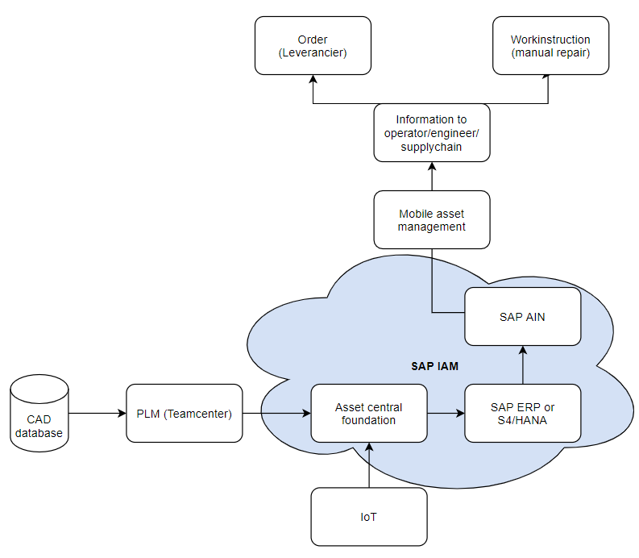
Figure 3-2 - Domain model

  - Sub question 2: Bottlenecks and Problems
SWOT Analysis
The basis for a SWOT analysis is an external and internal analysis. Both external and internal analysis have dozens of analysis possibilities, but they are not all necessary to come to a good result.
The following external and internal analysis have been carried out:
- External: PESTEL Analysis;
- External: Competitor Analysis;
- Internal: Financial Analysis;
- Internal: Business Model Canvas;
- Internal: BCG Matrix.

The analysis that has been carried out to come to the SWOT analysis and the corresponding confrontation matrix can be found in appendix B and result in the following:
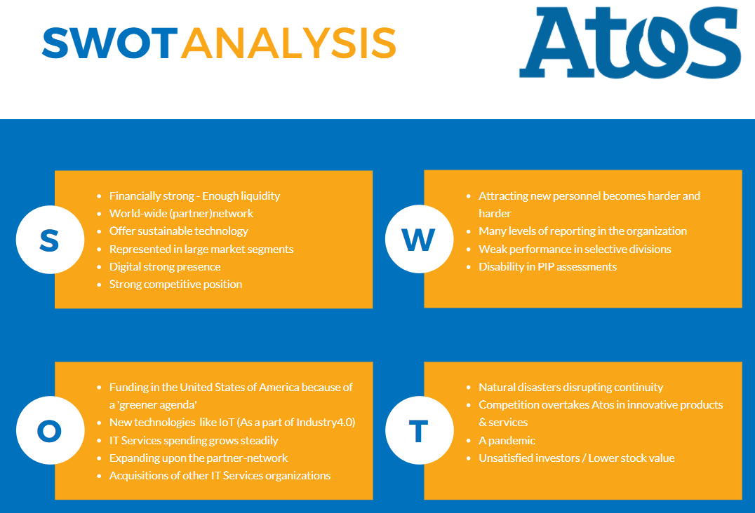
Figure 3-3 - SWOT Analysis

The confrontation matrix exists of the three main points for each Swot part. In a professional Swot analysis, the results based on the stakeholders filling in a survey to decide which score each cell receives. (Strategischemarketingplan.com, 2014).
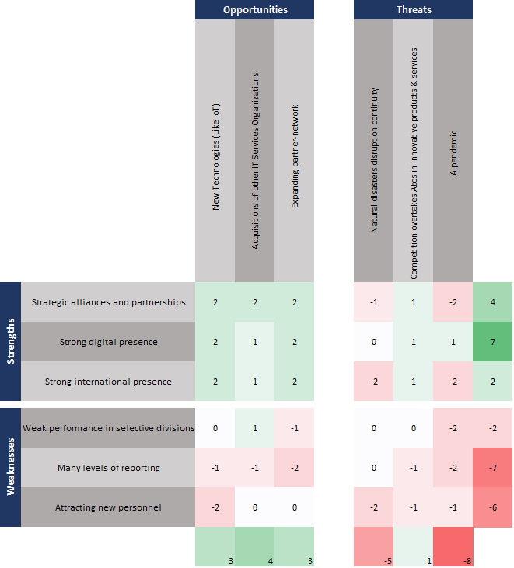
Figure 3-4 - Confrontation Matrix
The top-priorities that come forth from the confrontation matrix are:
- Having a strong digital presence (7) – Atos is mainly an information communication organization, so strong digital presence helps them cement a good foundation for IT activities.
- Having a focus on environmental change (-5) – Atos already does this by making sure datacenters are backed-up at other data centers and by monitoring areas near offices.
- Having strong alliances and partnerships (4) – Atos focusses on strong partnerships. On one side this binds customer to Atos and on the other side it makes sure Atos is aware of global needs in IT services.
- Remaining frontrunner in innovations (1) – There are currently rapid technological developments. Innovating and remaining a frontrunner is a must in order not to lose valuable market-share.

GAP Analysis
An architecture model has been created for both the current as the desired situation to show the gap between them. The models are constructed by three layers:
- The business layer: this shows the processes and the persons involved;
- The application layer: this shows the applications involved and how they are connected with one another;
- The technology layer: this shows the devices, databases, firewalls etc. and how these devices are connected with one another;
- The motivation layer: this shows the goals that need to be achieved. They are supported with drivers and principles and are sideways connected (mostly) to the business and application layer.

IST-situation ArchiMate
Figure 4-4 depicts the current situation of this project in ArchiMate, Annex B contains a legend for ArchiMate:
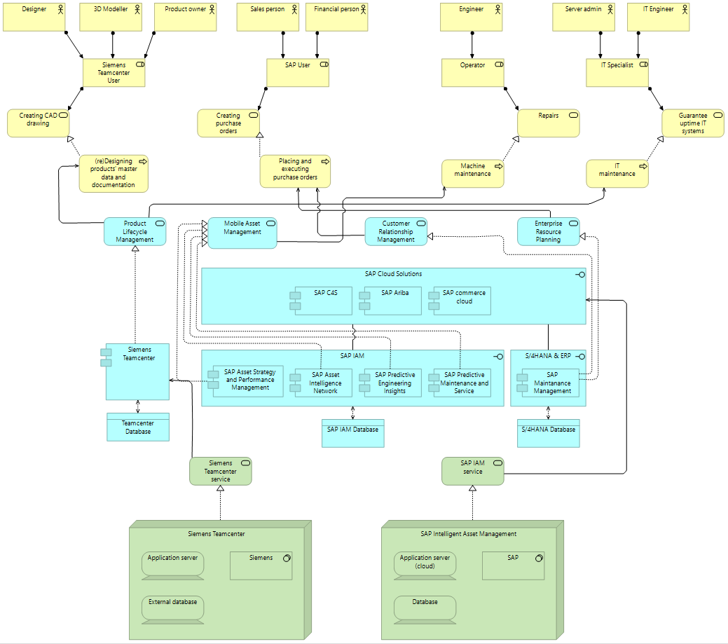
Figure 3-5 - ArchiMate Atos IST

SOLL-situation ArchiMate
Figure 4-5 depicts the desired situation of this project in ArchiMate, Annex B contains a legend for ArchiMate: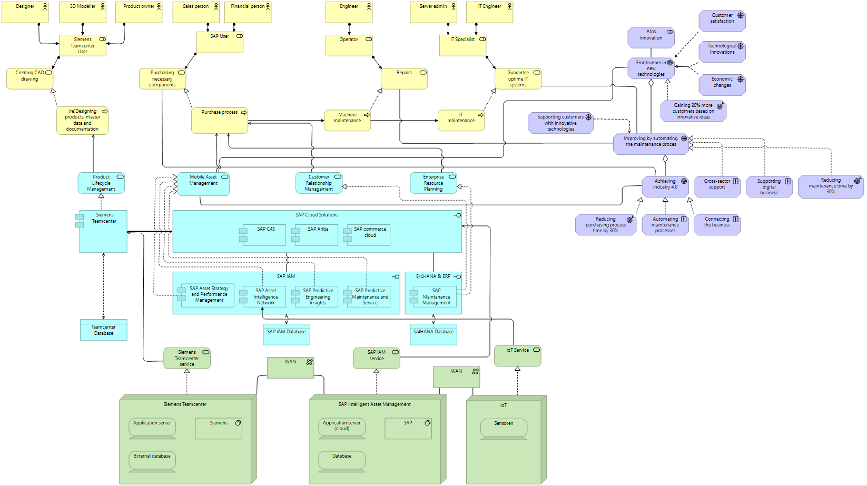
Figure 3-6 - ArchiMate Atos SOLL

Sub question 3: Data Security
How to assure the data security of the information architecture?
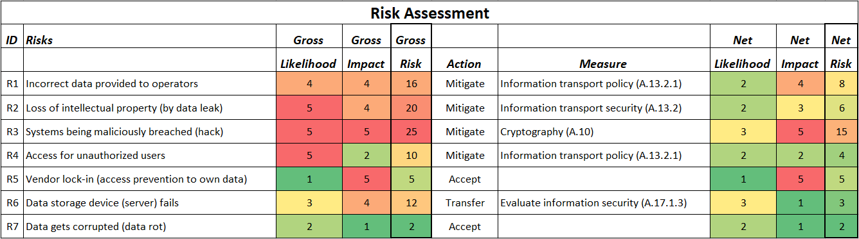
For the data security a IT audit report has been made, with a detailed risk assessment that has been worked out into a risk prioritization list. The detailed risk assessment as seen in the figure below, shows each risk, with a risk score and based on that the action/measure that will be taken. The list has an prioritization advice, in order to assure data security of the new information architecture.
Figure 3-7 - Risk Assessment
Prioritization
From the seven risks that are most applicable to this project, there are a few that have the highest priority to implement:
- R1 – Incorrect data provided to operators – Since incorrect data is an operational risk, it is advisable to prioritize this risk. If the control measure ‘Information Transport Policy’ is not implemented, wrong data could render equipment and machinery useless/unavailable. Also, ‘Information Transport Policy’ is a measure that applies to R4, which means two risks are simultaneously tackled.
- R2 - Loss of intellectual property (by data leak) – Intellectual property is one of the most valuable assets of an organization. A data leak could mean competitors have access to this data which would mean that strategic advantages fade away. Since a lot of the data from machines, which might be considered intellectual property, is transferred from Siemens Teamcenter to SAP AIN, a control measure should be implemented to minimize the risk of data leaks.
- R3 – Systems being maliciously breached (hack) – Hackers become more and more active. Hackers could install malicious software on the organizations’ servers and could potentially also install ransomware. This is a big operational risk because it could shut down a company for days/weeks.
The other risks have a lower risk score. This doesn’t mean they shouldn’t be addressed but they also do not have the highest priority.
Advice
The Audit report is an advice and should be treated as such. All control measures and advice on how to implement them are possible ways Atos can achieve better data security for their innovation project and get ISO27001 certified. This means that Atos is free to implement other measures how they see fit, and it also means that the advice will not necessarily mean ISO27001 certification will be possible if all stated control measures are implemented. The latter is dependent on how it is implemented in the final solution and if the solution will become exactly how it is described. For more detailed information check the IT Audit report.

Sub question 4: Use Case
In an article from (Sanders, 2013), he informs about the takeover of Tesis PLMware by Siemens. Siemens took over PLMware to integrate other business application (like ERP, CRM, MES or SCM) with Siemens Product Lifecycle Management system; Teamcenter.
With this takeover, Siemens was able to provide a company with the option to add an extension for Siemens Teamcenter gateway. This gateway is built for several application, including SAP. More specifically, for SAP Business Suite or S/4HANA (because S/4HANA is an ERP system). Neither of those systems are the focus of this research. Since the idea is to connect Teamcenter with SAP AIN, this is not yet the full solution. However, based on the slideshow from (Branding Mantenance, 2019) there might be a solution to connect SAP AIN to Siemens Teamcenter through the T4S4 gateway (S/4HANA gateway). This could work with a workaround. If a connection between S/4HANA and SAP AIN (or SAP IAM) is (or could be) established, then figure 3-8 could provide a decent solution.
The solution would work as follow:
- Connect Teamcenter to S/4HANA via the T4S4 Gateway;
- Use a Rest API or SAP Cloud Integration Services to connect to SAP AIN;
- Establish through this way a connection between Teamcenter and SAP AIN.
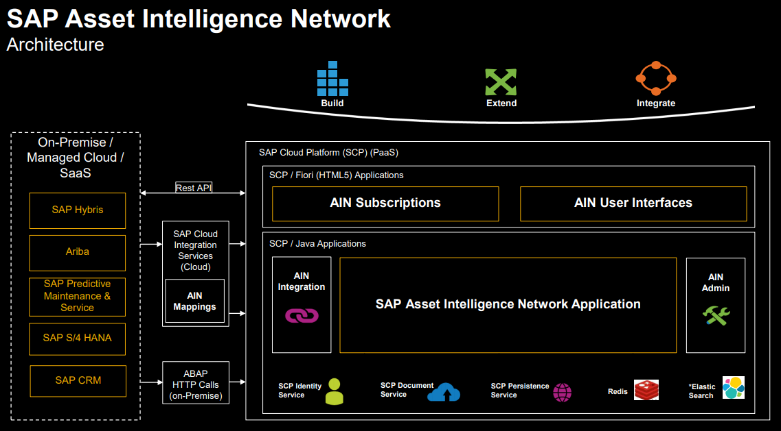
Figure 3-8 - SAP AIN to S/4HANA
Figure 3-9 provides a visual overview of how the connection between Teamcenter and S/4HANA would look like via the T4S4 gateway.

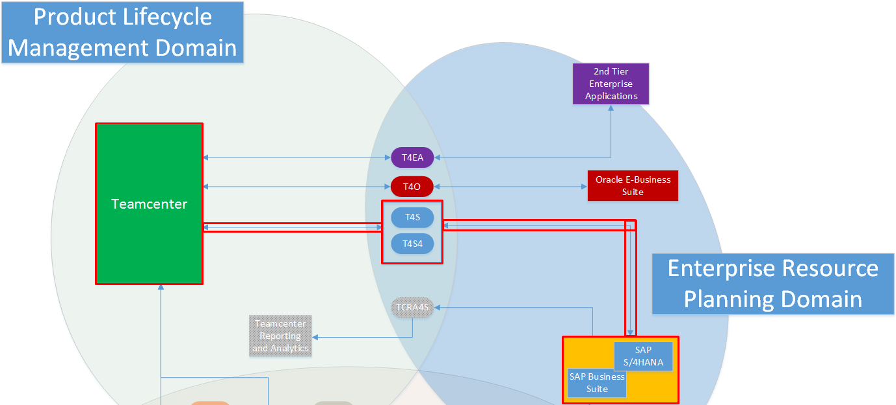
Figure 3-9 - Flow of the connection between Teamcenter and S/4HANA
With this gateway it is possible to send several items to SAP. These items are based on the formats SAP can receive and process in their system. The following items/ formats can be transferred from Teamcenter to S/4HANA:
- Material Master
- Document Info Record
- Bill of Material
- Change Master
- Equipment Master
- Functional Location
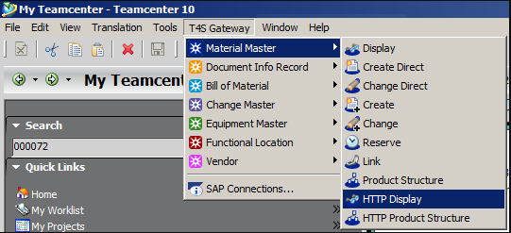
Figure 3-10 - Overview of the file formats
Depending on the item that needs to be transferred to S/4HANA, an item from one of above categories need to make via a ‘Create Direct’ function. From here an item can be created directly in S/4HANA. Once the action is performed the ‘transaction’ in Teamcenter will be executed, meaning that at this point the gateway is triggered to start working in the background. In the background it is creating, for example, a ‘Material Master’ template for S/4HANA and logging into S/4HANA to create this item/part directly in S/4HANA.

Example use case
This chapter needs to be taken as an global idea/example of what a possible solution could be.
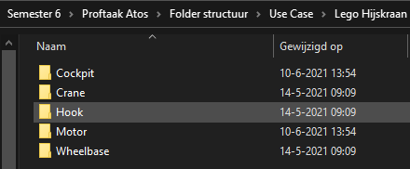
A folder structure has been made, to simulate a PLM of a crane without the possibility to use Teamcenter. It separates every part of the crane, with different documentations like blueprints, suppliers, and 3D CAD drawings.
Figure 3-11 - Folder structure

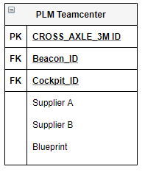
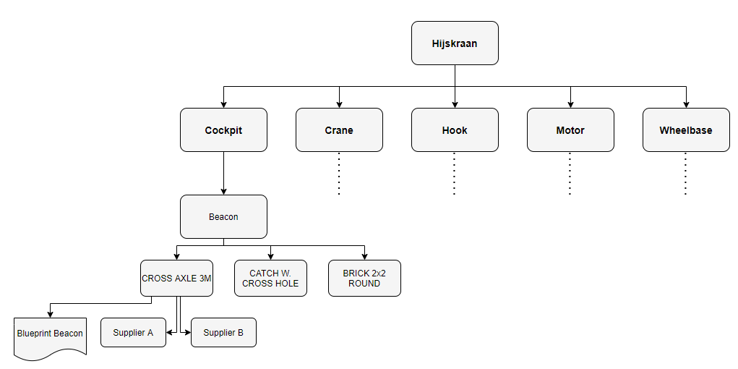
The figure below shows a product lifecycle management structure of the ‘Lego Hijskraan’. This is based on the Lego construction documentation.
Figure 3-12 - PLM Lego diagram
This diagram shows what the product decomposition is, with this a database example has been made. A data transfer between Teamcenter and SAP means certain data inputs are connected. Like sending the supplier information to SAP, so that a operator can easily reorder a certain part. Blueprint information for the assembly of the part.
Figure 3-13 - Data table information example
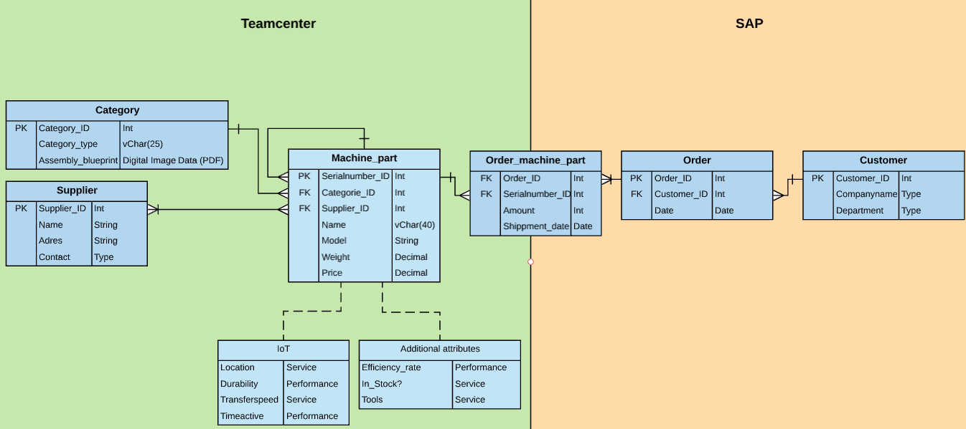
The beneficial part if both systems would be connected, is extending of data information. Ordering machine parts based on the PLM information, and the possibility to use predicative modelling/order automation. The figure below shows a global example on what the two different data sources would connect.
Figure 3-14 - Example ERD between Teamcenter & SAP
Assembly blueprints
When looking up store procedures, data types & file formats, it listed different file formats that are storable. In appendix C is a table on which formats are best storable in databases, based on this information, Portable Document Format (PDF) is the best option for saving and sending assembly instructions.
IoT
- Location:
  - Service so that operators can easily find the location of an asset.
- Durability
  - Gives an indication of how long that part will last
- Transfer speed
  - The speed of the machines that is send to SAP
- Time active
  - The duration that a machine is active
Additional attributes
- Efficiency rate:
  - The performance of a machine, how effective is the measured machine? Is the efficiency declining?
- In Stock:
  - Shows if a part is in stock and can be reordered.
- Tools:
  - List of tools that are needed to deconstruct the machine

Conclusion
The main question for this project is:

“How to design a bridge between Siemens Teamcenter, SAP AIN and the Internet of Things so that Atos can define the concepts for the implementation of this type of solution for their customers?”

The research focusses on three main parts:
- Security by Design by using the ISO27001 framework;
- Change portfolio for this project and connected projects;
- Setting up a connection from Siemens Teamcenter to SAP AIN.
In conclusion, this project has provided Atos with the tools needed to finish the project. The IT Audit helps Atos with implementing the right security measures and the change portfolio will help Atos with structuring this project and all related projects.
Last but not least, the conclusion can be made that the T4S4-gateway can be a possible way to connect Teamcenter to SAP AIN (with an extra connection in-between). However, finding out if a connection between S/4HANA and SAP AIN is not part of this research, it would be recommended to Atos to investigate this as part of the next research. The assumption is that since both systems are from SAP, that it should be possible to connect S/4HANA to SAP AIN using a rest API or SAP Cloud Integration Services.

Advice
The advice is made up of a few different components, which will be addressed below. Atos is free to follow the advice given but is also free to ignore it and make their own decisions.

Using the T4S4-gateway (Teamcenter to S/4HANA)
Paragraph 3.4 of this document describes the (possible way) to establish a connection between Siemens Teamcenter and SAP AIN. The part that would connect S/4HANA to SAP AIN might be a research on its own, which means that won’t be worked out in this research. However, the following website (PDF) described all about the T4S4 gateway. This including the information/ the steps to add the T4S4 gateway (or T4S gateway in Teamcenter) in Siemens Teamcenter. Following the information below from page 33 (paragraph 5.4.1) will enable the T4S4 Gateway in Teamcenter.

https://docs.plm.automation.siemens.com/content/pl4x/18.1/T4S_PDF/en_US/Teamcenter_Gateway-Installation_Guide.pdf

Security by Design
Part of this project was focused on giving advice on the ISO27001 – Data Security certification. Atos is advised to follow the outcomes of the IT Audit advice since it tackles the risks with the highest priority. Furthermore Atos is advised to also go through the rest of the ISO27001 certification checklists to fully ensure data security.

Advice on what measures to take to control the risks can be found in the IT Audit itself. This will supply Atos with all necessary components.

Change Portfolio
Atos is advised to make use of a change portfolio, which can be found in the Business Transformation Plan. This structures different projects that are all connected in a way to each other. A change portfolio helps with planning the different projects, when collaboration is needed, what timeframe is necessary for the whole project to be executed etc.
In the Business Transformation Plan a basic setup has been supplied to give Atos a direction. Atos’ task however is to define more action points, categorize them into projects and work out basic information for these projects.

Bibliography
Atos. (2020, February 27). ranked first overall in Whitelane’s 2020 IT Outsourcing Study for Belgium and Luxembourg. Retrieved from Atos Website: https://atos.net/en-be/belgium/atos-ranked-first-overall-in-whitelanes-2020-it-outsourcing-study-for-belgium-and-luxembourg
Atos. (2021, 02 18). 2020 annual results. Retrieved from Atos.net: https://atos.net/en/2021/press-release_2021_02_18/2020-annual-results
Atos. (2021, March 4). Partners and Alliances. Retrieved from Atos: https://atos.net/en/about-us/partners-and-alliances
Branding Mantenance. (2019, juni 2). SAP AIN Asset Intelligence Network. Retrieved from Slideshare website: https://www.slideshare.net/BrandingMaintenance/sap-ain-asset-intelligence-network-148671628?from_action=save
Business 2 You. (2016, 09 18). Scanning the Environment: PESTEL Analysis. Retrieved from Business-to-you: https://www.business-to-you.com/scanning-the-environment-pestel-analysis/
Eelants, M. (2021, March 10). Value chain Porter | Waardeketen volgens Michael Porter. Retrieved from Strategischmarketingplan.com: https://www.strategischmarketingplan.com/marketingmodellen/value-chain-porter/
Knoot, J. (2021, March 10). Vijfkrachtenmodel volgens Porter en concurrentieanalyse. Retrieved from Strategischmarketingplan Website: https://www.strategischmarketingplan.com/marketingmodellen/vijf-krachten-model-porter/
Owler. (2021, March 10). Attention Required! | Cloudflare. Retrieved from Owler Website: https://www.owler.com/company/atos#competitors
Petitjean, F. (2021, 02 18). Atos draaide minder omzet in 2020. Retrieved from Computable: https://www.computable.be/artikel/nieuws/management/7139029/5440850/atos-draaide-minder-omzet-in-2020.html
Ravikumar, R. (2019, 07 04). The Story of Enhanced Integration for Asset Central Foundation Has Just Gone Viral! Retrieved from SAP Community: https://blogs.sap.com/2019/07/04/the-story-of-enhanced-integration-for-asset-central-foundation-has-just-gone-viral/
Sanders, R. (2013, december 30). Siemens neemt Tesis PLMware over. Retrieved from Computable website: https://www.computable.nl/artikel/nieuws/erp/4958758/250449/siemens-neemt-tesis-plmware-over.html
Scheiba, M. (2021, 04 09). SAP IAM. (M. Post, N. Oort, & A. Voorn, Interviewers)
Simon, M. (2020, 10 27). Import data from files to SAP HANA Cloud. Retrieved from SAP Community: https://blogs.sap.com/2020/10/27/import-data-from-files-to-sap-hana-cloud/
Strategischemarketingplan.com (Director). (2014). SWOT en confrontatiematrix in 3 minuten [Motion Picture]. Retrieved from https://www.youtube.com/watch?v=qxCwbFygluc&ab_channel=Strategischmarketingplan.com
Weil, A. (2021, 04 14). The roadmap for a new generation of SAP and Teamcenter integration. Retrieved from SAP Community: https://blogs.sap.com/2021/04/14/the-roadmap-for-a-new-generation-of-sap-and-teamcenter-integration/

Appendix

Sub-Question 1: Expert Interview
Overview
Overview of questions about SAP IAM / AIN and Internet of Things.

SAP IAM / AIN
- How can data be imported into SAP?
  - Is it possible to do this through live connections? (E.G. API)
  - What are data columns that are obligatory, and which are optional? (Data requirements)
  - Which type of files/data cannot be imported?
- How is data structured in SAP (IAM)? (E.G. SQL Database)
- Are there already applications connected to SAP that send a lot of information in different file formats?
  - If so, how is this data restructured so it is usable in SAP?
  - Is it possible to not permanently save the data into SAP (Creating redundancy) but to load them in temporarily? (When requested by a user?)
- Can SAP AIN autonomously place orders for (replacement) products, or can it only make purchase requisition orders?

Responses
Responses given by Marco Scheibe for SAP IAM / AIN.

SAP IAM / AIN
- Asset central foundation is the connection layer with an SAP ERP or S/4HANA system. Asset central foundation requires mandatory field information for data objects during asset data maintenance. See document “Integration of Asset Central Foundation with SAP_2102.pdf”.
  - Real-time data exchange is possible (settings via the configuration cockpit).
  - See document “Integration of Asset Central Foundation with SAP_2102.pdf.
  - See document “Integration of Asset Central Foundation with SAP_2102.pdf.
- HANA DB. I cannot give more detailed information as I do not have the technical know-how in this area.
- –
  - Yes, the data will be restructured in Asset Central.
  - Data will be synchronized, whereby the ERP / S4 system is often the master (other variants possible). No temporarily data load possible.
- No autonomously place orders for (replacement) products, only Shopping Cart in relation to e-commerce ("Add to Cart" icon for the relevant spare parts in the Equipment and Models application) See document “AIN_SAP Commerce_Cloud_integration_Guide.pdf”.

Referred Documents

ArchiMate Legend
ArchiMate legend
Motivation layer
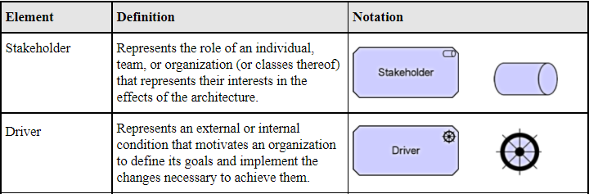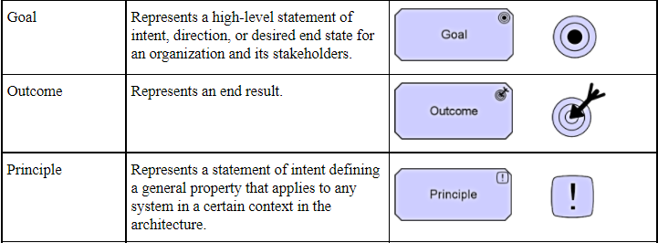
Business layer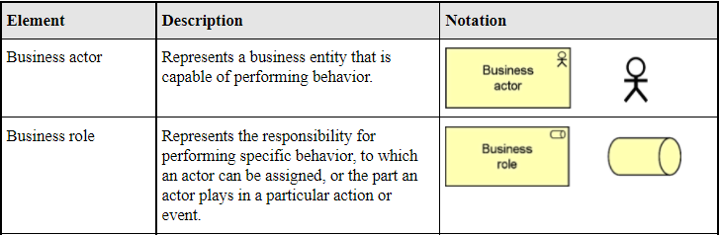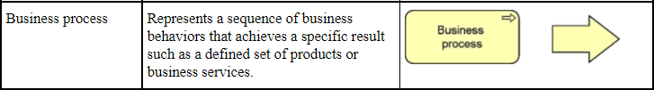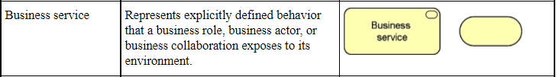

Application layer
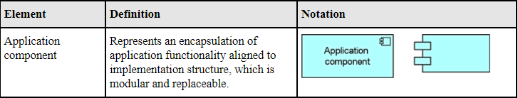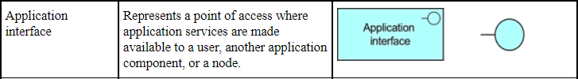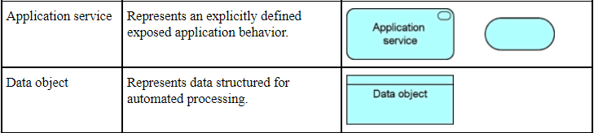
Technology layer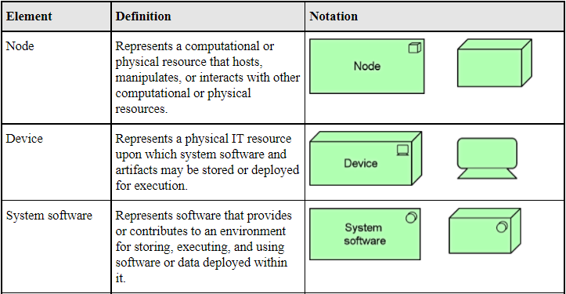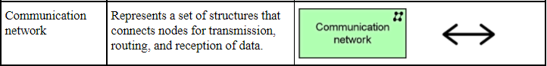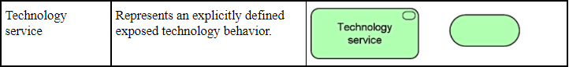

C
TYPE OF DATA | PREFERRED FILE FORMATS FOR SHARING, RE-USE AND PRESERVATION | Other Acceptable formats
Quantitative tabular data with extensive metadata  - a dataset with variable labels, code labels, and defined missing values, in addition to the matrix of data | - SPSS portable format (.por)  - delimited text and command (‘setup’) file  - (SPSS, Stata, SAS, etc.) containing metadata information  - structured text or mark-up file containing metadata information, e.g. DDI XML file | MS Access (.mdb/.accdb)
Quantitative tabular data with minimal metadata  - a matrix of data with or without column headings or variable names, but no other metadata or labelling | - comma-separated values (CSV) file (.csv)  - tab-delimited file (.tab)  - including delimited text of given character set with SQL data definition statements where appropriate | - delimited text of given character set -- only characters not present in the data should be used as delimiters (.txt)  - widely-used formats, e.g. MS Excel (.xls/.xlsx), MS Access (.mdb/.accdb), dBase (.dbf) and OpenDocument Spreadsheet (.ods)
Geospatial data  vector and raster data | - ESRI Shapefile  - (essential: .shp, .shx, .dbf ; optional: .prj, .sbx, .sbn)  - geo-referenced TIFF (.tif, .tfw)  - CAD data (.dwg)  - tabular GIS attribute data | - ESRI Geodatabase format (.mdb)  - MapInfo Interchange Format (.mif) for vector data
Qualitative data  textual | - eXtensible Mark-up Language (XML) text according to an appropriate Document Type Definition (DTD) or schema (.xml)  - Rich Text Format (.rtf)  - plain text data, UTF-8 (Unicode; .txt) | - plain text data, ASCII (.txt)  - Hypertext Mark-up Language (HTML) (.html)  - widely-used proprietary formats, e.g. MS Word (.doc/.docx)  - LaTeX (.tex)
Digital image data | TIFF version 6 uncompressed (.tif) | - JPEG (.jpeg, .jpg)  - TIFF (other versions; .tif, .tiff)  - JPEG 2000 (.jp2)  - Adobe Portable Document Format (PDF/A,  PDF) (.pdf)
Digital audio data | - Free Lossless Audio Codec (FLAC) (.flac)  - Waveform Audio Format (WAV) (.wav)  - MPEG-1 Audio Layer 3 (.mp3) - spoken word audio only | - MPEG-1 Audio Layer 3 (.mp3)  - Audio Interchange File Format (AIFF) (.aif)
Digital video data | - MPEG-4 High Profile (.mp4)  - motion JPEG 2000 (.jp2) | JPEG 2000 (.mj2)
Documentation & Scripts | - Rich Text Format (.rtf)  - Open Document Text (.odt)  - HTML (.htm, .html) | - plain text (.txt)  - widely-used proprietary formats, e.g. MS Word (.doc/.docx) or MS Excel (.xls/ .xlsx)  - XML marked-up text (.xml) according to an appropriate DTD or schema, e.g. XHMTL 1.0  - PDF/A or PDF (.pdf)
(Univesrity of Edinburgh Information Services, 2021)

