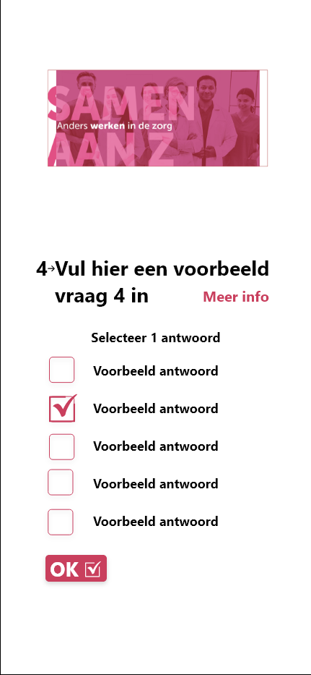
Group project case: Interreg Samen aan Z
Author(s): Jeffrey Cornelissen
Date: 05-07-2023

Context
The healthcare sector in Belgium and The Netherlands has been struggling with declining employee numbers. Vacancies are not filled, and courses are understaffed.

In both The Netherlands and in Belgium, the demand for complex and long-term care is very high and the labour costs will continue to rise. Staff is aging on average and in some areas the average age is over 50. This has an effect on the already hired employees. Approximately 10% of the current workforce is considering working in other professions and/or sectors.

“Samen aan Z” is a project that aims to intervene and reduce the number of employees who are considering leaving using various interventions. “Samen aan Z” tries to find the reason why employees are (considering) leaving.

Part of the project is to develop a platform which gathers and combines data for analysis. The most important data stream is the survey. Employees are asked to fill in these questionnaires at specific intervals to measure the mental state and overall wellbeing of the employee. The data from the questionnaires is available to the employee. Management and direction will only see the analysed data that cannot be traced back to an individual employee.

Existing work and available information
- There is an architecture design available that needs to be followed.
- There is a survey project available that can be used for reference (or more).
- A set of requirements is available for further analysis

The project goals
At the end of the semester, the project group needs to deliver a back-end that accepts data from different data streams, processes this data and displays the results in a dashboard.
It is of utmost importance that the roles of the users are taken into consideration. Both GDPR and ethical considerations need to be respected.

Solution characteristics

- The project is part of a bigger group of projects. Therefore, help is available regarding legal, ethical and design aspects. Make sure to consult others where needed
- Some possible keywords: Data processing, Message Queue System, Dashboarding, Data pipelines, ELT/ETL
- The project is to be built using Angular, Google Charts, Surveyjs and Java Spring Boot
- The project is to be pushed to and documented on the InnovationLab GitLab (wiki functionality is advised)
- Continuity: The tool needs to be up and running by the end of the semester. Help from Innovaction is available.
- Infrastructure: The backend is running on Azure. There is a resource group available, and access can be granted to project participants
- Concurrent users: The workload depends on the number of surveys and other data streams. The system will probably have around a couple of 100 concurrent users max. Some user types will use the system more extensively than others e.g., researchers.
- Roles: Care-employees, management, researchers and admins
- System needs to be easy to use. This is not necessarily a consideration at the beginning of the project
- Security related requirements: Data needs to be handled with care and the role of the user should always be taken into consideration.
- Required: The solution needs to be GDPR compliant (by law)
- Required: To enable a smooth project handover, the solution needs to be well documented, and the project code should be of high quality (e.g., readable, maintainable, extensible, etc.). Innovaction will take over the project after the semester.
