Project Plan

Intereg/ Samen Aan Z

Date 17.09.2023
Version 1.0
State 1st version
Author Group 2 - RB01
Members Florin Pană, Sytse Walraven, Rim Almeshal, Youssef Belganche, Francois Haan, Denys Sytnyk

Version history

Version | Date | Author(s) | Changes | State
1.0 | 13.09.2023 | Group 2 | Downloaded the template, added the initial content | Initial draft
1.1 | 14.09.2023 | Group 2 | Changes to several chapters and new additions to other chapters | 1st version
1.2 | 17.09.2023 | Group 2 | Spelling check, final touches for the first Canvas upload | 1st version
1.3 | 20.09.2023 | Group 2 | Applying feedback | 2nd version

Distribution
Version | Date | Receivers
1.2 | 17.09.2023 | Teague Murray Marshal (t.murraymarshall@fontys.nl)  Jeffrey Cornelissen (jeffrey.cornelissen@fontys.nl)  Frank Schürgers (f.schurgers@fontys.nl)
1.3 | 24.09.2023 | Teague Murray Marshal (t.murraymarshall@fontys.nl)  Jeffrey Cornelissen (jeffrey.cornelissen@fontys.nl)  Frank Schürgers (f.schurgers@fontys.nl)

1. Project assignment 3
1.1 Context 4
1.2 Goal of the project 4
1.3 Scope and preconditions 4
1.4 Strategy 6
1.5 Research questions and methodology 7
1.6 End products 7
2. Project organisation 9
2.1 Stakeholders and team members 9
2.2 Communication 9
3. Activities and time plan 9
3.1 Phases of the project 10
3.1.1 Initial phase 10
3.1.2 Implementation phase 10
3.1.3 Final phase 10
3.2 Time plan and milestones 10
4. Testing strategy and configuration management 11
4.1 Testing strategy 11
4.2 Test environment and required resources 11
4.3 Configuration management 11
5. Finances and risk 12
5.1 Project budget 13
5.2 Risk and mitigation 13

Project assignment

Context
The healthcare sector in Belgium and The Netherlands has been struggling with declining employee numbers. Vacancies are not filled, and courses are understaffed.

In both The Netherlands and in Belgium, the demand for complex and long-term care is very high and the labour costs will continue to rise. The staff is ageing on average and in some areas the average age is over 50. This influences the already hired employees. Approximately 10% of the current workforce is considering working in other professions and/or sectors.

Goal of the project
Samen aan Z is a project that aims to intervene and reduce the number of employees who are considering leaving using various interventions. Samen aan Z tries to find the reason why employees are (considering) leaving.

Part of the project is to develop a platform which gathers and combines data for analysis. The most important data stream is the survey. Employees are asked to fill in these questionnaires at specific intervals to measure the mental state and overall wellbeing of the employee. The data from the questionnaires is available to the employee. Management and direction will only see the analyzed data that cannot be traced back to an individual employee.

Scope and preconditions

Inside Scope:

Orchestrator Web Application:
The Orchestrator web application is a central component of this project, serving as the core platform for managing and orchestrating various project-related activities. the inside scope of these functionalities include:

User Authorization and Access Control:
The application connects to the AUTH service to authenticate and authorize users. Authorization levels are determined to control access to different parts of the system.

Survey Question Management:
Users, whether designated as restricted or all users, have the capability to create and submit survey questions. The system manages the storage and retrieval of these questions efficiently.

Notification and Reminder Configuration:
The application offers robust functionality for users to configure notification preferences and reminder settings according to that survey

Dashboard for Insights:
A comprehensive dashboard is integrated into the application, providing real-time data and insights on various aspects of the project, including Survey progress and completion rates and any other Important project metrics requested by stakeholders.

Mobile Application
The Mobile Application is a central component of this project, designed to provide users with a convenient and user-friendly platform for survey participation and user authentication. the inside scope of these functionalities include:

Survey Participation:
Users can effortlessly answer surveys using the mobile application

User Authentication:
The application ensures secure user authentication, allowing users to log in using their credentials to access survey content.

Survey Notifications:
Users receive timely notifications via the mobile application, including survey reminders, to keep them informed about survey opportunities.

Outside Scope

Orchestrator Web Application:
Implementing any sort of data science techniques for data analysis on depth.

Mobile application
Deploying to play Store and App Store.

Pre-conditions

Resource Availability:

- Authentication (Auth) Endpoint:
A functioning authentication endpoint must be provided and available for user authentication and authorization within the project environment to allow users to log in to the application.
- Kubernetes (k8s) & Computing:
Adequate computing power in the form of dedicated servers should be set up and operational. These servers will provide the necessary infrastructure for hosting containerized applications and services for the project. In addition, a dedicated Kubernetes (k8s) cluster will be established to manage these containerized resources efficiently.

- Access to Future Resources:
Ensuring that the project team has the necessary access permissions and procedures in place to procure additional resources that may be required during the project's lifecycle. This includes but is not limited to cloud resources, databases, third-party APIs, and any other resources that may be identified as project needs in the future.

- Stakeholder Approvals:
Stakeholder approvals will be sought as necessary for major project decisions. As of the project initiation, all required approvals are in place.

- Legal or Regulatory Compliance:
The end products resulting from this project must adhere to legal and regulatory requirements, including compliance with the General Data Protection Regulation (GDPR) as applicable in the Netherlands and Belgium.

- Dependencies on Other Projects:
The end products do not have dependencies on any third-party projects for their proper functionality except the Auth endpoint already mentioned above.

Strategy
During this project, we will be making use of the scrum methodology. Iteratively building towards the final product and dynamically managing the stakeholders’ wishes in the product backlog is the most fitting way to ensure that we reach a satisfactory final product.

Each day we work on the project, we will start off with a stand-up meeting. After each sprint, we will do a sprint review and retrospective.
When we reach the actual phase of implementation, we will be making use of the pair programming principle to combine strengths and learn from each other. In every field there is at least one person with more experience, and they can specialize on that initially, followed by each of them sharing their knowledge with the rest of the group.

Research questions and methodology

For the research phase of this project, we will be making use of the DOT framework to structure our research and make it easier to communicate our findings. Below are a couple of potential research questions and sub-questions regarding the successful completion of our assignment. These research questions will likely evolve during the early stages of the project.
Research Questions
V1 How can we effectively implement a survey system and mobile application with a focus on scalability, deployment, and user engagement to quantify and monitor the employee turnover rate in the healthcare industry?
- In what ways can the Survey Mobile Application be developed to encourage healthcare workers' active participation in surveys?
  - including through the effective use of push notifications and a user-friendly interface?
- How can we ensure that the right person gets the right survey at the right time?
- What are the best practices for handling and securing sensitive healthcare employee data, ensuring compliance with GDPR (General Data Protection Regulation) regulations, and maintaining data confidentiality within both the web and mobile applications?
- How should the data be processed/shaped ahead of data analysis?

ICT Research strategies:
- Library: Library research is done to investigate what has already been done by others and what guidelines and theories can be used in the project.
- Field: Field research is applied to explore the needs, wants, and limitations of the end user.
- Workshop: In workshop research, you explore opportunities by building or improving something.
- Lab: Lab research is done to test your ideas with the end user.
- Showroom: Showroom research tests your ideas about existing work

In what ways can the Survey Mobile Application be developed to encourage healthcare workers' active participation in surveys?

To start this research, the strategy of Field is used to get an idea of what features and requirements need to be in the project. The specific research methods are Interview and Explore User Requirements.
The interviews are taken with stakeholders to get a better understanding of their opinions, behaviours, goals, attitudes and experiences. The interview’s goal is to get a more complete set of user requirements for the project. To compliment the interview, a Library method of Available Product Analysis will be performed in order to gain an understanding of the currently available projects on the Gitlab and what they have to offer that could be used in this project.
Once enough information is gathered, a list of requirements is made and with a combination of Workshop and Field the requirements are prioritized and discussed.
Then as a final step the Showroom method Pitch is used to verify with stakeholders that the requirements that are created align with their expectations.

How can we ensure that the right person gets the right survey at the right time?

To answer this question, we will use Library: Literature study to find general information, guidance and best practices. Then we will use Workshop: Prototyping to test how well a technology can be applied in our situation, before we fully plunge into it.
Once a prototype is created, this prototype will be tested using the Lab methods System Test and Security Test. These will validate that the solution works.
What are the best practices for handling and securing sensitive healthcare employee data, ensuring compliance with GDPR (General Data Protection Regulation) regulations, and maintaining data confidentiality within both the web and mobile applications?

To answer this question, Library: Literature Study and Expert Interview will be used to gather more information about GDPR.
Once the information is gathered the Library strategy will be used to gain an understanding of best and bad practices. The specific research method here is Best, Good and Bad Practices.

How should the data be processed/shaped ahead of data analysis?
To answer this question, Lab: Data analytics will be used to gain insights by measuring and analysing data.
Then we will use Library: Literature Study to gather more information about the data.

End products
Survey orchestrator web application
An application that allows for the management of healthcare surveys through a web GUI.
Functional requirements:
- The survey creator, which allows users of the application to easily create and configure surveys.
- A scheduling system that allows users to set a time frame within which the survey must be completed, which will be connected to the notification system of the mobile application.
- The ability to assign surveys to healthcare workers based on their position, place of employment, or other roles
- Intuitive user interface, usable by less tech-savvy individuals as well.
Non-functional requirements:
- Apply Angular, Google Charts, and SurveyJS in the frontend

Survey mobile application
A mobile application that allows healthcare workers to fill in surveys.
Functional requirements:
- Filling in surveys received from the survey orchestrator.
- Send push notifications to the user whenever they need to fill in a new survey
Non-functional requirements:
- Apply Angular and Ionic.
- Support workloads of around a couple hundred of concurrent users at most.

General requirements
Functional requirements:

Non-functional requirements:
- Actively documenting the project to ensure a smooth handover; user stories can only be closed after the Wiki/README’s have been updated.
- Code must be readable, maintainable, and extensible.
- Secure handling of data, taking the authorization of the users into account.
- The end product must be GDPR compliant.
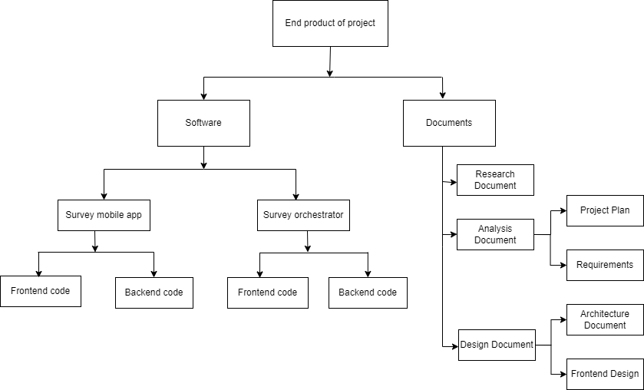

Figure 2 - Preliminary product breakdown structure

Project organisation

Stakeholders and team members
Name | Abbreviation | Role and functions | Availability
Jeffrey Cornelissen | JC | Stakeholder | Monday, Wednesday
Teague Murray Marshall | TM | Stakeholder | Monday, Tuesday, Wednesday, Thursday, Friday
Florin Pană | FP | Scrum master, developer | Monday, Wednesday, Thursday
Denys Sytnyk | DS | Developer | Monday, Wednesday, Thursday
Rim Almeshal | RA | Developer | Monday, Wednesday, Thursday
Youssef Belganche | YB | Developer | Monday, Wednesday, Thursday
Sytse Walraven | SW | Documentation manager, developer | Monday, Wednesday, Thursday
Francois Haan | FH | Contact person, developer | Monday, Wednesday, Thursday

Communication

The communication between the group and the stakeholders will be through meetings in person and through Teams if the former is not possible. Teacher communication will also be either in person or through Teams.

The goals of these meetings will be to show our progress, receive feedback, and potentially how to move forward and what our priorities should be. The frequency of these meetings will be at least at the beginning and end of every sprint, with the possibility of another meeting in between when required. These will be attended by all the group members and one or both stakeholders.

For the group meetings we will be on location on Monday, Wednesday, and Thursday, which will be in person barring any unforeseen circumstances. Group communication will be through WhatsApp and Teams.

Activities and time plan

Phases of the project

Initial phase
During the initial phase (sprint 0) the setup will be made for the project. First, the project plan and the research plan will be created. The features listed in this research will be prioritized and written as user stories. Then the project management tool will be set up with the initial backlog of those user stories. This will form a starting point for the project to start with in sprint 1, where the project will enter the implementation phase.

Implementation phase
During the implementation phase sprints of 3 weeks will be held using agile scrum methodology. The activity in each sprint varies depending on the previous sprint and the current state of the project. In general, these sprints will be filled with research, documentation, implementation of code and testing of the implementation. The sprints focus is to complete user stories, and research may span over multiple sprints.

Final phase
In this phase the project will be completed, and all research questions will be answered. This phase lasts two weeks.

Time plan and milestones

For this project we are going to use scrum agile, the length of the sprint will be 3 weeks to in the first week be able to do the retrospective and sprint planning for the upcoming sprint and set research goals for the sprint, the second week to apply the research and discuss it with teachers and the 3rd week to further work on the group project and prepare for the sprint delivery and for sprint reviews.

The stand-up will be at 9:30 on Monday, Wednesday and Thursday to talk about what we’re going to do that day and in general talking about how the sprint is coming along.

At the end of each sprint (assuming we have something to show) there will be a demo showcasing what we did in the sprint. For the retrospective we will look back at the sprint on an individual and group basis and look for things we did well and things we could improve on.

Sprints | Phasing | Start date | Finish date
HackIt week | - | 04-09-2023 | 08-09-2023
Sprint 0 | Setting up project plan, sprint board etc. | 11-09-2023 | 22-09-2023
Sprint 1 | Setting up infrastructure and checkout existing code | 25-09-2023 | 13-10-2023
Sprint 2 | Start work on frontend and backend | 23-10-2023 | 10-11-2023
Sprint 3 | Working towards implementing all requirements | 13-11-2023 | 01-12-2023
Sprint 4 | Minimal viable product/ all requirements done | 04-12-2023 | 22-12-2023
Sprint 5 | Final phase, finishing things up, preparing for handover | 08-01-2024 | 19-01-2024

Testing strategy and configuration management

Testing strategy

- Unit testing, Integration Testing, and System testing.
  - Unit testing is a method of doing tests by dividing code into smaller pieces known as units. The unit under consideration must be logically separate and not reliant on external systems. Unit testing aims to isolate the code and see if it works as intended to uncover any faults in code that may be difficult to detect in subsequent testing phases.
  - Integration testing involves combining and testing numerous separate units or components as a single entity. Integration testing seeks to determine whether any issues develop when multiple units or components are joined and interact with one another.
  - System testing involves running an entire, integrated program to observe how the components interact with one another and the system. Also, system testing tries to evaluate the application's user experience.

Test environment and required resources

The testing will be done using the integrated testing environment in GitLab.

Configuration management

GitLab is utilized as a group workspace. The repository we use is GitLab, and we utilize GitHub flow as a branching technique. GitHub flow is a straightforward branching method that facilitates project collaboration.

Branching strategy

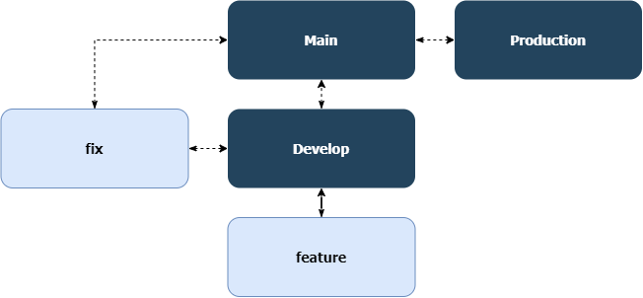

There are two branches that will always exist, Main and Develop. The main branch contains the latest release and is used for sharing with stakeholders. The develop branch is the branch that contains the version that is currently being edited. This is the branch where new features are merged.
When a user story is started, a new feature branch is created. The naming is as follows:
● User story: feature/ [ticket description], the feature branches will contain solutions related to user stories that have been created. So, ticket "SAZ-6 Project requirements" becomes feature/SAZ-6-project-requirements.
● Bug: fix/ [short description], the fix branches will contain fixes related to occurring problems.

The promotion, release, and baseline strategy are still in the talk and are subject to change in the future.

Finances and risk

Project budget

The only item that might require extra financing would be the working environment and tools, especially relating to the cost of working in the cloud. However, after the first meeting with the product owners, it has been decided that there is no need for a project budget since they will provide us with a working environment in Azure. We will however need to keep the limits of this environment in mind, as well as not use it excessively given that the budget for it is limited.

Risk and mitigation

Risk | Prevention activities | Mitigation activities
Falling behind schedule | Regular meetings with the team and project tutor | Have a deep sprint review and retrospective, discuss planning with tutor (and PO if necessary)
Not being able to deliver the required end-products | Good communication with the team and PO throughout the project | Leave ample documentation on how to finish the project for possible future handover
Damage to code due to improper version control management | Require peer review and approval before merge requests, rebase as a group | Require peer review and approval before merge requests, rebase as a group
Users getting unauthorized access to the system | Create a system that has a secure authorization setup following the security design principles | Inform PO and shut down the system until security fixes have been made.
Creating too high of a load on the cloud | Keeping to standards when it comes to cloud resource management, only deploy cloud functions when the team agrees | Inform PO of our mistakes (due to possible monetary loss)
Illness | Staying at home when you get any symptoms, be more cautious and dress according to the weather | Work from home/teams, provide ample comments and notes such that someone else can take over your work, communicate with the team and let them know of your estimated absence

