Asymmetric VR Party Game – Couch Player Design Research

Visual and UI Design Inspiration
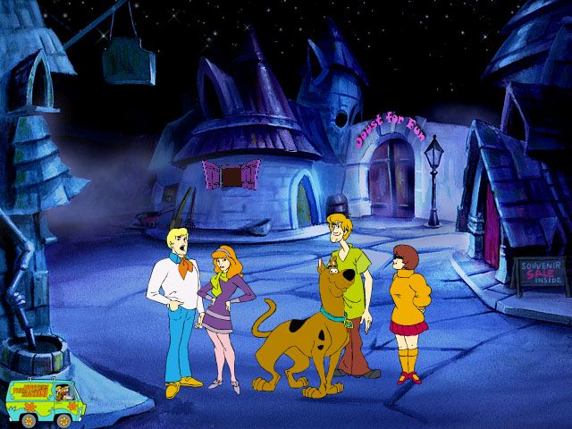
Figure: Cartoon spooky castle scene from Scooby-Doo! Phantom of the Knight (2000). This classic PC game showcases a family-friendly haunted castle aesthetic – note the playful, colorful art style and whimsical details like the “Joust For Fun” souvenir shop in the background[1]. Such nostalgic cartoon visuals set a lighthearted tone even in a spooky setting, which is ideal for our game’s castle theme.
Bird’s-Eye Cartoon Style: Emulate the top-down or bird’s-eye perspectives seen in nostalgic games and cartoons. Classic titles like Scooby-Doo’s castle adventures and Nintendo’s Luigi’s Ghost Mansion mini-game in Nintendo Land use an overhead view to display characters in a haunted environment. This perspective makes it easy for couch players to see the whole layout and plan traps. The art should be stylized and exaggerative – crooked castle halls, oversized trap doors, and comically spooky decorations. A slightly cartoonish, Scooby-Doo-like art style will keep the tone light: use muted eerie blues, greens, and purples for castle walls and corridors, contrasted with brighter character colors so the wizard and other characters pop out visually. Bold outlines and simple shapes will make characters and traps readable on a tablet screen for players of all ages.
Color Palette & Tone: Family-friendly “spooky” rather than realistic horror. Along the lines of Scooby-Doo or Luigi’s Mansion – a palette with purples, midnight blues, and hints of black for the castle, accented by fun brighter greens or oranges for magical effects. For example, Scooby-Doo games often balance dark hallways with colorful highlights (like glowing items or the Mystery Inc. crew’s outfits). Our traps can follow suit – e.g. a fire trap could have a bright cartoon flame icon, and a wind trap might use swirling white arrows – ensuring they’re easily noticed by attentive players. Overall, the visuals should invite all ages: kids find the cartoon castle cool, and adults feel nostalgic seeing a style reminiscent of classic animated mystery adventures.
UI Design for Tablet Players: The 2D couch-player interface should be extremely clear and touch-friendly. Use a top-down map of the castle that shows rooms, hallways, and the wizard’s location in real time (similar to how Luigi’s Ghost Mansion shows the entire floor layout from above). On this map, traps and characters should be represented by distinctive icons or sprites. For example, the wizard might appear as a little wizard hat icon or a tiny top-down character sprite with a pointed hat (instantly communicating “this is the VR wizard”). Hallways could be highlighted when a trap is selected, to indicate where placement is possible. Large, chunky buttons and icons around the edges of the screen will let players select or deploy traps easily. Each trap type can have a cartoon-style icon, and these should use bright colors to stand out against the darker map. Cooldown timers or charges can be shown with simple graphic overlays (like a dimming icon that refills, or a ticking clock animation) to keep it visual rather than numeric.

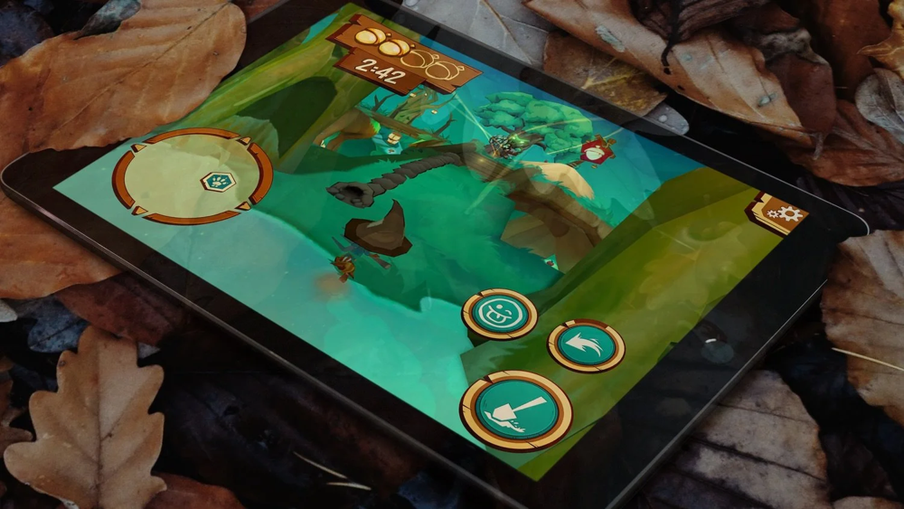
Figure: Example of a tablet UI from Acron: Attack of the Squirrels! – a cross-platform VR vs. mobile party game. Notice the top-down view and big, friendly icons on the tablet screen. This game uses clear circular buttons for abilities and a mini-map, all in a bright, stylized art style[4]. We can draw inspiration from such designs to make our couch-player interface intuitive and fun.

Stylized UI Elements: To maintain the castle theme, embed UI elements in a fitting style – for instance, buttons could be designed as “magical rune” circles or old wooden panels to match the fantasy setting, as long as they remain easy to recognize. Animate the UI where possible: a trap icon could wiggle or glow when it’s ready to use, giving players feedback at a glance. Keep text to a minimum; rely on icons and maybe subtle sound cues so even young players or those who can’t read quickly can play without frustration.

Interaction & Gameplay Design for Couch Players
Accessible Touch Controls: Couch players will use tablets or touch screens, so interactions must be simple and responsive. Common real-time mobile actions are perfect here:
Tap to Trigger: A single tap on a trap icon could instantly activate a preset trap in the hallway where the VR wizard is (if the wizard is in range). For example, if the wizard steps onto a trap tile, the couch player can tap a flashing on-screen button to spring it. This direct tapping is easy for all ages.
Drag and Place: For traps that need placement (e.g. laying a pitfall or a slippery oil slick in a hallway), players can drag the trap icon from the UI onto the desired location on the map. A translucent preview of the trap could appear under their finger, allowing them to position it and then release to set it. This drag-and-drop method is intuitive (similar to many tower-defense mobile games) and makes players feel like they’re physically placing traps in the castle
Real-Time Abilities with Feedback: All trap actions should happen in real-time to match the VR player’s live exploration. Incorporate visual feedback so couch players feel the impact of their actions. For example, when a couch player triggers a Hurricane Trap, they could see a little tornado icon spin on the map and watch the wizard’s icon get swirled or slowed. If they activate a Fire Burst, a flame icon might light up the targeted hallway on their map.
Cooldowns and Resource Management: To keep gameplay balanced and strategic, implement cooldowns or limited charges for each trap ability. Couch players shouldn’t be able to spam traps endlessly – that would frustrate the VR player and reduce the challenge. Instead, design a short cooldown after using a trap, indicated by the trap’s icon graying out or a timer circle. This encourages the couch team to time their attacks and coordinate: while one trap is recharging, maybe use a different one. We can also introduce a resource (like “mana” or energy points) that slowly regenerates, which couch players spend to activate certain traps. This adds a light layer of strategy (players might save up energy for a big trap at the perfect moment) but must be presented simply (perhaps each trap icon shows an energy cost in a corner).

Keeping Couch Players Engaged at All Times: A key challenge is ensuring couch players have fun even when the VR wizard is hiding safely in a room (where traps can’t reach them). We could do that by:
Preparation Phase: When the wizard enters a safe room, couch players can use that downtime to set up future traps. For example, they could drag new traps into adjacent hallways or reset traps that were sprung.
Mini-Activities: Give couch players a small activity while waiting. Perhaps they have a “magical radar” mini-game on their screen – a dial or meter they can tune to guess which room the wizard will exit from, for a bonus effect. Or a simple puzzle like connecting wires to “power up” the next trap (nothing too involved – just a quick distraction that rewards them with a faster cooldown or an extra trap charge if completed). T
Persistent Challenge: The game might gently pressure the VR player to leave rooms (e.g. a ticking clock or the fact that magical items are out in the halls to collect). This indirectly keeps couch players engaged because they know the wizard must move eventually.
Intuitive for All Ages: We must ensure that a child, teen, or adult can all pick up the tablet and understand the basics quickly. Use an in-game tutorial with minimal text – perhaps a friendly guide character on the tablet UI (e.g. a talking castle gargoyle or a friendly ghost) that gives quick tips: “Drag a ctrap onto the hallway now!” or “Tap the flashing button to trigger your fire trap!”. Visual indicators (glowing buttons, arrows pointing to what to do next) should guide new players. Also, the mechanics themselves remain simple: basically see wizard → place/activate trap. The depth comes from timing and strategy, not from complex controls.

Character and Trap Design
Couch Players’ Avatar/Role: To give couch players a sense of identity (beyond being an invisible “trap setter”), we can characterize their role within the game’s fiction. One idea is to cast them as the Castle Spirits or a rival Wizard who controls the castle’s defenses. This could be represented by a cute villainous character on the tablet interface – for example, a cartoon ghost, imp, or witch that represents the couch team. The UI might feature this character’s face in the corner, providing reactions (cheering when a trap hits the wizard, looking shocked when the wizard dodges). This adds personality to the couch side of the game.
The character design for these avatars should be goofy and lovable – think along the lines of a Ghostbusters or Scooby-Doo ghost rather than anything truly frightening. For example, a plump ghost with a silly grin, or a tiny evil wizard who is more comic than sinister.
Wizard (VR Player) Appearance from Top-Down: The VR player is a wizard exploring the castle, so on the couch players’ top-down view, the wizard needs to be clearly visible. We could design the wizard’s in-game avatar with a distinct silhouette for top-down readability. A classic approach is the pointy wizard hat – from above, a cone-shaped hat and perhaps a flowing robe or cape can be seen. For instance, the wizard could wear a bright blue robe and a big star-tipped hat that is obvious even in small top-down form. We can also give the wizard a glowing outline or aura on the map (maybe a ring at their feet) to differentiate them from any other moving objects. In Luigi’s Ghost Mansion, the human players (ghost hunters) are shown as colored icons with little hats (Luigi/Mario caps) so they stand out; similarly, our wizard icon should maybe have a unique color (like gold or bright white) and an animated effect (a sparkle or slight bobbing motion) so couch players can’t lose track of it. On the VR side, the wizard might be richly detailed, but on the 2D map it boils down to a little animated sprite or icon.
Trap Designs and Visual Cues: Traps are the core tool for couch players, so each trap must be both visually distinct and have telegraphed cues in the VR world. This means VR players can potentially spot or avoid traps with sharp eyes, making it skill-based, while couch players feel clever for timing them well. Here are some trap design suggestions, balancing visibility and subtlety:
- Whirling Hurricane Gust: A trap that, when triggered, unleashes a cartoon tornado in the hallway, knocking the wizard backward or spinning them around. On the tablet map, this could be represented by a little spiral icon that the couch player can drag onto a hallway. Visual cue for VR player: a few leaves or papers blowing in that hallway just beforehand, and maybe a soft wind sound – a perceptive wizard might notice these signs. This trap adds humor and a moment of dizzy confusion for the VR player, which fits our lighthearted tone.

- Fire Burst Trap: A classic flamethrower or fire jet trap from the castle wall or floor. Couch players tap a fire icon to trigger it, causing a quick “whoosh!” of flame across a corridor. Visual cue: the corridor might have unlit torches or dragon gargoyle heads on the walls – and one flickers to life right before it spits fire. Alternatively, a patch of the floor has a slightly different color (scorch marks) to hint a flame trap is there[8]. The fire burst itself is bright but cartoony (think of a Zelda game fire or a Mario firebar – vibrant orange with a white-hot center, maybe a smiling face on the flame for extra charm). It should startle the VR player without being truly scary; perhaps it singes the wizard’s cape, causing no lasting harm but making them jump.
- Pitfall Trap: A trapdoor on the floor that opens to drop the wizard into a pit (or perhaps a slide that spits them out at an earlier location – a funny setback rather than death). Couch players can place these pit traps in hallways or right outside room doors. Visual cue: the floor panel for the pit trap is a slightly different shade or has a thin outline if you look carefully, rewarding players who watch their step. When triggered, the panel swings open in an obviously cartoonish way and the wizard avatar would briefly flail as they fall.
- Illusory Ghost Decoy: Since the theme has a Scooby-Doo vibe, an illusory ghost trap could be great. When activated, a translucent, goofy ghost pops up in front of the wizard in a hallway to scare and slow them (no real damage, just causing them to pause or take a longer route). Visual cue: perhaps a painting on the wall with eyes that follow the wizard, or a suit of armor that subtly shakes – hinting that a ghostly presence might appear. When it triggers, the ghost might say “Boo!” in a silly way, causing the wizard to stop (and the VR player to laugh or be surprised). The ghost vanishes quickly after.
Each trap should be distinct in color and animation, so both the VR player and the couch players can tell what’s happening. Importantly, none of these traps are invisible or unfair – there’s always a small hint or delay.

Design Justifications
Thematic & Family-Friendly Appeal: Every design choice above is geared toward a spooky-fun theme that appeals to a broad audience. By drawing on cartoonish inspirations (Scooby-Doo, Nintendo’s playful ghost games), we ensure the castle setting is engaging without being genuinely scary. This is crucial for a family party game – kids might be intimidated by a realistic haunted castle, but a stylized one with bright colors and funny ghosts is “cool” instead of frightening. The nostalgic touch (a vibe reminiscent of classic cartoons) also gives older players a hook – parents or older siblings will appreciate the Scooby-Doo-like humor, making them more invested. This strengthens the game’s appeal as a party game where the goal is group fun, not just competitive victory.
Inclusive Gameplay & Continuous Engagement: In asymmetrical VR games, one of the biggest design goals is to avoid having non-VR players feel like second-class participants. Our design ensures that couch players are actively involved at all times, which is backed by the success of similar games. For instance, the developers of Fruit Golf emphasize that with this style of gameplay, “no one is left on the sidelines… your time as an innocent bystander is over!”. This ethos is at the heart of our couch player design. By giving the couch players real-time control of traps, meaningful decisions (which trap to use when), and things to do even during downtime, we keep them as engaged as the VR player.
Intuitiveness and Accessibility: Every interaction was chosen for simplicity because our audience is “everyone in the living room.” We expect players who may not be avid gamers – maybe a younger child or a grandparent – to pick up a tablet and play. Tapping and dragging are the most natural touch interactions, so we centered the controls on those. We avoided complex multi-touch gestures or heavy UI menus, which is intentional to lower the barrier to entry. The large, icon-driven interface (like the one inspired by Acron: Attack of the Squirrels!, ensures that even if someone isn’t familiar with games, they can quickly learn “press the picture to do the thing.”
Replayability through Variety and Strategy: Our design introduces multiple trap types and a dynamic environment, which greatly enhances replayability. Variety is critical – as one game design guide puts it, “variety is king… keep shaking things up and introducing new hazards”[10]. Each play session can differ: couch players might try a different combo of traps or timing strategies, and the wizard player will adapt in turn. Because traps are avoidable with skill, the VR player can improve over time, forcing the couch side to get craftier – this evolving challenge keeps the game interesting round after round. Also, the social dynamics contribute to replay value: players will want to swap roles. One round you’re the wizard dodging fire, next round you’re the one unleashing the traps. The game thus stays fresh as you experience both sides of the chaos. We’ve made sure the mechanics support quick role rotation (e.g. rounds could be short, like 5-10 minutes each, given the real-time intensity). This balance between sides – giving each side a fair chance through cues and cooldowns – means neither role feels overpowered or helpless. A well-balanced game encourages rematches (“Let’s go again, I know how to trick you this time!”) and fosters lighthearted competition.
Group Fun and Social Interaction: At its core, this is a party game, and the measure of success is how much laughter and excitement it generates in the room. The design choices emphasize comedic outcomes and direct interaction between VR and couch players. Sabotaging your friend in a funny way creates memorable moments – just as games like Mario Party or Jackbox excel at causing friendly banter and teasing. Our traps are engineered to deliver those moments (the sudden whoosh of a wind trap sending the wizard reeling, or the perfectly timed pitfall that drops them with a yelp). We also allow the couch team to feel like a team, which is enjoyable in a group setting – there’s a camaraderie in plotting against the VR player, much like players teaming up as ghosts in Luigi’s Ghost Mansion. The VR player, on the other hand, gets the thrill of outsmarting multiple people, which is a delightful feeling of triumph when it happens. By making the traps just dangerous enough to create tension but not so harsh as to cause frustration, we keep the atmosphere jovial. Indeed, one reason Fruit Golf and similar titles are praised is because they turn competition into comedy – “part mini-golf, part mayhem, and 100% a good time” as the Fruit Golf devs describe their game[11]. We aim for the same spirit. The visual gags, the avatar reactions, and the need for coordination all contribute to players talking, laughing, and yelling (in fun) throughout the game. This social energy is what makes party games compelling and is a strong justification for each design element we chose, from the art style to the mechanics.
In conclusion, the 2D couch player design is crafted to delight players of all ages with its approachable cartoon visuals, engage them constantly through intuitive interactive gameplay, and immerse them in a whimsical battle of wits against the VR wizard. By grounding our approach in proven examples and clear design principles, we ensure the couch player experience isn’t just an afterthought but a core pillar of this asymmetric VR party game – one that transforms the living room into a magical, trap-filled playground where everyone is eagerly involved in the adventure.
Sources:
- Luke Hart, The DM Lair – “How to Design and Run a D&D Trap” – on the importance of trap variety and giving players fair clues[10][8].
- Fruit Golf – “What is an Asymmetrical VR Game (And Why Are They So Fun)?” – discussion on inclusive, chaotic fun in asymmetrical VR, with examples of sabotage gameplay[5][11].
- Nintendo Land – Luigi’s Ghost Mansion (Nintendo, 2012) – a family-friendly asymmetric game using top-down view and ghostly theme[2].
- Resolution Games – Acron: Attack of the Squirrels! (2019) – a cross-platform VR vs. mobile party game noted for its colorful visuals and simple mobile UI design[4].
- Scooby-Doo! Phantom of the Knight (The Learning Company, 2000) – inspiration for a spooky yet humorous castle setting and character style[1].

[1] Scooby-Doo!: Phantom of the Knight screenshots - MobyGames
https://www.mobygames.com/game/38439/scooby-doo-phantom-of-the-knight/screenshots/
[2] [7] Nintendo Land - Wikipedia
https://en.wikipedia.org/wiki/Nintendo_Land
[3] Scooby-Doo's eerie backgrounds deserve a closer look ... - Facebook
https://www.facebook.com/reviewwales/posts/scooby-doos-eerie-backgrounds-deserve-a-closer-look-%EF%B8%8Fin-scooby-doo-where-are-you/1181444003807720/
[4] Acron - Become a rebel squirrel and steal the golden acorns! — Resolution Games
https://www.resolutiongames.com/acron
[5] [6] [9] [11] What is an Asymmetrical VR Game (And Why Are They So Fun)? | Fruit Golf
https://www.fruitgolf.com/what-is-an-asymmetrical-vr-game-and-why-are-they-so-fun
[8] What are some guidelines when making a trap based dungeon?
https://www.reddit.com/r/DMAcademy/comments/7zsx93/what_are_some_guidelines_when_making_a_trap_based/
[10] How to Design and Run a D&D Trap – The DM Lair
https://thedmlair.com/blogs/news/how-to-design-and-run-a-d-d-trap?srsltid=AfmBOoqddH_jUvmKDTg2qK0N2bvY0o6asvTl-IlHoXG1loH0ekYnIPpG

