Design choice document

VisionTech
Vanderlande

Table of Contents
Introduction and Overview 3
Purpose of the Document 3
Background 3
Scope 3
Objectives of the System 3
High Level Solution Description 4
System Architecture 4
Overview of Architecture 4
High-Level Architecture Diagram 5
System Component 5
SharePoint Integration 6
Architectural Constraints 6
Data Design 6
Overview 6
Data Inputs 7
Data Output 8
Design Rationale 8
Interface Design 8
Overview 8
Conversation Flow 8
Error Handling and Recovery 9
Tone and UX Consideration 9
Accessibility and Inclusiveness 10
Inference Limitations 10
Component Design 10
Overview 10
Component Breakdown 10
Design Rationale Summary 13
Assumption and Dependencies 14
Overview 14
Assumptions 14
Dependencies 14
Design Rationale for Assumptions 15
Known Risk Related to Assumptions 15
Glossary 16

Introduction and Overview

Purpose of the Document
This Design Choice Document is to explain the design decisions, architecture, and rationale behind the development of the Vanderlande Ideation Support Agent. A template is used (Atlassian, 2025). This document aims to provide clarity on how and why specific technical and functional choices were made during the development process. It ensures transparency for stakeholders, supports future maintenance, and aligns the solution with Vanderlande’s innovation workflow.

Background
Vanderlande’s current ideation process contains several bottlenecks, especially in the clarification loop between employees submitting ideas and assessors reviewing them. Employees often struggle to structure their ideas clearly, leading to repeated clarification requests, delays, and wasted effort.
To support this process, a Copilot Agent was designed to assist employees in:
- Extracting the initial idea from a problem or challenge
- Brainstorming potential solutions
- Structuring the idea into a complete format aligned with the ideation workflow
- Checking for similar ideas recorded previously (one-time lookup)
The agent aims to reduce the number of unclear submissions and improve the speed and quality of idea assessment.

Scope
This document focuses on:
- Functional design choices
- Technical design and architecture
- Data design and system interactions
- User interface and conversation flow design
- Assumptions, limitations, and dependencies

Objectives of the System
The Ideation Support Agent is designed to:
- Guide employees step-by-step in structuring their ideas
- Ensure clarity and completeness before submission
- Reduce unnecessary back-and-forth communication
- Support assessors by improving the quality of submitted ideas
- Provide a consistent format for all submissions
These objectives support Vanderlande’s goal of improving the quality of the idea input to the system
Target User
- Employees submitting ideas
- Innovation team who monitors and improves ideation processes
- Project stakeholders involved in testing and refinement

High Level Solution Description
The system is implemented using Microsoft Copilot Studio, connected to:
- A SharePoint Ideation List (knowledge source)
- Custom series of conversation flows designed to guide the user
- Validation and confirmation steps to prevent incomplete submissions
The agent interacts with users in a conversational interface where each step requires user confirmation before continuing.

System Architecture

Overview of Architecture
The Vanderlande Ideation Support Agent is built within Microsoft Copilot Studio and operates as a conversational interface that helps employees structure their ideas before submission. The agent interacts with external systems primarily SharePoint to retrieve relevant information and support the user throughout the ideation flow.
The architecture is designed with modularity in mind, separating the conversation logic, data retrieval, and idea-structuring functionality into distinct components. This ensures scalability, clarity, and easier maintenance.

High-Level Architecture Diagram
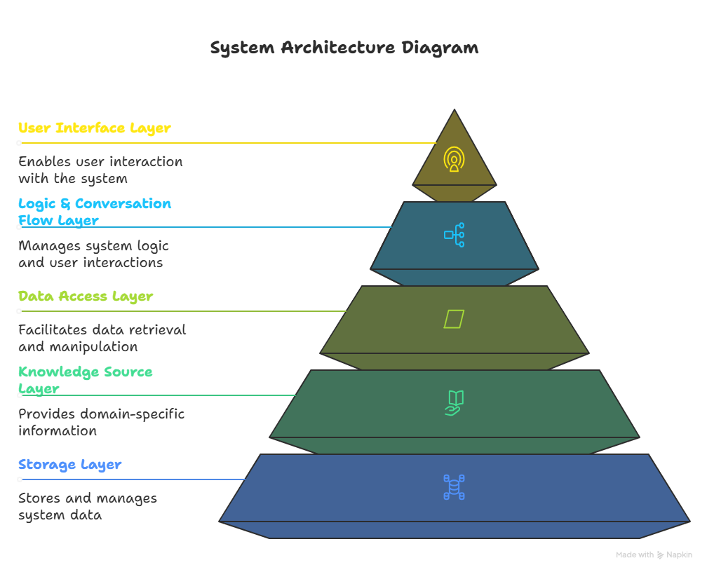
- User Interface Layer
  - User interacts with the agent through a chat interface.
  - The agent asks for confirmation at every major step (problem statement, solution, impact, resources).
- Logic & Conversation Flow Layer
  - Main conversation
  - Idea extraction
  - Brainstorming
  - Structured idea generation flow
  - One-time SharePoint lookup flow
  - Confirmation flow
- Data Access Layer
  - Connection to SharePoint
  - One time lookup for similar idea
- Knowledge Source Layer
  - SharePoint Ideation List with previous idea
  - Business rules inside copilot
- Storage Layer
  - Structured data will be stored in SharePoint

System Component
Copilot Studio Agent
This is the core component where:
- Business rules are implemented
- Conversation flow is defined
- User inputs are validated
- Knowledge lookup is triggered (one-time only)
- Confirmation steps are enforced
The agent has three main functional blocks:
- Idea Extraction Module
- Brainstorming & Solution Support Module
- Structured Idea Generator
These modules are independent but connected in a linear guided process.

SharePoint Integration
SharePoint acts as both a knowledge source and a storage layer for the ideation system. The Copilot Agent is directly connected to the SharePoint Ideation List using the built-in SharePoint connector inside Copilot Studio.
One-Time Knowledge Lookup
When a new idea is introduced, the agent performs one SharePoint query to:
- Check for similar ideas already submitted
- Provide the user with any related abstracts
- Avoid duplicates and highlight existing initiatives
This lookup only happens once at the start of the conversation.
Direct Idea Submission to SharePoint
Once the user completes all steps (problem -> solution -> impact -> resources -> confirmation), the agent compiles a final structured idea. The agent then directly writes this idea into the SharePoint list.
This direct integration simplifies the architecture and ensures:
- Faster submission
- Fewer dependencies
- No additional flow configuration
The architecture is therefore leaner, relying only on Copilot Studio and SharePoint.

Architectural Constraints
- Copilot Studio does not always provide deterministic execution, making repeated knowledge checks possible if not designed carefully.
- SharePoint access must comply with organizational permissions.
- Publishing limitations may temporarily force testing via developer mode.
- No database or external APIs are used beyond SharePoint.

Data Design

Overview
The data design defines how information is captured, structured, processed, and stored by the Ideation Support Agent. The system focuses on transforming unstructured user input into a standardized ideation format that can be stored directly in SharePoint.

Data Inputs
1. Problem Statement
- Description of the challenge or issue
- Pain points or bottlenecks
- Why this problem matters
2. Proposed Solution / Idea
- The user’s initial idea
- Key features of the idea
- How it solves the problem
3. Expected Impact
- Benefits (time savings, cost reduction, improved quality, etc.)
- Stakeholders affected
- Expected scale of improvement
4. Required Resources
- Tools, technologies, or support needed
- Departments involved
- Estimated effort
5. Additional Metadata (Auto-captured or provided)
- Submission timestamp
- Username (if available in session)
- Duplicate detection result (if similar idea found)

Data Output
A. Structured Idea Object
Generated after validating each step with the user.
This object contains:
Field Name | Description
IdeaTitle | A short title generated based on problem/solution
ProblemStatement | Confirmed final problem description
ProposedSolution | User-approved solution
ExpectedImpact | User-defined expected outcomes
RequiredResources | Inputs needed to execute the idea
SubmittedBy | User identity (if available)
SubmissionDate | Auto-generated timestamp

B. Final SharePoint List Item
Using the SharePoint connector, the structured idea object is mapped into SharePoint columns.

Design Rationale
- Standardized structure improves clarity and reduces assessment time.
- Modular data fields ensure easy future integration with workflows or dashboards.
- Direct SharePoint write eliminates need for additional tools and reduces dependencies.
- Temporary variables ensure user can edit and confirm each section without losing context.
- Duplicate detection adds value by avoiding repeated ideas.

Interface Design

Overview
The Ideation Support Agent uses a conversational interface within Microsoft Copilot Studio. The interaction is designed to be guided, step-by-step, and non-awkward, ensuring that users can clearly structure their ideas with minimal confusion. Each stage requires explicit user confirmation before moving forward, preventing incomplete or unclear submissions. The interface aims to feel natural, supportive, and easy to follow while still enforcing a structured ideation process.

Conversation Flow
The system follows a linear guided flow, divided into five main sections:
- Idea Introduction
- Problem Statement Extraction
- Solution Description
- Expected Impact
- Required Resources
- Final Structured Idea Summary + Confirmation
- Automatic Submission to SharePoint
Each step includes:
- A clear question
- Examples (optional, depending on user responses)
- A confirmation step
- A fallback response if the user is unsure

Error Handling and Recovery
To create a non-awkward experience, the agent uses the following strategies:
Fallback Prompts
If the user gives unclear input:
- The agent asks clarifying questions
- Provides examples
- Does not move forward until input is sufficient
Confirmation Enforcement
The flow never proceeds without user confirmation.
This reduces human errors and incomplete submissions.
Handling Ambiguity
If the user says, “I’m not sure,” the agent responds with:
- Short guiding questions
- Small prompts to help the user think
- Suggestions instead of assumptions

Tone and UX Consideration
The interface is designed to be:
- Friendly but professional
- Non-repetitive
- Supportive and clear
- Minimal in unnecessary fillers
- Consistent across all steps
Examples of tone guidelines:
- Avoid: “Sure! Let’s continue!!!”
- Prefer: “Great. Let’s move to the next step.”
The goal is to ensure the conversation feels smooth and natural, suitable for professional use at Vanderlande.

Accessibility and Inclusiveness
To support a diverse workforce:
- Language is kept simple
- No technical jargon is used
- Messages are short and broken into clear chunks
- Confirmation messages use “Yes/No” options for clarity

Inference Limitations
- Copilot Studio may sometimes rephrase questions unexpectedly
- User identity may not always be available depending on environment setup
- SharePoint write errors may require fallback messaging
These limitations are acknowledged and handled through friendly fallback responses.

Component Design

Overview
The Ideation Support Agent is designed using a modular architecture, where each component handles a specific part of the ideation workflow. This makes the system easier to maintain, debug, and extend in the future. The modular structure also supports clarity and alignment with the existing ideation process at Vanderlande.
The key components include:
- Idea Intake & Duplicate Check Module
- Problem Statement Module
- Solution Development Module
- Impact Assessment Module
- Resource Requirement Module
- Structured Idea Generator
- SharePoint Integration Module
- Confirmation Control Module
- Conversation Guidance & UX Module
Each component is described below.

Component Breakdown
Idea Intake & Duplicate Check Module
Purpose:
Capture the user’s initial idea and perform a one-time SharePoint lookup for similar submissions.
Responsibilities:
- Receive free-text user input
- Query SharePoint’s Ideation List once
- Compare similarity using list content
- Return any matching ideas to the user
- Ask user whether they want to proceed
Rationale:
This module reduces redundancy and supports smoother assessment by preventing duplicate idea submissions.

Problem Statement Module
Purpose:
Refine and structure the user’s problem into a clear statement aligned with Vanderlande’s ideation format.
Responsibilities:
- Ask guiding questions to clarify the problem
- Rephrase input into structured form
- Request explicit user confirmation
Rationale:
A well-defined problem significantly reduces clarification loops and improves idea quality.

Solution Development Module
Purpose:
Help users articulate their proposed solution or improvement clearly.
Responsibilities:
- Ask for solution details
- Highlight main features
- Convert user input into a concise solution paragraph
- Ask for approval
Rationale:
Ensures consistency of solutions and aligns with expectation of assessors.

Impact Assessment Module
Purpose:
Structure the user’s expected impact using business-oriented language.
Responsibilities:
- Ask the user what improvements they expect
- Identify categories (e.g., time savings, cost reduction)
- Convert input into measurable impact statements
- Confirm with the user
Rationale:
Improves assessment accuracy and supports prioritization by innovation teams.

Resource Requirement Module
Purpose:
Collect and structure the resources needed to implement the idea.
Responsibilities:
- Ask for required tools, teams, or support
- Organize input into list or paragraph form
- Request confirmation
Rationale:
Makes idea submissions more realistic and implementation ready.

Structured Idea Generator
Purpose:
Combine all confirmed components into a final structured idea object.
Responsibilities:
- Compile the following fields:
  - Title (auto-generated)
  - Problem statement
  - Solution
  - Impact
  - Resources
  - Metadata (Username)
- Validate data completeness
- Prepare for SharePoint submission
Rationale:
Creates a standardized submission that matches the ideation process requirements.

SharePoint Integration Module
Purpose:
Submit the final structured idea directly into the SharePoint Ideation List.
Responsibilities:
- Connect to SharePoint using Copilot Studio Connector
- Map internal variables to SharePoint fields
- Write a new list item with:
  - Title
  - Problem Statement
  - Solution
  - Impact
  - Resources
  - Date + user metadata if available
- Return success or failure message
Rationale:
Eliminates the need for manual submissions and ensures consistency across all idea entries.

Confirmation Control Module
Purpose:
Ensure that users approve each step before the system continues.
Responsibilities:
- Pause flow until user confirms
- Handle “yes/no” logic
- Allow revisions when needed
Rationale:
Prevents unclear or incomplete submissions, reducing waste in the ideation review process.

Conversation Guidance & UX Module
Purpose:
Maintain a smooth, non-awkward user experience throughout the conversation.
Responsibilities:
- Manage tone and language
- Avoid repetitive or robotic phrasing
- Provide helpful examples when users struggle
- Offer fallback prompts
- Manage transitions between modules
Rationale:
Ensures the agent feels professional, friendly, and easy to use within a corporate environment.

Design Rationale Summary
- Modular approach supports easier updates and maintenance.
- Each module mirrors one step of the real-life ideation process.
- Confirmation control prevents mistakes and increases clarity.
- SharePoint integration ensures seamless submission flow.
- UX module ensures a natural, professional conversation experience.

Assumption and Dependencies

Overview
This section outlines the assumptions made during the design of the Ideation Support Agent and identifies the external dependencies required for the system to function correctly. These help define the boundaries of the solution and ensure realistic expectations from stakeholders.

Assumptions
User Assumptions
- Users understand basic English and can express their ideas in simple sentences.
- Users follow the guided flow and respond when asked for confirmations.
- Users are familiar with the concept of submitting an idea within the company.
- Users will interact with the agent in a professional context and avoid irrelevant content.
System Assumptions
- Copilot Studio will execute the conversation flows consistently as configured.
- The agent will only check SharePoint for similar ideas one time, as intended.
- The direct SharePoint write operation will succeed if the user’s input passes validation.
- The structured idea object passed to SharePoint contains the necessary fields.
- User identity (name/email) may or may not be available depending on environment settings.
Workflow Assumptions
- The structured idea format (Problem -> Solution -> Impact -> Resources) matches Vanderlande’s current ideation requirements.
- Assessors can review ideas based on the data stored in the SharePoint list.
- Submitting the idea to SharePoint is sufficient to count as an official submission (no manual form required).
- Stakeholders will test the agent using the provided flow, even if the publication issue is unresolved.

Dependencies
Platform Dependencies
- Microsoft Copilot Studio:
  - Responsible for conversation logic, variables, confirmation flow, and message delivery.
  - Must support SharePoint connectors in the environment.
- Microsoft SharePoint Online:
  - Houses the Ideation List.
  - Must allow read and write operations from the agent.
  - Requires stable permissions and connection credentials.
Data Source Dependencies
- SharePoint Ideation List must exist with correct column structure:
  - Title
  - ProblemStatement
  - Solution
  - Impact
  - Resources
  - SubmissionDate
  - SubmittedBy
Any missing or renamed fields will cause submission failure.
Infrastructure Dependencies
- User can access to Microsoft Teams or Web Interface to interact with the agent.
- Stable network connection inside Vanderlande’s digital environment.
- Agent must be hosted in the same tenant as the SharePoint site.
- Environment must allow reading/writing via SharePoint connectors.
Organizational Dependencies
- Innovation / Ideation team agrees to test and evaluate the prototype.
- Assessor workflow remains compatible with the structured data format.
- Stakeholders provide feedback based on real scenarios.
- Support from IT (if needed) to resolve Copilot Studio publishing errors.

Design Rationale for Assumptions
These assumptions were necessary to:
- Keep the solution lightweight and focused
- Align with Vanderlande’s existing SharePoint-based ideation process
- Avoid unnecessary complexity (such as extra databases or Power Automate flows)
- Ensure the agent could be tested despite publishing limitations

Known Risk Related to Assumptions
- Copilot Studio limitations may cause occasional re-checks of the knowledge base.
- SharePoint write operations may fail if column names or permissions change.
- If users provide insufficient detail despite guidance, the idea quality may still vary.
- Publishing errors may delay deployment to wider audiences.

Glossary
Agent / Copilot Agent
The conversational AI assistant built using Microsoft Copilot Studio that guides users through the idea submission process.
Assessor
A member of the innovation or ideation team responsible for reviewing submitted ideas and deciding whether they proceed to further evaluation.
Confirmation Step
A required user approval checkpoint (Yes/No) before the agent progresses to the next part of the ideation flow. Prevents unclear or incomplete submissions.
Duplicate Check
A one-time SharePoint lookup performed at the beginning of the conversation to find similar existing ideas and avoid repetitive submissions.
Ideation List
The SharePoint list used at Vanderlande to store, track, and manage ideas submitted by employees.
Knowledge Source
A data source connected to the agent (e.g., SharePoint Ideation List) used to retrieve information such as similar ideas or historical entries.
Problem Statement
A structured description of the issue or challenge the user wants to address. It is the first main component the agent helps clarify.
Proposed Solution
The user’s idea or improvement, refined by the agent into a clear and actionable statement.
Expected Impact
The benefits or improvements anticipated if the idea is implemented (e.g., time savings, cost reduction, efficiency).
Required Resources
Tools, departments, materials, or support needed to implement the idea.
Structured Idea
The final, fully formatted idea composed of:
- Problem
- Solution
- Impact
- Resources
- Duplicate information
- Metadata
This structure aligns with the Vanderlande ideation process.
SharePoint Integration
The mechanism through which the agent reads data (for duplicate checks) and writes data (submitting new ideas) directly to a SharePoint list.
User Flow / Conversation Flow
The ordered sequence of steps the agent uses to guide the user through the ideation process.
Metadata
Automatically generated information about the submission, such as the submission date or the user’s identity if available.
Variable (varProblem, varSolution, etc.)
Internal Copilot Studio storage fields that temporarily hold user inputs until the final structured idea is generated.

Bibliography
(2025). Retrieved from Atlassian: https://www.atlassian.com/work-management/knowledge-sharing/documentation/software-design-document

