Research Document
Satellite Image Analysis for Solar Energy
Radiation and Grid Congestion



Nikola Momchilov
Fontys Innovation Lab
Sustainable Data & AI Applications
February 2026 - June 2026

Version History
Version | Date | Author | Description
v0.1 | 11/02/2026 | N. Momchilov | Initial draft: structure and problem context
v0.5 | 20/03/2026 | N. Momchilov | Literature review complete, RQs refined
v1.0 | 15/05/2026 | N. Momchilov | All SQs answered, DOT framework applied
v2.0 | 08/06/2026 | N. Momchilov | Corrected model, radiation pipeline complete
v2.1 | 15/06/2026 | N. Momchilov | Final: DOT structure, portfolio alignment

Introduction

Background and Context
The Netherlands is experiencing rapid growth in solar energy adoption, but the electricity grid has not kept up. When too many solar installations in one area feed energy back into the network, the local cables and substations can become overloaded. This is called grid congestion. In Amsterdam, distribution system operator Liander has already declared congestion in specific districts, and the problem is expected to spread as more solar panels are installed.
At the same time, satellite imagery and artificial intelligence have become useful tools for analysing large areas from above. Satellites like Sentinel-2 capture detailed images of cities at 10-metre resolution, which can be used to identify building types, land use patterns and urban density. Geostationary satellites like Meteosat capture images every 15 minutes, which makes them suitable for tracking cloud cover and estimating how much solar radiation reaches the ground.
However, these two fields have developed separately. Grid congestion research uses load flow models and electrical network data, but does not look at what is visible in the city from satellite imagery. Solar radiation research uses satellite data and AI to estimate how much sunlight reaches the surface, but does not connect the results to grid infrastructure. No existing study combines both in one workflow for a specific city.

Problem Statement
Two things are missing in the current literature. No study combines satellite-based spatial data with grid congestion analysis in one workflow for a city. And no study uses solar radiation estimation as a validation layer for congestion indicators. This means grid planners cannot see which neighbourhoods have the highest congestion risk from satellite data, and they cannot distinguish whether congestion is driven by solar feed-in or by consumption demand.

Research Objective and Main Research Question
The objective of this study is to investigate how satellite imagery and AI techniques can be combined to analyze grid congestion in Amsterdam and validate those findings using solar radiation estimation.
Main Research Question:
How can satellite imagery and AI techniques be used to analyze grid congestion in Amsterdam, and how can solar radiation estimation support the validation of those findings?

Scope
The project includes: systematic literature review of 25 papers (15 grid congestion, 10 solar radiation estimation), acquisition and processing of Sentinel-2 satellite imagery, developing a Random Forest classifier for congestion risk, solar radiation analysis using CM SAF SARAH-3 data, a web application for visualization, and full documentation. The project does not include: real-time monitoring, physical inspection of grid infrastructure, or analysis of areas outside Amsterdam.

Reading Guide
This document is organized around the six sub-questions that structure the research. Each sub-question section explains what was done, how it was done (which DOT strategies were used and why), and what the answer is. The sections build on each other: SQ1 defines the problem, SQ2 identifies what to look for, SQ3 builds the analysis pipeline, SQ4-SQ5 add the radiation layer, and SQ6 combines both.
For the full academic analysis with all references, see the Research Paper (HBO-ICT format). For detailed preprocessing steps, see the Proof of Data Cleaning document. For the full notebook technical documentation, see the Notebook Documentation and Radiation Notebook Documentation in the portfolio.

Research Methodology

DOT Framework
This research uses the DOT Framework (HBO-i) to structure the approach. DOT organises research activities into five strategies: Library (reading and reviewing existing knowledge), Field (collecting and exploring data in its real context), Lab (testing, training, and evaluating), Workshop (building and constructing), and Showroom (presenting and getting feedback).
No single strategy could handle the full scope of this project. Literature explained grid congestion theory but could not produce a congestion map. Data collection provided satellite imagery but needed AI methods to extract useful features. Model training produced predictions but needed peer review to validate the approach. Each strategy addressed a different part of the problem.

Research Questions
The five (sub-)questions that guide the research:
SQ1: What is electricity grid congestion, and how does it occur?
SQ2: What patterns in satellite imagery and other spatial data could point to areas where the electricity grid is likely congested?
SQ3: How can AI be used to analyse the grid congestion from satellite images, and what can make the estimates uncertain or inaccurate?
SQ4: What is solar radiation, and how can we measure or represent it using satellite-based data?
SQ5: How can AI be used to analyse solar radiation from satellite images, and what can make the estimates uncertain or inaccurate?
SQ6: Why is it important to analyse the combined grid congestion with solar radiation estimation with indicators, and what practical insights does this combined approach give?

DOT Strategy per Sub-Question (Planned vs Actual)
Table 1 shows which DOT strategies were planned at the start of the project and which were actually used. Changes are highlighted with the reason for the change.
Sub-Question | Planned Strategies | Actually Used | What Changed and Why
SQ1 | Library, Field, Showroom | Library, Field, Showroom | No change. Answered from literature and document analysis.
SQ2 | Library, Field, Showroom | Library, Field, Lab, Showroom | Added Lab (data quality checks in SNAP: cloud assessment, L1C vs L2A comparison, pixel value verification).
SQ3 | Library, Lab, Showroom | Library, Field, Lab, Workshop, Showroom | Expanded significantly. The original project plan did not include Workshop or Field for SQ3. Field was added because I needed to collect and explore the actual datasets (Sentinel-2, CBS, Liander). Lab expanded from evaluation-only to full model training, cross-validation, temporal validation, and feature importance analysis. Workshop was added for building the notebook pipeline and web application.
SQ4 | Library, Field, Showroom | Library, Field, Showroom | No change. Answered from radiation papers and satellite specifications.
SQ5 | Library, Lab, Showroom | Library, Field, Lab, Showroom | Changed significantly. Did NOT train a custom radiation model. Used CM SAF SARAH-3 SIS (pre-validated product) instead. Lab reduced to data quality checks. Added Field (CM SAF documentation analysis). Change discussed with supervisor.
SQ6 | Library, Field, Showroom | Library, Field, Lab, Showroom | Added Lab (statistical comparison between congestion classes and GHI values). Ethical check and guideline conformity were addressed in limitations, not as separate exercises.

Project Phases
Phase 1 (Feb-Mar 2026): Literature review. Searched Google Scholar and IEEE Xplore for 42 papers, screened 36, selected 25 final papers across grid congestion and solar radiation domains.
Phase 2 (Mar 2026): Career Day prototype. Built a Leaflet.js web prototype with dummy data to present the project concept at the Fontys career day.
Phase 3 (Mar-Apr 2026): Data collection and preprocessing. Downloaded 21 Sentinel-2 images, processed all in SNAP Desktop (1-2 weeks). Collected CBS, Liander, BAG, and STORM datasets.
Phase 4 (Apr-May 2026): Pipeline 1 development. Built the congestion analysis notebook (74 code cells), trained the Random Forest model, evaluated results.
Phase 5 (May-Jun 2026): Pipeline 2 development. Built the radiation estimation notebook using CM SAF SARAH-3 SIS data, performed driver classification.
Phase 6 (Jun 2026): Web application integration and documentation. Integrated both pipelines into Anh's Streamlit application, wrote all portfolio documents.

SQ1: What is electricity grid congestion, and how does it occur?
SQ1: What is electricity grid congestion, and how does it occur?

DOT Methods Used
[Library] 
[Field] 
[Showroom] 

SQ1 was the starting point of the whole project. Before building any pipeline or training any model, I first had to understand the real problem the project is trying to support. Grid congestion is the reason this project exists, so I needed a clear and correct picture of what it is, why it happens, and why it is getting worse in the Netherlands. This is a definitional and contextual question, so it was answered mainly through reading and document analysis, not through code.
At the start it looked like a simple question. Congestion sounds like a traffic word, and the first idea is just "too much electricity in the cables". In practice the topic is more layered. There are two different physical causes, there is a legal and regulatory side where the grid operator formally declares congestion, and there is the policy context of the Dutch energy transition. SQ1 became the foundation that the rest of the sub-questions build on, so it was worth getting right.

The Library Method -
The Library method was the main strategy for SQ1. I searched two databases: Google Scholar for broad coverage and IEEE Xplore for power systems engineering papers. The keywords included things like "grid congestion distribution network", "solar PV feed-in overload", and "hosting capacity". The search returned 42 initial results. I then screened these papers by reading their titles and abstracts and checking that each one covered at least two of the three research domains the project sits in: Satellite or Remote Sensing, AI or Machine Learning, and Grid or Energy. Papers that only covered one domain were excluded, because the project lives at the intersection of all three. After screening, 36 papers remained, and 25 were selected for full evaluation across the two domains (15 grid congestion, 10 solar radiation).
The reading gave me the core definition. Grid congestion is the condition where the amount of electrical energy flowing through a part of the distribution network is larger than the physical capacity of the cables, transformers, or substations in that section. When that happens, the equipment heats up, ages faster, and in the worst case fails. To avoid this, the grid operator limits or refuses new connections in that area. So congestion is not only a physical state, it is also an administrative decision that has real consequences for households and companies that want a new or larger connection.
The literature also separated the two mechanisms behind congestion clearly. The first is reverse power flow from solar PV. Distribution cables were originally designed to carry electricity in one direction, from the substation to the homes. When many houses in one area have solar panels and generate more electricity than the neighbourhood consumes at that moment, the surplus flows backwards into the network. The cables were not designed for this, and on sunny days around midday this reverse flow can push a section over its limit. The second mechanism is consumption overload. Demand is growing because of electric vehicles, heat pumps, and data centres. The existing cables and transformers were sized for older, lower demand, so rising consumption can also push a section past its capacity. These two mechanisms became important later, because the whole point of combining congestion with radiation in SQ6 is to tell them apart.
A key methodological lesson came from this phase. I learned that a research gap must describe what the field has not done methodologically, not what data I personally cannot access or what tools I do not have. My first attempts at writing the gap described my own project constraints, which is not a real literature gap. This was one of the hardest things to get right in the research phase.
[Reference: Research Paper Section 2, Literature Survey Table 1]

The Field Method -
The Field method for SQ1 meant placing the academic definition into the concrete Dutch and Amsterdam context, so the project was anchored to a real situation and not only to theory. I did this through document analysis of public material from the Dutch grid operators and the national capacity overview, rather than only through papers.
The most important field source was the official capacity map published by Netbeheer Nederland at capaciteitskaart.netbeheernederland.nl. This map shows, per area, whether there is available capacity, limited capacity, a queue under investigation, or a shortage with a waiting list. Studying this map made the problem real. Large parts of the Amsterdam region are already marked as having transport capacity shortages, which confirmed that congestion is not a future hypothetical for this city but a present condition. The map later also served as the external reference for visually validating the model in SQ3, so the Field work in SQ1 paid off twice.
The field context also clarified the role of Liander, the distribution system operator for the Amsterdam region. Liander is the organisation that physically owns and operates the local network and formally declares congestion when a section can no longer safely take more load. Understanding that the declaration is made by a specific operator, using their own internal load measurements, explained why truly precise per-street congestion data is not openly available, and why the project needed to construct a proxy target from open data instead. That realisation directly shaped the design choices in SQ3.

The Showroom Method -
The Showroom method for SQ1 was the feedback loop with my company supervisor Priyanka Darbari during the weekly meetings between February and June 2026. I presented my understanding of congestion and my first drafts of the research gap, and used her feedback to correct the framing.
This was where the research gap was actually fixed. Priyanka corrected the gap framing several times. She kept pointing out that I was describing project constraints, such as data I could not get, instead of describing what existing studies had not done. After about three iterations the gap was reframed correctly: no existing study combines satellite-based spatial data with grid congestion analysis in one workflow for a specific city, and no study uses solar radiation estimation as a validation layer for congestion indicators. Writing it that way turned a personal limitation into a genuine scientific opening for the project.
These review rounds are documented in the meeting minutes and the Feedpulse entries, which also serve as evidence for Personal Leadership (LO4), because they show how I used structured feedback to improve the work rather than defend the first version.
[Reference: Meeting minutes February to June 2026, Feedpulse entrie; check them in Canvass]

Key Findings
Grid congestion is both a physical and an administrative condition. Physically it is the point where flow exceeds the capacity of cables, transformers, or substations. Administratively it is the formal declaration by the grid operator that restricts new connections in that area.
There are two distinct causes, and they matter for the rest of the project. Reverse power flow from clustered solar PV creates congestion on sunny days, while rising consumption from EVs, heat pumps, and data centres creates congestion through demand. Telling these two apart per area is exactly what the combined analysis in SQ6 is built to do.
In the Amsterdam region congestion is already a present-day reality, confirmed by the national capacity map. This grounded the project in a real problem and gave it an external reference point for later validation.

Result and Answer to SQ1
Grid congestion is the condition where the amount of electrical energy flowing through a section of the distribution network exceeds the physical capacity of the cables, transformers, or substations. It occurs through two main mechanisms. The first is reverse power flow from solar PV, where local generation exceeds local consumption and surplus electricity flows backwards through cables that were not designed for it. The second is consumption overload, where increasing demand from electric vehicles, heat pumps, and data centres exceeds infrastructure that was not sized for these loads. In the Amsterdam region the distribution system operator Liander formally declares congestion and restricts new connections when a section can no longer safely handle more load, and the national Netbeheer Nederland capacity map shows that large parts of the area already face transport capacity shortages.

Reflection: Planned vs Actual and What I Would Do Better
The planned strategies for SQ1 were Library, Field, and Showroom, and these were the strategies actually used, so there was no change for this sub-question. What I would do differently is read two or three examples of well-written published research gaps before writing my own. The multiple correction rounds with Priyanka could have been shorter if I had understood the expected format from the start. I would also build a structured screening template before beginning the literature search, instead of developing the screening criteria while already searching, which would have made the 42-to-25 screening more consistent and faster to document.

SQ2: What spatial features indicate congestion?
SQ2: What patterns in satellite imagery and other spatial data could point to areas where the electricity grid is likely congested?

DOT Methods Used

[Library]
[Field]
[Lab] 
[Showroom]

After SQ1 defined what congestion is, SQ2 asks the practical follow-up: what can actually be seen from satellite imagery and other open spatial data that might point to areas where the grid is likely congested. A machine learning model can only learn something useful if the features it receives carry real signal about energy demand and solar generation. So SQ2 is about choosing the right features before any model is built. A wrong choice here would make the whole pipeline in SQ3 weaker, no matter how good the model is.
The challenge is that congestion itself is invisible from space. A satellite cannot see electricity flowing through a cable. What it can see is the physical city: how built-up an area is, how much vegetation there is, how dense the housing is. The research question for SQ2 was therefore how to translate visible physical patterns into proxies for invisible electrical stress.

The Library Method
The Library method was used to find out which spatial features the literature links to grid stress. Reviewing the grid congestion papers, four categories of congestion-relevant spatial features came up repeatedly. The first is building density and urban surface cover, which relates to how many connections and how much demand an area has. The second is vegetation cover and land use, which is the inverse signal, since more vegetation usually means less built-up area and lower demand. The third is population density and socioeconomic patterns, which proxy for consumption intensity. The fourth is PV installation clustering, which relates directly to reverse power flow risk.
From these four categories I had to decide what was actually implementable with the data and time available. I chose NDVI and NDBI from Sentinel-2 as the two satellite-derived features, because they can be calculated directly from the satellite bands at 10 metre resolution without needing a complex deep learning model. NDVI, the Normalized Difference Vegetation Index, is computed as (B8 - B4) / (B8 + B4) and measures vegetation density. NDBI, the Normalized Difference Built-up Index, is computed as (B11 - B8) / (B11 + B8) and measures built-up density. Both indices have a clear physical link to energy patterns: more buildings and less vegetation usually means more electricity connections and more rooftop area available for solar panels. NDVI was first described by Rouse et al. in 1974 and NDBI by Zha et al. in 2003, so both are well established and defensible choices.
The Library method also confirmed that demographic data is a legitimate complementary feature. Population density and age distribution are standard proxies for consumption intensity in energy studies, which justified bringing in the CBS neighbourhood statistics alongside the satellite indices rather than relying on imagery alone.
[Reference: Research Paper Section 2, SQ2 answer]

The Field Method -
The Field method meant actually collecting and exploring the candidate datasets in their real form, to see whether the features chosen in theory could survive contact with the real data. This is where the abstract feature list became concrete columns in a table.
I downloaded the CBS Wijken en Buurten 2024 dataset from PDOK, the official Dutch government spatial data portal, and loaded it in Python with GeoPandas. I filtered it for the Amsterdam municipality (CBS code GM0363) and created a 15 km buffer around it to include the surrounding municipalities that fall inside Liander’s service territory, such as Zaanstad, Haarlem, Amstelveen, Diemen, and Almere. On top of this area I built a regular grid of 1 by 1 km cells, producing 2,217 cells that became the spatial backbone for every later step. The cell size of 1 km was chosen because it is small enough to capture local variation but large enough that each cell contains roughly 10,000 Sentinel-2 pixels, which gives a stable average.
I then explored the Sentinel-2 imagery itself, extracting NDVI and NDBI per grid cell from 21 GeoTIFF images across 8 seasons and building seasonal composites with the median to reduce cloud contamination. Exploring the real imagery is what surfaced the practical limits of the data, which fed straight into the Lab work below: not every cell has clean data in every season, and the satellite tile does not cover the whole study area.
[Reference: Notebook Documentation Sections 3, 6, 7; CBS and Sentinel-2 datasets]

The Lab Method -
The Lab method for SQ2 was an unplanned addition. It was not in the original project plan, but it became necessary once I started processing the real images in SNAP and discovered data quality issues that had to be tested before I could trust the chosen features. This is a clear example of the DOT strategies evolving from planned to actual during the project.
The main issue was that three of the winter images were only available as Level-1C products, which means they did not have the atmospheric correction that Level-2A products carry, and they also lacked the Scene Classification Layer used for automated cloud masking. Because NDVI and NDBI are sensitive to atmospheric effects, I had to verify that the indices still produced meaningful values on L1C data. I did this by comparing index values between L1C and L2A images of the same area, checking that the spatial patterns of vegetation and built-up density stayed consistent even if the absolute numbers shifted slightly. The patterns held, which justified keeping the winter images rather than dropping that season entirely.
The Lab work also included pixel value verification and cloud assessment in SNAP: confirming that the band order in the exported GeoTIFFs was consistent, that NoData pixels were correctly handled, and that cloud-affected pixels were masked out before averaging. Without these checks, a single cloud over a park could make that cell look built-up and corrupt the feature. Testing this up front is what made the feature extraction in SQ3 reliable.

The Showroom Method -
The Showroom method for SQ2 was again the feedback loop with Priyanka during the weekly meetings. I presented the feature selection, explaining why NDVI and NDBI were chosen from the satellite data and why CBS demographics were added as a complementary source. Priyanka confirmed that these were appropriate choices and aligned with the literature, which gave me the confidence to commit to this feature set before investing the larger effort of the full pipeline in SQ3.
[Reference: Meeting minutes; check them in Canvas]

Key Findings
Four categories of spatial features are relevant to congestion: building density (NDBI), vegetation and land use (NDVI), population density and demographics (CBS), and PV installation clustering (Liander). Of these, NDVI, NDBI, and CBS demographics were chosen as the implementable feature set, while the Liander energy data was reserved for the target variable only, to avoid the model predicting its own input.
The chosen features proved to carry real signal once the model was trained. Population density ranked first in feature importance (0.092), the percentage of working-age adults (25 to 45) ranked second (0.061), and NDVI_summer ranked fifth (0.037). This confirmed that both satellite-derived and socioeconomic features contribute congestion-relevant information, which is exactly what SQ2 set out to establish.
The Lab checks showed that even imperfect winter Level-1C imagery can still provide usable NDVI and NDBI signal, as long as the consistency is verified rather than assumed.

Result and Answer to SQ2
The patterns in satellite imagery and spatial data that point to likely congestion fall into four categories: built-up density measured by NDBI, vegetation and land use measured by NDVI, population density and demographics from CBS, and PV clustering from Liander. The project implements NDVI and NDBI from Sentinel-2 combined with CBS demographics as the model features, and reserves the Liander energy data for constructing the target. In the trained model, population density, working-age share, and summer NDVI all rank among the most important features, which confirms that satellite-observable physical characteristics, together with open demographic data, are valid indicators of where the grid is likely to be congested.

Reflection: Planned vs Actual and What I Would Do Better
The planned strategies for SQ2 were Library, Field, and Showroom. In practice I also used the Lab strategy, which was added because the SNAP data quality checks (cloud assessment, the Level-1C versus Level-2A comparison, and pixel value verification) turned out to be necessary to trust the chosen features. This is an honest example of the research evolving once it met the real data. What I would do better is investigate the BAG building data earlier and through a different method than the PDOK WFS, which returned only 13 rows because of API pagination limits. Building function data, separating residential from commercial, could have added a valuable independent spatial feature that the current model does not have.

SQ3: How can AI analyse congestion from satellite images?
SQ3: How can AI be used to analyse the grid congestion from satellite images, and what can make the estimates uncertain or inaccurate?

DOT Methods Used
[Library]
[Field]
[Lab]
[Workshop] 
[Showroom]
SQ3 is the core of the project. It covers the entire technical pipeline that turns raw satellite images into a working congestion risk map for the Amsterdam region. Where SQ1 defined the problem and SQ2 chose the features, SQ3 builds the actual machine learning system: collecting the data, extracting features per grid cell, constructing a target, training a Random Forest classifier, evaluating it, and exporting the result for the web application. This is also where the most strategies were used and where the project changed the most from its original plan.
Because this sub-question is large, the work is described per DOT method below, in the order the strategies contributed: first the literature that justified the modelling choice (Library), then the data collection and exploration (Field), then the model training and evaluation (Lab), then the building of the maps and web application (Workshop), and finally the stakeholder review (Showroom).

The Library Method -

The Library method selected the machine learning model. From the grid congestion papers, the work of Hernandez-Matheus et al. (2024) was the most directly relevant, because it tested Random Forest, SVM, and XGBoost for congestion classification. Random Forest achieved the highest accuracy while staying interpretable and not requiring GPU hardware. Interpretability mattered for this project because I needed to inspect feature importances and explain to stakeholders why the model made its predictions. Hardware mattered because the project ran on a normal laptop, not a GPU cluster. For those reasons Random Forest was chosen as the classifier.
The Library reading also shaped how the features and target would be structured. It confirmed that spectral indices like NDVI and NDBI are standard inputs for land cover classification, and that combining them with socioeconomic data is a recognised way to proxy for energy demand. This gave a theoretical backing for the feature matrix built later in the Lab work.
[Reference: Research Paper Section 2, Table 1]

The Field Method -

The Field method covered all the data collection and preprocessing. I downloaded 21 Sentinel-2 Level-2A GeoTIFF images from the Copernicus Data Space Ecosystem (dataspace.copernicus.eu) covering tile T31UFU, which contains the Amsterdam region. Images were chosen across 8 seasons spanning winter 2023/2024 through winter 2025/2026, and only images with roughly less than 20% cloud cover over the study area were kept.
Each image was preprocessed in SNAP Desktop version 11 through a 7-step workflow. The steps were: a visual quality check using an RGB composite, resampling all bands to a uniform 10 m resolution using B2 as the reference band, NDVI calculation with Band Maths, NDBI calculation with Band Maths, cloud masking using the Scene Classification Layer, spatial subsetting to the study area, and export to GeoTIFF with 5 bands (B2, B3, B4, B8, B11). Processing all 21 images took about 1 to 2 weeks including the time to learn the tool. Three winter images were Level-1C only, so for those the SCL-based cloud masking step was skipped, which links back to the data quality checks done in SQ2.
[Reference: Proof of Data Cleaning document]

Figure: SNAP Preprocessing Examples
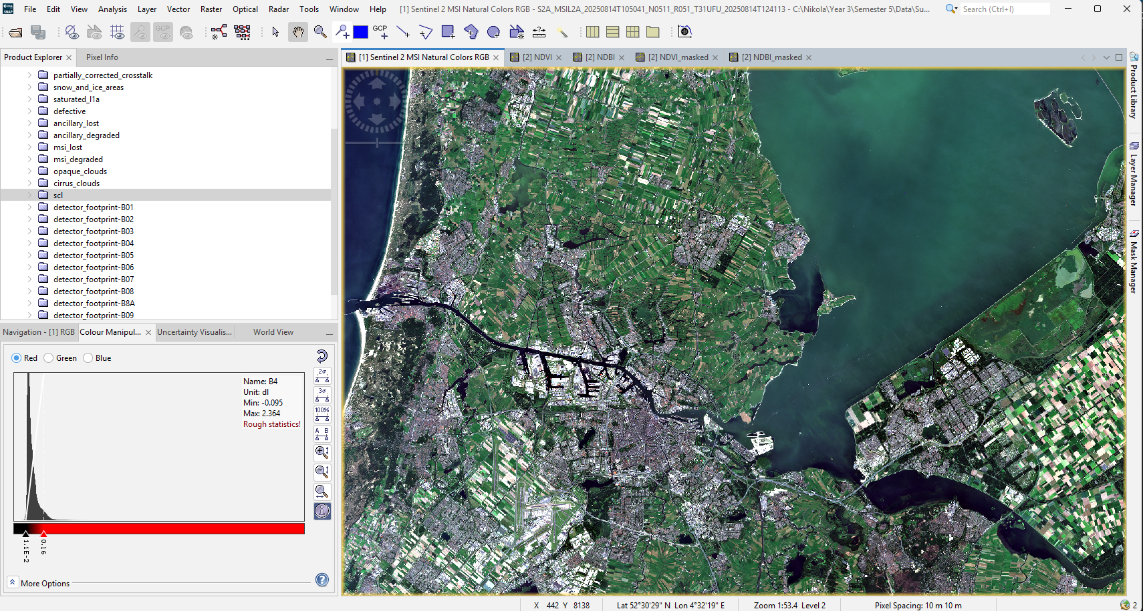
SNAP RGB composite showing cloud-free view of Amsterdam
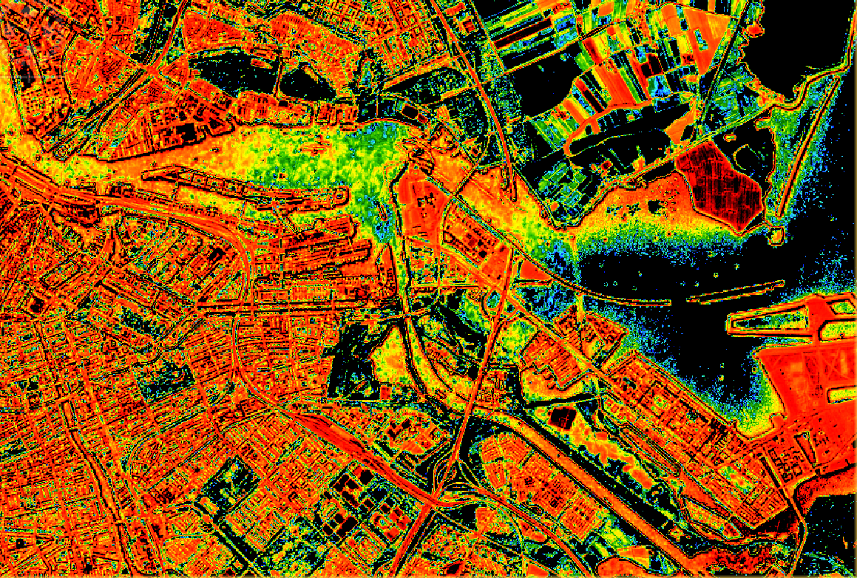
SNAP NDVI result: lighter areas indicate more vegetation
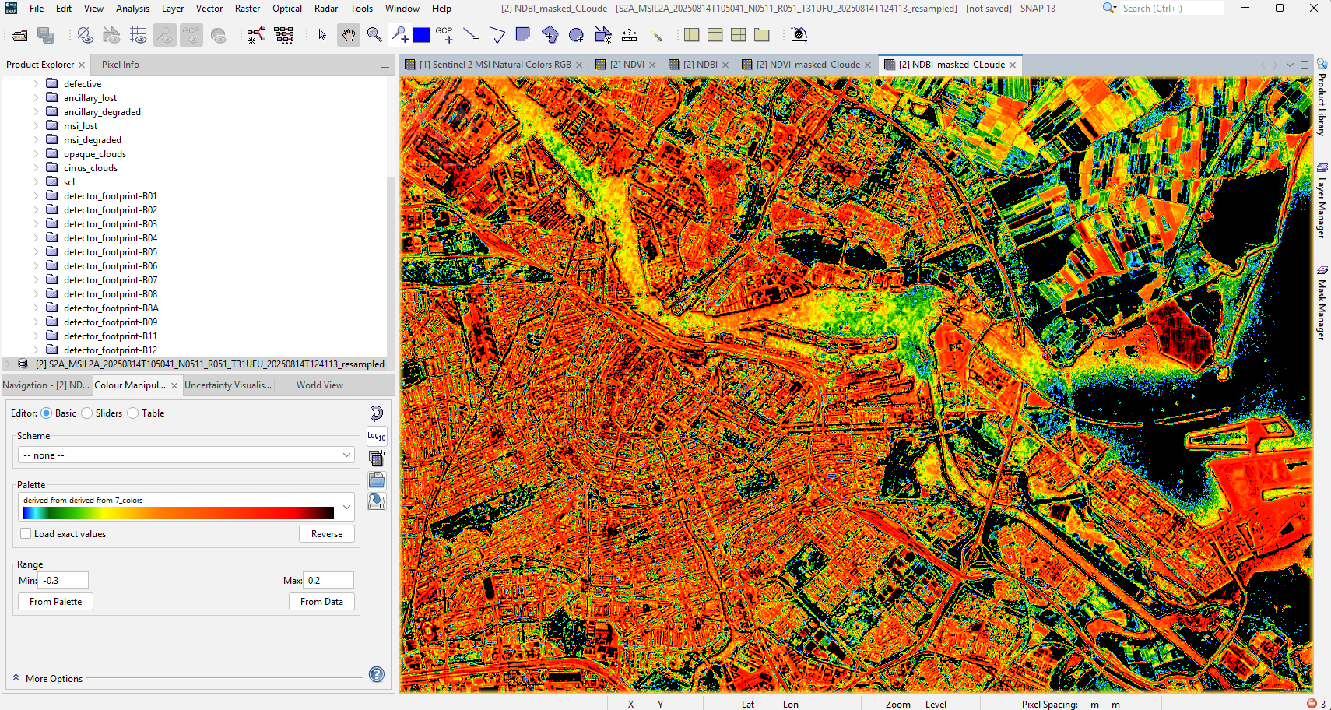
SNAP cloud masking: contaminated pixels set to NaN
With the imagery prepared, I built the study grid and extracted features. The study area is the Amsterdam municipality plus a 15 km buffer, divided into 2,217 cells of 1 by 1 km in EPSG:28992, the Dutch national grid in metres. For each image, the analysis grid was reprojected from EPSG:28992 to the satellite’s native CRS (EPSG:32631, UTM zone 31N), the cell IDs were rasterised onto the satellite pixel grid, and the mean NDVI, mean NDBI, and mean reflectance for bands B2, B3, B4, B8, and B11 were computed per cell. SNAP does not write band descriptions into its GeoTIFF exports, so the notebook identifies bands strictly by position, with the fixed order B2(1), B3(2), B4(3), B8(4), B11(5). Seasonal composites were then built using the median across all images in each season, because the median resists outliers like a single hazy image far better than the mean. The final satellite feature matrix contains 28 features: NDVI and NDBI plus 5 raw reflectance bands, across 4 seasons.
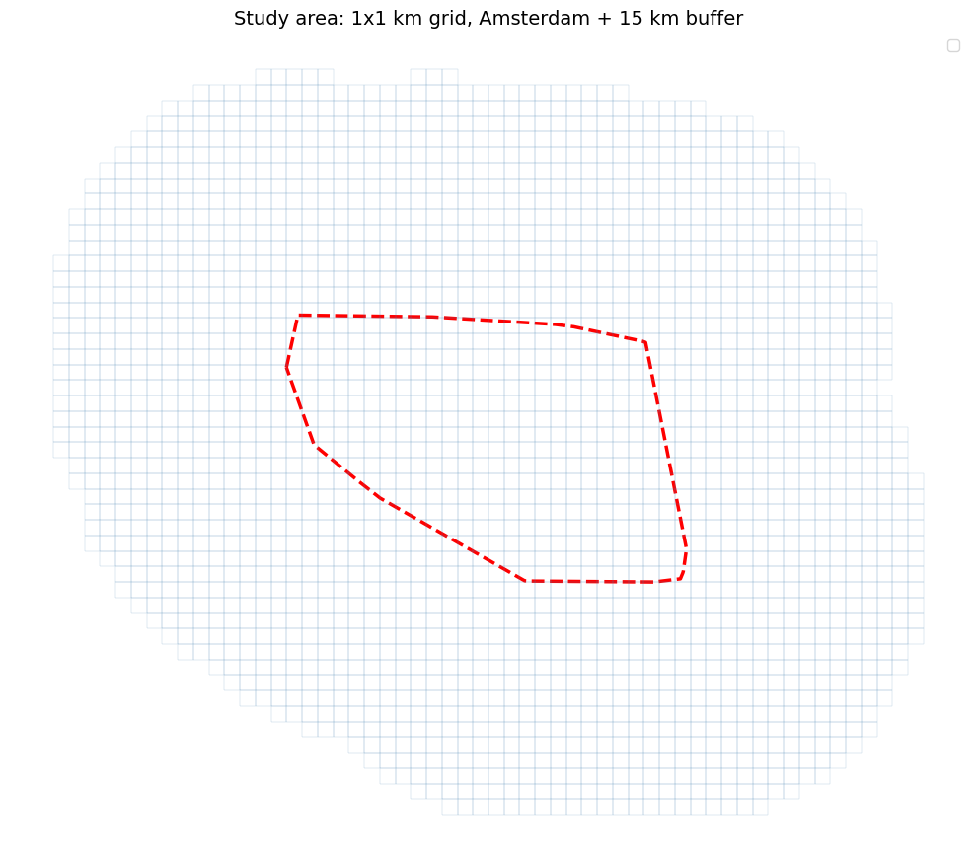
Study area: 2,217 grid cells covering Amsterdam + 15km buffer
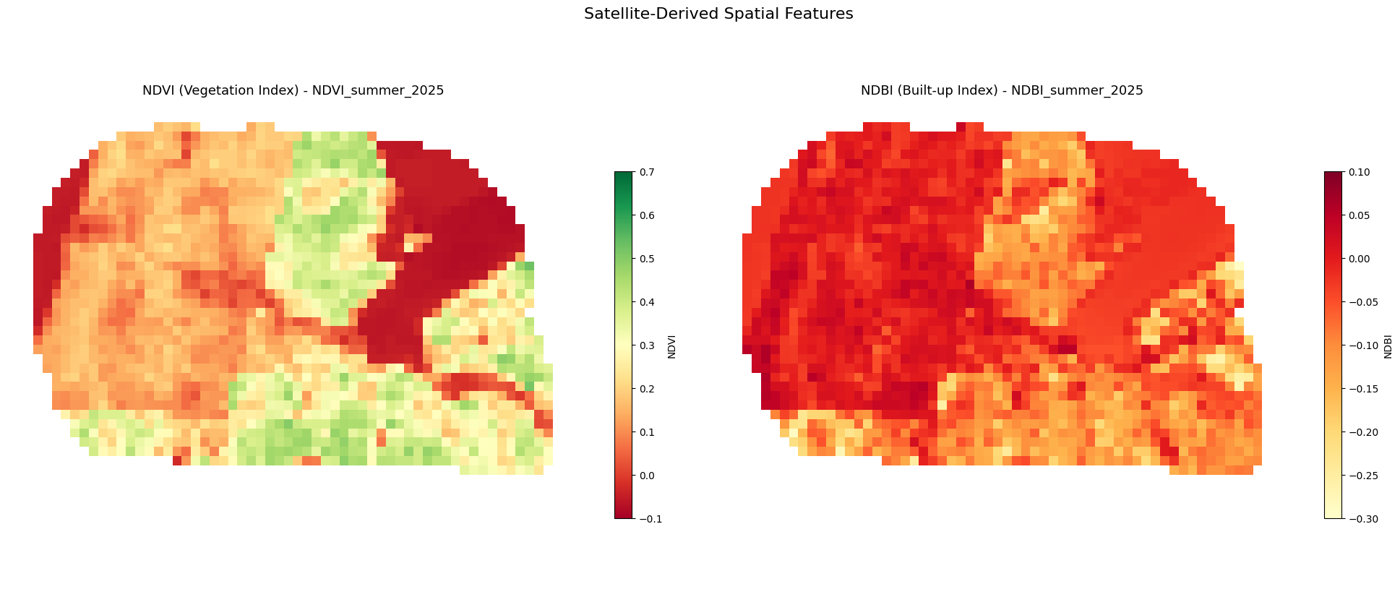
NDVI (vegetation) and NDBI (built-up) maps from Sentinel-2 seasonal composites
The Field work also brought in the socioeconomic and energy data. CBS Wijken en Buurten 2024 was joined to the grid through an area-weighted spatial join, reaching 99.4% coverage and contributing 9 features such as population density, address density, urbanization, age groups, and housing. The CBS value -99995, which marks "data not available", was converted to NaN during preprocessing so it would not corrupt training. Liander open data was loaded for the target variable: PV installations, feed-in through the column TOT_E_INV, and consumption through the column TOT_E. These Liander CSV files use semicolons as the delimiter and Dutch decimal formatting with commas instead of dots, and the PV buurtcodes required a .str.strip() to fix whitespace before they would join. PV rows marked "Onbepaald", which are privacy-anonymized, were filtered out before the spatial join, which reduced the PV rows from 7,491 to 5,346 and is the reason PV data only covers about 42% of cells. Crucially, the Liander energy data was used only to build the target variable and never as a model feature, to avoid circular reasoning where the model would partly predict its own input.
Two intended data sources had to be dropped, and documenting this honestly is part of the answer to SQ3. BAG building data was attempted through the PDOK WFS API but returned only 13 rows because of pagination limits, so it was excluded. The STORM substation dataset published by Liander contains real transformer loading data but is fully anonymized with no geographic coordinates, which makes it impossible to place on the grid, so it was also excluded.
[Reference: Notebook Documentation Sections 2, 8 to 12]

The Lab Method -

The Lab method covered target construction, model training, and evaluation. Because actual grid operator congestion declarations are not publicly available at the spatial resolution needed, a proxy target was constructed from Liander’s published energy data. Three components were combined with deliberate weights: consumption density at 55%, feed-in ratio at 25%, and PV penetration at 20%. Each component was normalized to a 0 to 1 scale using percentile clipping, and the weighted sum was split into three classes using tercile thresholds. This produced High, Medium, and Low congestion risk classes, with cells lacking sufficient Liander coverage excluded from training. The 55% consumption weight is the highest because a visual comparison with the official Netbeheer Nederland capacity map confirmed that Amsterdam’s congestion is primarily driven by consumption overload rather than solar feed-in.
Target component | Weight | Source | Logic
Consumption density | 55% | Liander kleinverbruik | High demand stresses cables and transformers
Feed-in ratio | 25% | Liander terugleverdata | Reverse power flow can overload one-directional infrastructure
PV penetration | 20% | Liander opwekdata | Clustered installations create concentrated injection points

The model is a Random Forest classifier configured with 300 trees, a minimum of 5 samples per leaf, balanced class weights to handle the uneven class sizes, and a fixed random_state of 42 for reproducibility. Missing values were handled with a median SimpleImputer, which is standard for Random Forest. It was trained on 37 features in total: the 28 satellite features plus the 9 CBS features. A temporal validation design was used: the model trains on satellite features from 2024 and 2025 images and validates on the winter 2025/2026 images, using the same grid cells but satellite observations from a different time period, which tests whether the model generalises to unseen imagery.
The 5-fold stratified cross-validation gave an F1-macro of 0.578 with a standard deviation of 0.029, which is well above the 0.333 baseline that random guessing would give on a 3-class problem, and the low spread shows stable performance across folds. The temporal validation gave an F1-macro of 0.55, a drop of only about 0.03 from cross-validation, which indicates the model holds up reasonably well on unseen time periods.
Metric | Value
Cross-validation F1-macro | 0.578 (std 0.029)
Temporal validation F1-macro | 0.55
Validation accuracy | 56%
Per-class F1 (Low / Medium / High) | 0.52 / 0.53 / 0.61
Features used | 37 (28 satellite + 9 CBS)

Looking at the per-class behaviour, the High congestion class is predicted most accurately (F1 of 0.61), while the Low class has lower recall (0.41), meaning the model tends to overpredict risk. For grid planning this conservative bias is preferable, because it is safer to flag an area that might be congested than to miss a real congestion zone.

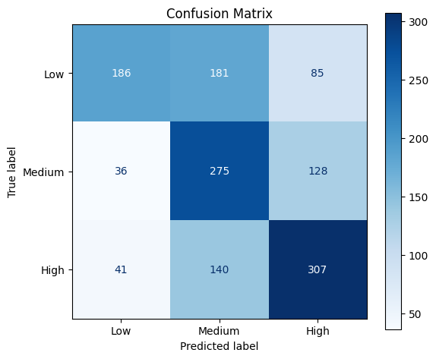
Confusion matrix: validation set performance per class
The feature importance analysis confirmed that the model learned sensible patterns. Population density ranked first (0.092), the percentage of people aged 25 to 45 ranked second (0.061), address density ranked third (0.061), and NDVI_summer ranked fifth (0.037). The top CBS features act as proxies for consumption intensity, while the satellite features collectively contribute a substantial share of the total importance, confirming that satellite-derived characteristics carry real congestion signal and are not just noise next to the demographic data.

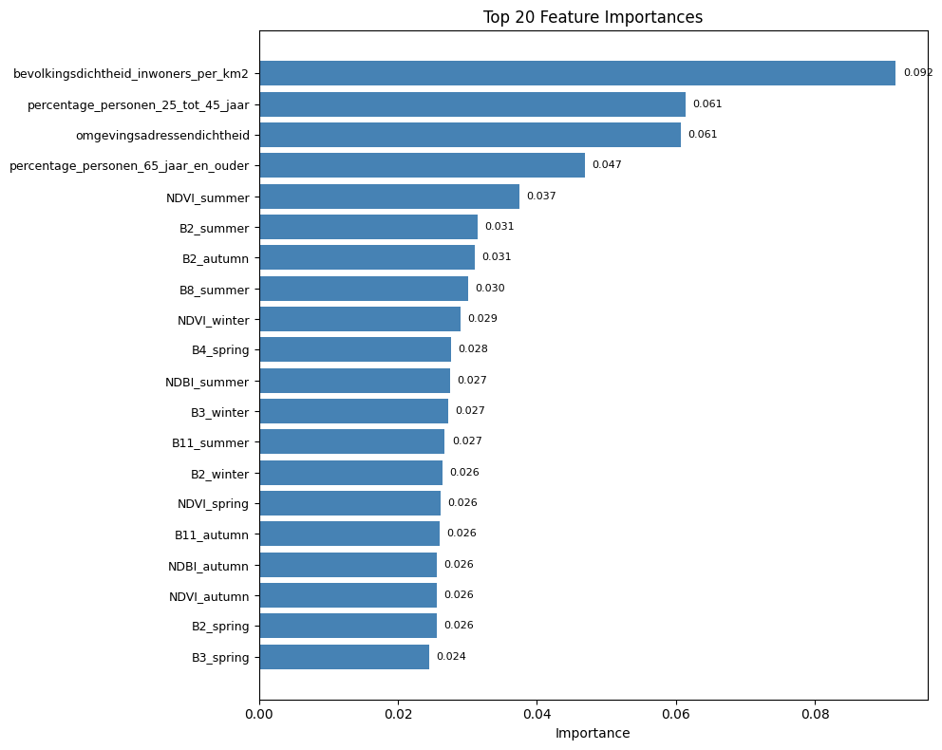
Feature importance ranking. Population density and demographics rank highest.

The Workshop Method -
The Workshop method was about building the visual outputs and the web application from the model results. I generated the congestion risk maps, including a side-by-side comparison of the constructed risk labels against the model predictions, and a continuous probability map for high congestion risk. These maps turn the numbers into something a planner can actually read.
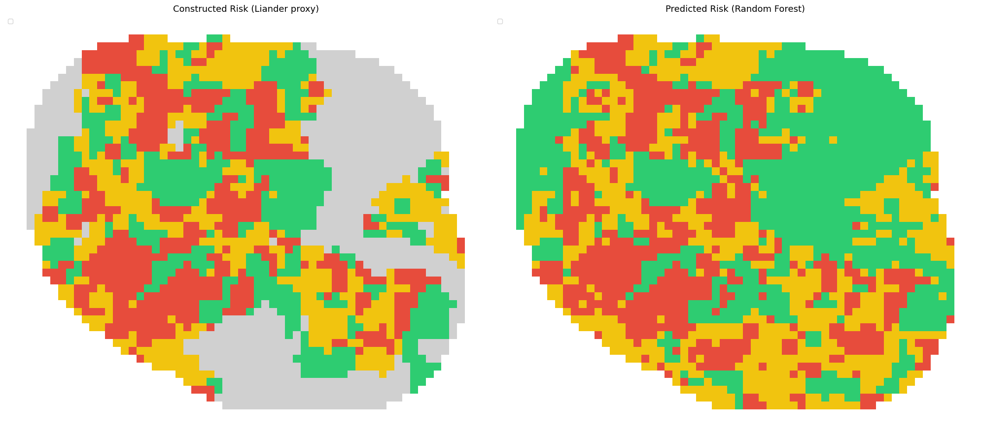
Side-by-side: constructed risk labels (left) vs model predictions (right)
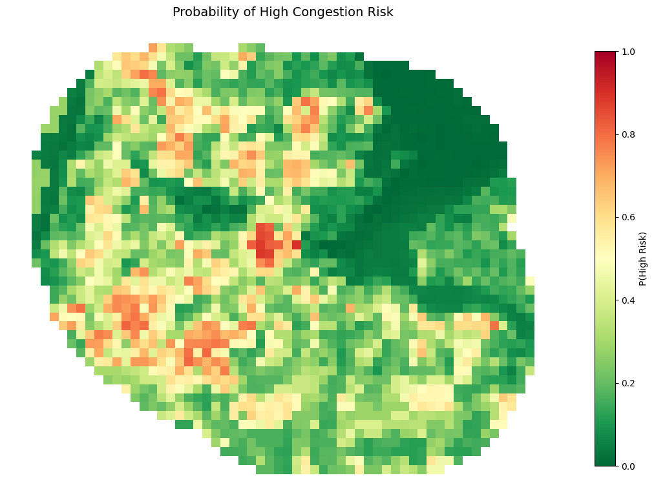
Continuous probability map for high congestion risk
All 2,217 grid cells were then exported to a GeoPackage with 23 columns, including the predicted class, the probability of high risk, and supporting feature values, and this was converted to GeoJSON for the web prototype. The web application itself was first built for the Fontys Career Day using dummy data, then upgraded to show the real model outputs. It was integrated into Anh’s Streamlit application by adding two new pages, a grid analysis page and a radiation versus congestion page, while leaving all of Anh’s existing code untouched. I also wrote a knowledge page in accessible language explaining Meteosat SEVIRI, CM SAF SARAH-3, how radiation estimation works, and the combined analysis, which is evidence that I can translate technical work for a non-technical audience.
[Reference: Notebook Documentation; congestion_analysis.html web application]

The Showroom Method -
The Showroom method was the review of the results with stakeholders. I presented the model, the maps, and the limitations to Priyanka during the weekly meetings, and discussed openly the validation accuracy and the circularity concern around the target. I also presented progress to my university assessor Aleyna Arslan-Kartal, who confirmed that the prototype and the overall progress were strong. These reviews kept the technical work honest, because explaining the limitations out loud forced me to be precise about what the model can and cannot claim.
[Reference: Meeting minutes; Feedpulse entries check them in Canvas]

Key Findings
AI can analyse congestion from satellite imagery by extracting spectral indices per grid cell and combining them with open demographic data to train an interpretable Random Forest classifier. The pipeline reaches an F1-macro of 0.578 on cross-validation and 0.55 on temporal validation, which is clearly above the random baseline and stable across folds.
The model’s conservative bias, overpredicting rather than underpredicting risk, is an advantage for grid planning. Population density is the single strongest feature, consistent with the finding that Amsterdam’s congestion is mostly consumption-driven, but the satellite features together still carry meaningful signal.
Several factors make the estimates uncertain, and naming them is part of answering the sub-question honestly. The target is a constructed proxy rather than real grid operator data, winter imagery has higher missing rates, the Sentinel-2 tile T31UFU does not fully cover the eastern study area (about 391 cells, 18%, have no satellite data), and the BAG and STORM datasets could not be used.

Result and Answer to SQ3
AI can analyse grid congestion from satellite images by extracting spectral indices (NDVI and NDBI) per 1 by 1 km cell, combining them with CBS demographic data, and training a Random Forest classifier to predict a Low, Medium, or High congestion risk class. The model achieves an F1-macro of 0.578 on cross-validation and 0.55 on temporal validation, with population density as the most important feature. The estimates are made uncertain by the constructed proxy target, the higher missing-data rate in winter imagery, the partial satellite coverage of the eastern study area, and the exclusion of the BAG and STORM datasets. Within these limits, the pipeline demonstrates that satellite-observable features carry a real and usable congestion signal at the neighbourhood scale.

Reflection: Planned vs Actual and What I Would Do Better
SQ3 changed the most from the original plan. The planned strategies were Library, Lab, and Showroom. In practice I used Library, Field, Lab, Workshop, and Showroom. Field was added because I needed to collect and explore the actual datasets (Sentinel-2, CBS, Liander), which turned out to be a substantial part of the work. The Lab strategy expanded from evaluation-only to full model training, cross-validation, temporal validation, and feature importance analysis. Workshop was added because building the notebook pipeline, the maps, and the web application was real construction work that the original plan had underestimated.
What I would do better is investigate alternative building data sources from the start rather than relying on the PDOK WFS. I would also experiment with a model version that excludes the Liander energy data from the target entirely, to build a purely satellite-based congestion indicator and measure how much signal comes from imagery alone versus from the socioeconomic data. That experiment would directly address the circularity concern that PV penetration appears both in the target and as a strong driver of the pattern.

SQ4: What is solar radiation, and how can we measure it?
SQ4: What is solar radiation, and how can we measure or represent it using satellite-based data?

DOT Methods Used
[Library]
[Field]
[Showroom]
SQ4 opens the second half of the project, the radiation side. Before any radiation could be estimated or compared with congestion, I needed a clear understanding of what solar radiation is, how it is described, and which satellites are suitable for measuring it. Like SQ1, this is mainly a definitional and contextual question, answered through literature and specification analysis rather than code. Getting it right was important because it directly determined which satellite the radiation pipeline in SQ5 would be built on.
The key turning point in SQ4 was realising that the satellite I had originally planned to use for everything, Sentinel-2, is the wrong tool for radiation. That realisation reshaped the whole radiation approach and is the main story of this sub-question.

The Library Method -
The Library method reviewed 10 solar radiation estimation papers to understand both the physical quantity and the satellite options. Solar radiation is described through three components: Global Horizontal Irradiance (GHI), the total solar energy reaching a horizontal surface; Direct Normal Irradiance (DNI), the direct beam; and Diffuse Horizontal Irradiance (DHI), the scattered light. GHI is measured in watts per square metre and is the standard metric for solar energy planning because it determines how much electricity a panel can generate. For this project GHI is the relevant component, because the goal is to relate solar resource to PV-driven grid stress.
The most important technical finding was that the choice of satellite depends on temporal resolution, not just spatial resolution. Sentinel-2 is a polar-orbiting satellite with excellent 10 m spatial resolution, but it only passes over Amsterdam roughly every 5 days. Clouds move on a timescale of minutes, so a satellite that images every 5 days simply cannot track the cloud cover that determines surface radiation at any given moment. Meteosat SEVIRI, by contrast, is geostationary and captures an image of Europe every 15 minutes, at a coarser 5.5 km resolution. For radiation, the 15-minute cadence is exactly what matters, so Meteosat SEVIRI is the appropriate satellite and Sentinel-2 is not. This is why the two satellites have fixed, non-swappable roles in the project: Sentinel-2 for spatial and congestion features, geostationary data for radiation.
[Reference: Research Paper Section 2, Table 2]

The Field Method -
The Field method meant studying the technical specifications of the two satellites through the reviewed papers and confirming the radiation approach against validated ground-truth references. The decisive piece of context was that Cui et al. (2024) validated SEVIRI-based radiation estimates against Dutch ground stations at Cabauw and De Bilt. Having validation in the Dutch context, rather than just in general, justified choosing SEVIRI for the radiation pipeline with confidence, because it meant the radiation estimates had already been checked against real measurements in the same country and climate the project is about.
Studying the specifications also produced concrete reference numbers for Amsterdam that the later pipeline could be checked against: an annual mean GHI of roughly 118 W/m2, a summer average around 224 W/m2, and a winter average around 34 W/m2. These figures anchored the radiation work in SQ5 and SQ6 to known Dutch solar resource values.
[Reference: Research Paper Section 2, SQ4 answer]

The Showroom Method -
The Showroom method was the discussion of the satellite choice with Priyanka. This is where I had to admit that my initial plan was wrong. I had originally told her I would use Sentinel-2 for everything, including radiation. After the literature study I understood this was incorrect and proposed switching to Meteosat SEVIRI for the radiation side. Communicating this change openly, rather than quietly hiding the mistake, turned a planning error into a technically stronger two-satellite pipeline, and Priyanka approved the updated approach. This exchange is good evidence for Personal Leadership, because it shows correcting course based on evidence.
[Reference: Meeting minutes; Feedpulse entries check them in Canvas]

Key Findings
Solar radiation is described by GHI, DNI, and DHI, of which GHI is the relevant metric for this project. The right satellite for radiation is determined by temporal resolution: a geostationary satellite imaging every 15 minutes can track clouds, while a 5-day polar orbiter cannot.
Meteosat SEVIRI is therefore the correct radiation satellite, validated for the Netherlands at Cabauw and De Bilt, while Sentinel-2 stays on the spatial and congestion side. Amsterdam’s known solar resource sits around 118 W/m2 annual mean, which became the reference for the later pipeline.

Result and Answer to SQ4
Solar radiation is the incoming solar energy reaching the surface, described through GHI, DNI, and DHI and measured in watts per square metre, with GHI being the key planning metric. It can be measured from satellite data using geostationary satellites such as Meteosat SEVIRI, which images every 15 minutes and has been validated against Dutch ground stations at Cabauw and De Bilt. Sentinel-2 is not suitable for radiation because of its 5-day revisit time and is instead used for spatial feature extraction. For Amsterdam the annual mean GHI is about 118 W/m2, with a summer average near 224 W/m2 and a winter average near 34 W/m2.

Reflection: Planned vs Actual and What I Would Do Better
The planned strategies for SQ4 were Library, Field, and Showroom, and these were the strategies actually used, so there was no change. What I would do better is build a satellite comparison table at the very start of the project, listing resolution, revisit time, and suitable task for each satellite, and discuss it with my supervisor before committing to any approach. If I had done that in week one, I would not have needed to walk back the Sentinel-2-for-everything plan later.

SQ5: How can AI estimate radiation from satellites?
SQ5: How can AI be used to analyse solar radiation from satellite images, and what can make the estimates uncertain or inaccurate?

DOT Methods Used
[Library]
[Field]
[Lab]
[Showroom]

SQ5 builds the radiation pipeline that SQ4 made possible. The original plan was to build and validate a custom radiation estimation model. During the project I changed this to use the pre-computed CM SAF SARAH-3 SIS product instead, a decision discussed with and approved by my supervisor. The reasoning, the data, and the sources of uncertainty are described per method below. This change is one of the clearest examples in the project of a planned strategy shifting to a different actual strategy for good reasons.

The Library Method -

The Library method surveyed how AI estimates radiation from satellite data and identified the data source to use. The general pipeline is well established: a geostationary satellite captures cloud images every 15 minutes, a cloud index is computed per pixel describing how much sunlight is blocked, and this index is combined with a clear-sky model (which gives the radiation that would arrive with no clouds, based on the sun’s position and the atmosphere) to estimate the actual surface radiation. The CM SAF SARAH-3 product applies exactly this Heliosat methodology at continental scale and publishes validated monthly mean values.
The literature also catalogued the machine learning methods used for this task. LightGBM (Suwanwimolkul et al.) gives strong GHI accuracy without GPU hardware and generalises across locations. ConvLSTM (Yeom et al.) combines spatial cloud patterns with temporal cloud motion and does well under fast-changing clouds. UNet and DGMR-SO (Cui et al.) were validated in the Dutch context, with UNet giving the lowest overall errors. Hybrid CNN-plus-LSTM models (Attya et al.) reach very high accuracy but need specialist hardware and are hard to reproduce. Reviewing these confirmed that a custom model was possible but not necessary: the project’s contribution is the combination of radiation with congestion, not a new radiation model, so using a validated pre-computed product was the better engineering choice.
[Reference: Research Paper Section 2, Table 2; Radiation Notebook Documentation Section 6]

The Field Method -
The Field method covered acquiring and exploring the CM SAF SARAH-3 SIS data. SIS stands for Surface Incoming Shortwave radiation, a climate data product from the CM SAF, part of EUMETSAT, providing monthly mean GHI in W/m2, derived from Meteosat SEVIRI at a spatial resolution of 0.05 degrees, which is about 5.5 km at Amsterdam’s latitude. I downloaded 27 monthly NetCDF files covering December 2023 through February 2026 from the EUMETSAT Data Store, searching for the SARAH Edition 3 product, filtering for the SIS monthly mean type, and extracting the .nc files from the downloaded archives. Each month is stored in its own folder, and only the NetCDF data file is used by the notebook.
Exploring the files in Python with the xarray library showed the practical details that the pipeline had to handle: the coordinate names are lat and lon, the latitude axis can be stored in descending order and has to be flipped when that happens, and the data has to be clipped to the Amsterdam bounding box (latitude 52.143 to 52.574, longitude 4.507 to 5.331). This is the same bounding box used for the congestion grid, which kept both pipelines on one spatial framework.
[Reference: Radiation Notebook Documentation Sections 2, 3]

The Lab Method -
The Lab method was the technical processing that mapped radiation onto the congestion grid. The notebook loads the exported GeoPackage from Pipeline 1, with all 2,217 cells, and reprojects it from EPSG:28992 to EPSG:4326 because the SIS data uses geographic coordinates. Because the SIS pixels (about 5.5 km) are much larger than the 1 km grid cells, nearest-neighbour interpolation through the scipy RegularGridInterpolator assigns each cell the value of the closest SIS pixel. Out of 2,217 cells, 1,933 receive valid radiation data; the remaining 284 fall outside the SIS coverage at the edges of the grid.
The monthly values were aggregated into seasonal and annual statistics matching Pipeline 1. The results line up with known Dutch values, which is itself a validation: a summer mean GHI of about 224 W/m2, a winter mean of about 34 W/m2, an annual mean of about 118 W/m2, a summer-to-winter ratio of roughly 6.5, and an annual total near 905 kWh/m2/year, which sits inside the published Dutch range of 900 to 1100. The spatial variation across the whole study area is under 7 W/m2, an early signal of the uniformity finding that becomes central in SQ6.
Statistic | Value | Interpretation
GHI summer (mean) | 223.9 W/m2 | Peak solar resource, about 5.4 kWh/m2/day
GHI winter (mean) | 34.3 W/m2 | Minimum, very low PV generation
GHI annual mean | 118.5 W/m2 | Consistent with the Dutch solar atlas
Seasonal ratio | 6.54 | Summer gets ~6.5x more energy than winter
Spatial variation | 114.6 to 122.1 W/m2 | Under 7 W/m2 across the area: radiation is uniform

It is worth being clear that no custom AI model was trained for radiation in the end. The Lab strategy here was reduced from training-and-validating a model down to data quality checks and spatial processing of a validated product. That is a deliberate, supervisor-approved scope decision, not a gap in the work.
[Reference: Radiation Notebook Documentation Sections 3, 5]

The Showroom Method -
The Showroom method was presenting the radiation results and the decision to use CM SAF to Priyanka for review before final submission. The switch from a custom model to the pre-computed product was discussed and approved, and the seasonal radiation results were reviewed against expectations. Walking through why the product choice was the right one, given the project’s actual contribution, was part of keeping the scope honest and defensible.
[Reference: Meeting minutes; Feedpulse entries, check them in Canvas]

Key Findings
Radiation can be estimated from geostationary satellite data using the Heliosat method (cloud index combined with a clear-sky model), and several AI methods (LightGBM, ConvLSTM, UNet) can do this with high accuracy. For this project the validated CM SAF SARAH-3 SIS product was used instead of a custom model, because the project’s contribution is the combination with congestion.
The processed radiation values match known Dutch solar resource figures, which validates the pipeline, and they already hint that radiation is spatially uniform across Amsterdam. The main sources of uncertainty are cloud variability, the coarse 5.5 km resolution, low winter sun angles, and a small temporal mismatch between the radiation and energy datasets.

Result and Answer to SQ5
AI can estimate solar radiation from satellite images by deriving a cloud index from 15-minute geostationary imagery and combining it with a clear-sky model, and methods such as LightGBM, ConvLSTM, and UNet achieve this with high accuracy. For this project the pre-computed and Dutch-validated CM SAF SARAH-3 SIS product was used, mapped onto the 1 km congestion grid through nearest-neighbour interpolation. The estimates are made uncertain by persistent cloud cover in the Netherlands, the coarse 5.5 km spatial resolution that cannot resolve urban-scale effects, the lower accuracy at low winter sun angles, and the temporal mismatch between the 2023 to 2026 radiation data and the 2024 to 2025 energy data. Because solar resource is set by geography and climate rather than infrastructure, this temporal mismatch is minor.

Reflection: Planned vs Actual and What I Would Do Better
The planned strategies for SQ5 were Library, Lab, and Showroom. The actual strategies were Library, Field, Lab, and Showroom, and the content of the Lab strategy changed significantly: I did not train a custom radiation model, but used the validated CM SAF product instead, and added Field work to analyse the CM SAF documentation and download the data. What I would do better is decide earlier whether to train a custom model or use a pre-computed product, because the switch to CM SAF was correct but happened later than ideal. I would also process at least one raw SEVIRI image from scratch to demonstrate the full estimation pipeline end to end, even if the project ultimately uses the pre-computed data.

SQ6: Why combine congestion and radiation analysis?
SQ6: Why is it important to analyse the combined grid congestion with solar radiation estimation with indicators, and what practical insights does this combined approach give?

DOT Methods Used

[Library]
[Field]
[Lab]
[Showroom]
SQ6 is where the two pipelines come together and the project delivers its main contribution. With Pipeline 1 producing congestion risk per cell and Pipeline 2 producing radiation per cell on the same grid, SQ6 asks why combining them matters and what practical insight the combination gives that neither pipeline gives alone. This is the sub-question that turns a descriptive map into an explanatory and actionable one.

The Library Method -
The Library method connected the combined analysis back to the research gap. The literature review had established that no existing study combines satellite-based spatial data with grid congestion analysis in one workflow for a specific city, and that no study uses solar radiation estimation as a validation layer for congestion indicators. SQ6 is the part of the project that directly fills both halves of that gap. The literature on grid intervention strategies also provided the framing for why distinguishing congestion drivers matters: solar-driven and consumption-driven congestion call for fundamentally different solutions, which only becomes useful information once you can tell the two apart.
[Reference: Research Paper Section 2; Radiation Notebook Documentation Section 7]

The Field Method -
The Field method was the spatial overlay of the two pipeline outputs on the same 1 km grid. Because both pipelines were deliberately built on the identical 2,217-cell grid in the same coordinate framework, the radiation values and the congestion predictions sit on exactly the same cells, so they can be compared directly cell by cell without any resampling mismatch. This shared spatial framework is what makes the comparison meaningful rather than approximate, and it was a design decision made back in Pipeline 1 specifically so that SQ6 would be possible.

The Lab Method -
The Lab method was the statistical comparison between congestion classes and radiation, and it produced the single most important finding of the project: solar radiation does not vary across congestion classes. The mean annual GHI is 118.4 W/m2 for Low-risk cells, 118.9 for Medium, and 119.1 for High, a difference of less than 1 W/m2. All of Amsterdam receives essentially identical sunlight, which makes sense because the study area is only about 30 km across.

Congestion class | Mean GHI (W/m2) | Mean PV penetration | Cells
Low risk | 118.4 | 3.1% | 477
Medium risk | 118.9 | 19.9% | 460
High risk | 119.1 | 111.6% | 493

In sharp contrast to the flat radiation, PV penetration varies by a factor of about 36 between Low-risk cells (3.1%) and High-risk cells (111.6%). This is the key insight: congestion risk is not driven by how much sun an area gets, because every area gets the same. It is driven by how many solar panels were installed and how much electricity is consumed. Two neighbourhoods can receive identical radiation, but if one has many times more panels, only that one faces solar feed-in congestion. This reframes the planning question from "where is it sunny?" to "where are people installing panels faster than the grid can handle, and where is consumption outgrowing the cables?"
Building on this, each high-risk cell was classified by its dominant congestion driver. Consumption-driven cells (223) have high risk with low PV adoption, where the problem is demand on aging infrastructure. Solar-driven cells (163) have high risk with high radiation and high PV adoption, where the problem is reverse power flow. Mixed cells (107) have both factors. Consumption-driven congestion being more common than solar-driven matches the official Netbeheer Nederland capacity map, which shows Amsterdam is predominantly in consumption-side shortage, while solar-driven congestion shows up mainly in the newer suburban areas around the city such as Zaanstad, Purmerend, and parts of Haarlem, where rooftop solar adoption is higher.
Driver type | Count | What it means for intervention
Consumption-driven | 223 | Cable and transformer upgrades, demand management (slow, expensive)
Solar-driven | 163 | Smart inverters, batteries, local energy communities (faster, cheaper)
Mixed drivers | 107 | Both factors contribute; combined measures needed
Low / Medium risk | 937 | No significant congestion risk detected

[Reference: Radiation Notebook Documentation Sections 4, 7]

The Showroom Method -
The Showroom method was presenting the combined findings to Priyanka, in the final portfolio, and through the web application. The radiation-versus-congestion page lets a user select seasons and locations and see how the patterns change, and the driver classification is shown directly on the map. Presenting the uniformity finding and the driver split was the moment the project’s value became clear to stakeholders, because it answered not just where congestion is but why, and what to do about it.
[Reference: Meeting minutes; solar_vs_grid web application page]

Key Findings
Solar radiation is spatially uniform across Amsterdam (under 1 W/m2 variation across congestion classes), so congestion variation cannot be explained by solar resource. It is explained by PV adoption, which varies by a factor of about 36, and by consumption patterns.
This makes the combined analysis actionable. The 493 high-risk cells split into 223 consumption-driven, 163 solar-driven, and 107 mixed, and each driver needs a different and differently-priced intervention. Neither pipeline alone produces this distinction; only the combination does, which is precisely why combining them matters and is the gap the project set out to fill.

Result and Answer to SQ6
Combining congestion and radiation analysis matters because it transforms a descriptive risk map into an explanatory and actionable tool. The central insight is that radiation is uniform across Amsterdam, so congestion variation is driven by PV adoption rates and consumption density, not by differences in solar resource. The combined approach classifies high-risk cells into 223 consumption-driven, 163 solar-driven, and 107 mixed zones, and each type requires a different grid intervention: smart inverters and batteries for solar-driven zones, cable and transformer upgrades for consumption-driven zones. This driver classification, which neither the congestion pipeline nor the radiation pipeline can produce on its own, is the project’s primary practical contribution and directly fills the literature gap of combining satellite-based congestion analysis with radiation estimation for a specific city.

Reflection: Planned vs Actual and What I Would Do Better
The planned strategies for SQ6 were Library, Field, and Showroom. In practice I also used the Lab strategy, added for the statistical comparison between congestion classes and GHI values. The ethical check and guideline conformity were addressed within the limitations rather than as separate exercises. What I would do better is build the comparison framework earlier and define the driver classification criteria before running the radiation pipeline, instead of developing those criteria after seeing the results. Defining the thresholds up front would have made the classification feel less like a post-hoc choice and more like a pre-registered test.

Answer to the Main Research Question
Based on the work across the six sub-questions, the main research question can be answered as follows.
Satellite imagery and AI can analyze grid congestion by extracting spatial features from Sentinel-2 images (vegetation density via NDVI, built-up density via NDBI) and combining them with public socioeconomic data (CBS population statistics) to train a Random Forest classifier that predicts congestion risk per 1x1 km grid cell. The model achieves an F1-macro score of 0.578 on cross-validation and 0.55 on temporal validation, demonstrating that satellite-observable characteristics carry meaningful congestion signal.
Solar radiation estimation supports validation by revealing that GHI is spatially uniform across Amsterdam (less than 1 W/m2 variation across congestion classes), which proves that congestion patterns are driven by PV adoption rates and consumption density, not by natural solar resource differences. The combined analysis classifies high-risk cells into solar-driven (163 cells) and consumption-driven (223 cells) congestion zones, producing actionable information that neither pipeline delivers alone.
For the full academic analysis, see the Research Paper (HBO-ICT format).
[Reference: Research Paper]

Conclusion and Recommendations

Conclusion
This research investigated how satellite imagery and AI techniques can be combined to analyse grid congestion in Amsterdam and validate those findings using solar radiation estimation. The work was structured across six sub-questions, each addressed using DOT Framework strategies and documented with evidence throughout.
The main conclusion is that satellite-based grid congestion classification is technically feasible using publicly available data and reproducible tools. The Random Forest model trained on Sentinel-2 spectral indices and CBS demographic features achieved F1-macro 0.578, confirming that spatial features carry congestion-relevant information. The model performance is not yet sufficient for operational use, but it provides a spatial view of congestion risk that existing network-only models do not offer.
The radiation analysis produced the most important single finding: solar radiation is spatially uniform across Amsterdam. This means congestion variation is structurally driven by adoption rates and consumption patterns, not by differences in solar resource. The combined analysis enables classification of congestion zones by their dominant driver (consumption vs solar), which has direct implications for which interventions grid planners should prioritize per area.
The project also demonstrated the importance of honest evaluation. The target variable is a constructed proxy, the circularity between features and target components is acknowledged, and the BAG and STORM data failures are documented rather than hidden. These limitations define the boundaries within which the results should be interpreted.

Recommendations
For future research: (1) Train a model version without consumption and PV data in the target to test how much signal comes from satellite features alone. (2) Use alternative building data sources to add independent spatial features. (3) Investigate higher-resolution radiation data to detect potential urban-scale effects.
For grid operators: The spatial congestion risk map and driver classification provide an overview of where and why congestion concentrates. Solar-driven zones can be addressed with battery storage and smart inverters. Consumption-driven zones require infrastructure upgrades.
For the Fontys Innovation Lab: The pipeline, web application, and methodology serve as a foundation for future student projects. Desislav will continue the project next semester. The handover includes: both Jupyter notebooks (congestion and radiation), the exported GeoPackage file, the web application code (Leaflet.js pages integrated into Streamlit), the Proof of Data Cleaning document, and the Notebook Documentation. The radiation pipeline connects to the same grid, making continuation straightforward. All code, notebooks, and documentation are prepared for handover.

References
See the Research Paper (HBO-ICT format) for the complete reference list of all 25 reviewed papers.
Key references cited in this document:
[1] Hernandez-Matheus et al. Congestion forecast framework based on probabilistic power flow and machine learning. Int. J. Electrical Power & Energy Systems, 2024.
[2] Cui et al. Solar radiation nowcasting based on geostationary satellite images and deep learning models. Solar Energy, 2024.
[3] Rouse et al. Monitoring vegetation systems in the Great Plains with ERTS. Third ERTS Symposium, 1974.
[4] Zha et al. Use of normalized difference built-up index in automatically mapping urban areas from TM imagery. Int. J. Remote Sensing, 2003.

Portfolio Document References
Document | What It Contains | Where Referenced
Research Paper (HBO-ICT) | Full academic paper with literature review, methodology, results, discussion | Throughout this document
Proof of Data Cleaning | Detailed SNAP preprocessing workflow with screenshots for all 7 steps | SQ2, SQ3
Notebook Documentation | Full Pipeline 1 technical documentation: data sources, code, processing steps | SQ3
Radiation Notebook Documentation | Full Pipeline 2 technical documentation: CM SAF, xarray, driver classification | SQ5, SQ6
Project Report | Assignment description, process per SQ, reflection on learning outcomes | Portfolio
LO Documents (4x)  LO1  LO2  LO3  LO4 | Evidence tables, reflections, future actions per learning outcome | Portfolio
Meeting Minutes | Minutes from weekly meetings with Priyanka (Feb-Jun 2026) documenting decisions, feedback, and progress | SQ1 (Showroom), LO4 (feedback evidence)
Feedpulse Entries | Progress reflections after meetings with Aleyna documenting what was learned and next steps | LO4 (Personal Leadership)

