Testing Document
Satellite-Based Grid Congestion Analysis
Nikola Momchilov | Fontys Innovation Lab | 2026

1. Introduction
This document reports all testing and validation activities performed on the grid congestion analysis pipeline and the solar radiation estimation pipeline. Since the project does not have a traditional software backend with API endpoints or database transactions, testing focuses on three areas: whether the machine learning model produces reliable predictions, whether the input data is clean and correctly processed, and whether the results are consistent with known real-world patterns.
Each test section states what was tested, the expected outcome, the actual outcome, and whether the test passed. Where a test failed or produced unexpected results, the cause and resolution are documented.

2. Model Performance Testing
The Random Forest classifier predicts congestion risk (Low, Medium, High) per 1x1 km grid cell. Model performance is measured using standard classification metrics.

2.1 Cross-Validation (Training Set)
5-fold stratified cross-validation was performed on the training data (2024-2025 satellite features). Each fold trains on 80% of the data and tests on the remaining 20%. Stratification ensures each fold preserves the class distribution.
Fold | F1-macro | Status
Fold 1 | 0.545 | PASS
Fold 2 | 0.596 | PASS
Fold 3 | 0.619 | PASS
Fold 4 | 0.601 | PASS
Fold 5 | 0.552 | PASS
Mean +/- Std | 0.578 +/- 0.029 | PASS

Interpretation: F1-macro of 0.578 means the model is significantly better than random guessing (which would score 0.333 for a 3-class problem). The low standard deviation (0.029) indicates stable performance across folds. The model has learned real patterns in the data.
Threshold for passing: F1-macro > 0.40 (better than random baseline + margin). Result: 0.578. PASS.

2.2 Temporal Validation (2026 Data)
The model was trained on 2024-2025 satellite features and validated on winter 2025/2026 features. Same grid cells, different time period satellite data. This tests whether the model generalizes to unseen satellite observations.
Class | Precision | Recall | F1-score | Support | Status
Low | 0.71 | 0.41 | 0.52 | 452 | PASS
Medium | 0.46 | 0.63 | 0.53 | 439 | PASS
High | 0.59 | 0.63 | 0.61 | 488 | PASS
Macro avg | 0.59 | 0.56 | 0.55 | 1,379 | PASS

Interpretation: The F1 drops from 0.578 (cross-validation) to 0.55 (temporal validation), a decrease of 0.028. This small drop shows the model generalizes reasonably well to unseen time periods. The High congestion class is predicted most accurately (F1 = 0.61). The Low class has lower recall (0.41), meaning the model tends to overpredict risk. For grid planning, this conservative bias is preferable: it is safer to flag a potentially congested area than to miss one.
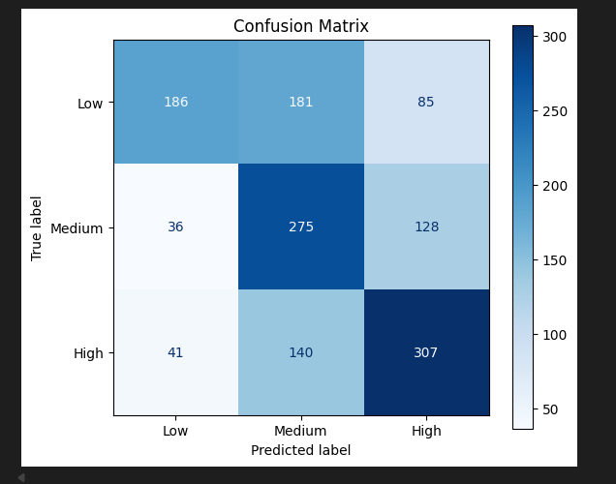Figure 1. Confusion matrix showing the number of cells classified into each combination of actual and predicted class. The diagonal shows correct predictions.

2.3 Feature Importance Validation
Random Forest provides a ranking of which features contributed most to predictions. This ranking is checked against domain expectations.
Rank | Feature | Importance | Expected? | Status
1 | Population density (CBS) | 0.092 | Yes, consumption proxy | PASS
2 | % age 25-45 (CBS) | 0.061 | Yes, high consumption age group | PASS
3 | Address density (CBS) | 0.061 | Yes, consumption proxy | PASS
5 | NDVI_summer (Sentinel-2) | 0.037 | Yes, urbanization indicator | PASS
8 | B8_summer (Sentinel-2) | 0.030 | Yes, NIR band for land cover | PASS
10 | NDBI_autumn (Sentinel-2) | 0.028 | Yes, built-up density | PASS

Interpretation: CBS demographic features dominate individually (population density is the single strongest predictor), which is consistent with the finding that Amsterdam's congestion is primarily consumption-driven. However, the 28 satellite features collectively contribute a substantial share of total importance. The ranking confirms that both data sources carry meaningful congestion signal, supporting the project's hypothesis that satellite imagery adds value beyond socioeconomic data alone.
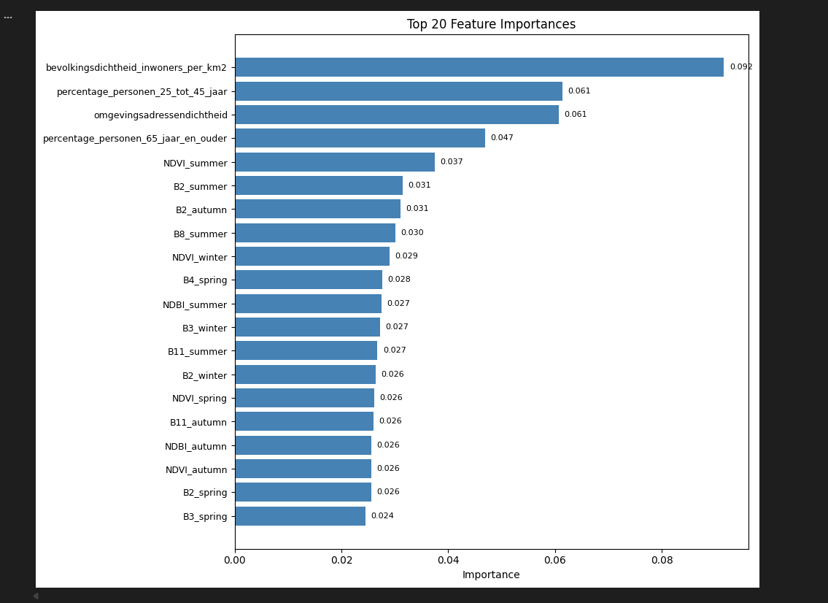Figure 2. Top 20 feature importances from the Random Forest model.

3. Visual Validation Against Official Data
Since quantitative ground truth data (actual Liander congestion declarations at grid cell resolution) is not publicly available, visual comparison with the official Netbeheer Nederland capacity map serves as the primary external validation.

3.1 Comparison Method
The model's predicted congestion risk map is placed next to a screenshot of the official capacity map from capaciteitskaart.netbeheernederland.nl. Both maps cover the Amsterdam region. Areas of agreement and disagreement are identified visually.

3.2 Results
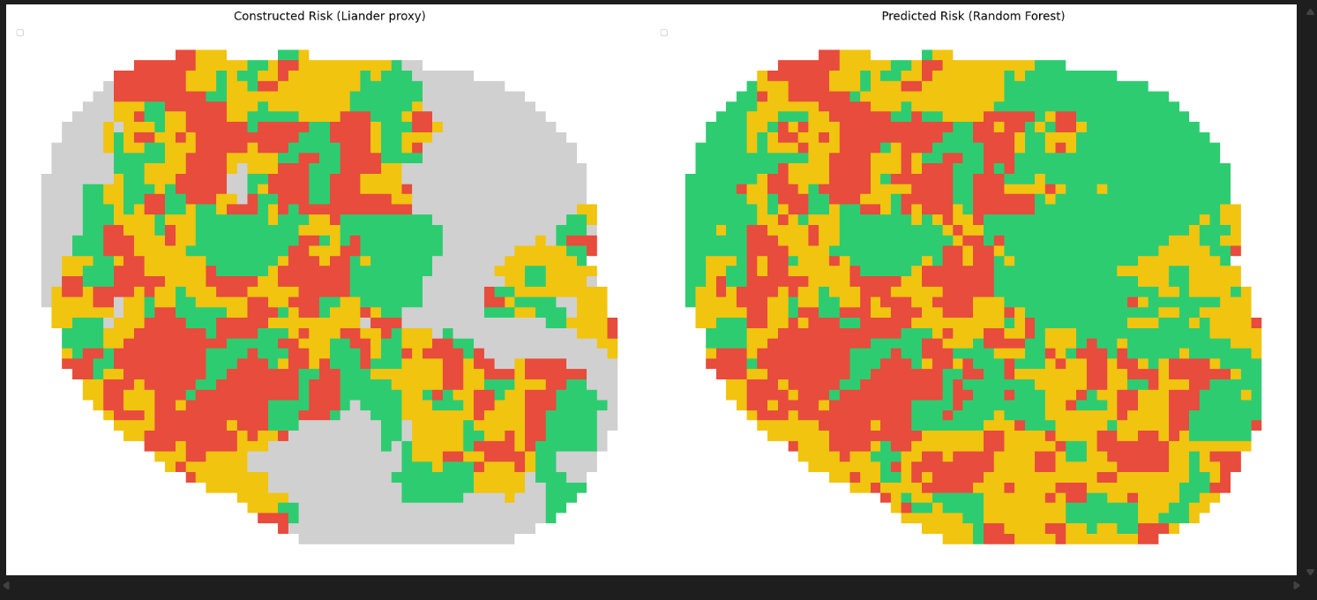
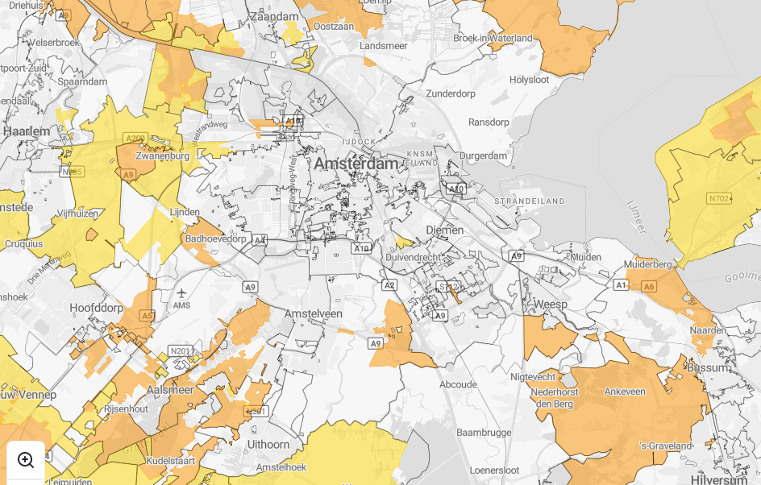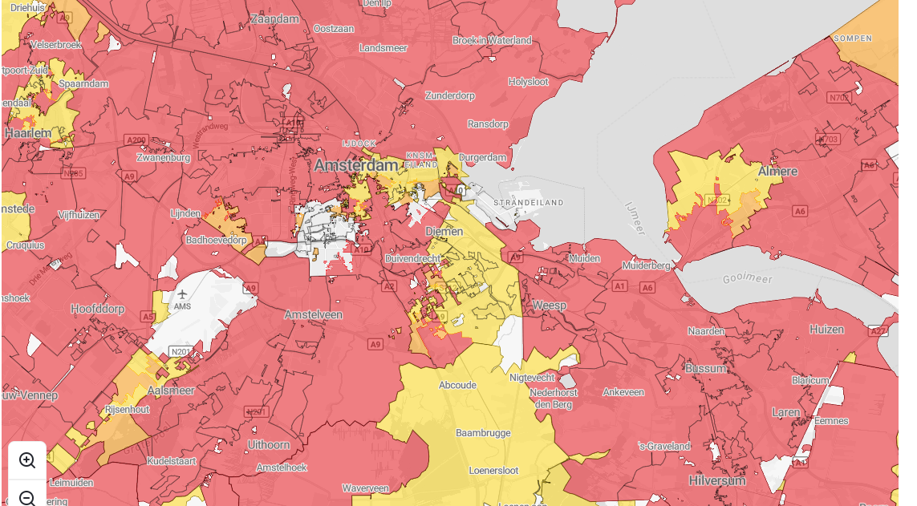Figure 3. Left: congestion classes constructed from Liander energy data. Middle: Random Forest predictions using satellite and CBS features only. Right: official Netbeheer Nederland capacity map.

Area | Model prediction | Official map | Agreement?
Amsterdam North (Westpoort, Noord) | High risk | Red (shortage with queue) | MATCH
Amsterdam Centrum | Medium-High risk | Yellow-Orange (limited capacity) | PARTIAL MATCH
Southern suburbs (Amstelveen) | Medium risk | Yellow-Red (mixed) | PARTIAL MATCH
Eastern water areas (IJmeer) | No data (water) | No data | MATCH
Rural edges (15km buffer) | Low risk | White-Yellow (available) | MATCH

Interpretation: The model correctly identifies northern Amsterdam and industrial areas as high risk, matching the official map. The city centre shows partial agreement: the model predicts medium-to-high risk while the official map shows limited-to-shortage capacity. Rural and water areas match well. The overall spatial pattern is consistent, but exact boundaries differ because the model uses 1x1 km cells while the official map uses network topology boundaries.
Limitation: This is qualitative validation only. The capacity map data cannot be exported for numerical comparison. The visual alignment provides supporting evidence but not proof of accuracy.

4. Data Quality Testing
Each data source was tested for completeness, format correctness, and expected value ranges before being used in the pipeline.

4.1 Sentinel-2 Image Quality
Test | Expected | Actual | Status
Images downloaded | 3-4 per season, 8 seasons | 21 images across 8 seasons | PASS
Cloud cover filter | < 20% over Amsterdam | 2 images excluded (Cloudy_, CLO_ prefix) | PASS
Band count per GeoTIFF | 5 bands (B2, B3, B4, B8, B11) | 5 bands, no descriptions (all None) | PASS with workaround
NDVI value range | -1.0 to +1.0 | -0.09 to 0.60 (mean 0.18) | PASS
NDBI value range | -1.0 to +1.0 | -0.30 to 0.07 (mean -0.05) | PASS
Spatial coverage | Full Amsterdam study area | 391 cells (18%) missing (tile edge + water) | PASS with limitation
L1C vs L2A consistency | Similar index values | 3 L1C images produced usable NDVI/NDBI | PASS

Key finding: SNAP GeoTIFF exports do not preserve band descriptions (all show as None in Python). This was discovered during development and resolved by identifying bands by their position (Band 1=B2, Band 2=B3, Band 3=B4, Band 4=B8, Band 5=B11) and computing NDVI/NDBI in Python from the raw bands. The band order was confirmed by checking value ranges: B8 (NIR) has the highest mean reflectance (~3060) because vegetation strongly reflects near-infrared.

4.2 CBS Data Quality
Test | Expected | Actual | Status
Coverage | All cells in study area | 2,203 cells (99.4%) | PASS
Missing value codes | NaN for missing | CBS uses -99995 for missing data | PASS with cleaning
Amsterdam filter | gemeente = Amsterdam | Correctly filtered on gemeentenaam | PASS
Spatial join | Buurten overlap grid cells | Area-weighted mean per cell | PASS

4.3 Liander Data Quality
Test | Expected | Actual | Status
PV data: buurtcode format | Clean CBS codes (BU...) | Trailing whitespace + 'Onbepaald' rows | PASS with cleaning
PV data: coverage after cleaning | > 50% of cells | 931 cells (42.0%) | PARTIAL - limited by anonymization
Feed-in data: column name | Documented column | TOT_E_INV (not obvious name) | PASS after investigation
Consumption data: column name | Documented column | TOT_E | PASS after investigation
CSV separator | Comma | Semicolon (Dutch CSV standard) | PASS with sep=';'
Feed-in/consumption coverage | > 60% of cells | 1,523 cells (68.7%) | PASS

Key finding: Liander buurtcodes had trailing whitespace (e.g., 'BU00340101 ' instead of 'BU00340101') which caused the spatial join to fail silently, producing 0 matched cells. This was fixed by applying .str.strip() to both the Liander and CBS buurtcode columns before joining. Additionally, 2,145 rows with 'Onbepaald' (privacy-anonymized) buurtcodes were filtered out, reducing PV coverage from 7,491 to 5,346 usable rows.

4.4 BAG and STORM Data
Test | Expected | Actual | Status
BAG WFS API: building footprints | > 1000 cells | 13 cells (0.6%) | FAIL - API pagination
STORM: substation locations | Geographic coordinates | Fully anonymized, no coordinates | FAIL - unusable

Resolution: BAG features (building function classification) were excluded from the model due to insufficient coverage. The STORM substation dataset was excluded because geographic identifiers were removed for privacy. Both exclusions are documented as limitations. The model relies on satellite features and CBS demographics, which have sufficient coverage (82.4% and 99.4% respectively).

4.5 Radiation Data Quality
Test | Expected | Actual | Status
Monthly files loaded | 27 months (Dec 2023 - Feb 2026) | 27 files loaded successfully | PASS
GHI annual mean | 900-1100 kWh/m2/year (Dutch reference) | 905 kWh/m2/year | PASS
GHI summer mean | 200-250 W/m2 | 223.9 W/m2 | PASS
GHI winter mean | 25-45 W/m2 | 34.3 W/m2 | PASS
Seasonal ratio | 5-8x for Netherlands latitude | 6.54x | PASS
Spatial uniformity | < 5 W/m2 across study area | < 1 W/m2 across congestion classes | PASS (expected result)
Cell coverage | > 80% of grid | 1,933 cells (87.2%) | PASS

Interpretation: All radiation values fall within expected ranges for the Netherlands, consistent with KNMI solar atlas data and the CM SAF validation at Cabauw and De Bilt ground stations (Cui et al., 2024). The spatial uniformity across Amsterdam is not a data quality issue but a genuine finding: the study area is too small (~30 km) for radiation to vary meaningfully.

5. Alternative Approaches Considered
This section documents which alternative satellites, models, and data sources were considered and why the chosen approach was selected.

5.1 Alternative Satellite Data Sources
Alternative | Resolution | Advantage | Disadvantage | Why not used
Sentinel-1 (SAR) | 5-10m, all weather | Sees through clouds, works at night | Cannot compute NDVI/NDBI (no visible/NIR bands) | Project requires vegetation and built-up indices which need optical bands
Landsat-8 | 30m, 16-day revisit | Long data archive (since 1972) | 3x coarser resolution, fewer revisits | Sentinel-2 provides 10m resolution and 5-day revisit, giving more pixels per cell and more seasonal images
SPOT/Pleiades | 1.5-6m | Very high resolution | Commercial, expensive, limited archive | Project uses only free/open data sources
Planet (Dove) | 3-5m, daily | Daily revisit, high resolution | Commercial subscription required | Not accessible within project budget

Conclusion: Sentinel-2 is the optimal choice for this project because it provides free, open-access multispectral imagery at 10m resolution with 5-day revisit. The 13 spectral bands include visible, NIR, and SWIR, enabling computation of standard vegetation (NDVI) and built-up (NDBI) indices. No alternative satellite offers a better combination of resolution, spectral coverage, revisit frequency, and data accessibility for urban spatial analysis.

5.2 Alternative ML Models
Alternative | Expected performance | Advantage | Disadvantage | Why not used
XGBoost | Similar or slightly better F1 | Often outperforms RF on tabular data | Requires hyperparameter tuning, less interpretable | RF was top performer in literature (Hernandez-Matheus et al., 2024) and provides direct feature importances
Neural Network (MLP) | Potentially higher F1 | Can learn non-linear interactions | Needs more data, GPU, harder to interpret | Only ~1,500 training rows, too few for deep learning. Interpretability is important for stakeholder trust
U-Net (pixel-level) | Unknown for congestion | Works on raw satellite images | Needs labeled pixel-level ground truth | No pixel-level congestion labels available. Would need dense labeling which does not exist
Logistic Regression | Lower F1 (~0.45) | Very interpretable, fast | Cannot capture non-linear patterns | RF handles feature interactions better, shown in literature

Conclusion: Random Forest was selected based on literature evidence, interpretability requirements, and dataset size constraints. Future work could compare RF with XGBoost on the same features to quantify whether gradient boosting improves performance. Neural network approaches would require significantly more labeled data than the current 1,524 cells provide.

5.3 Alternative Radiation Data
Alternative | Resolution | Advantage | Disadvantage | Why not used
Raw SEVIRI processing | 5.5 km, 15-min | Full control over method | Weeks of development, likely less accurate than CM SAF | CM SAF is validated against Dutch stations. Custom model would not be more reliable within project time
CAMS Radiation Service | ~40 km | Free API, easy access | Very coarse resolution | Only 1-2 pixels cover entire Amsterdam, too coarse for cell-level analysis
PVGIS (JRC) | Point-based | Free, instant results | No raster output, point estimates only | Cannot produce a spatial map across all 2,217 cells efficiently
KNMI ground stations | Point measurements | Highest accuracy (ground truth) | Only 2-3 stations near Amsterdam | Too few points for spatial analysis across 2,217 cells

Conclusion: The CM SAF SARAH-3 SIS product provides the best balance of spatial coverage (full European domain at 0.05 degrees), temporal coverage (1983 to present), validation quality (tested at Dutch ground stations), and accessibility (free, NetCDF format). It is the standard reference dataset for European solar resource assessment.

6. Tests That Failed or Were Excluded
Documenting failed tests is as important as documenting successful ones. It shows that data sources were critically evaluated, not blindly accepted.
Test | What happened | Impact | Resolution
BAG WFS API retrieval | PDOK API returned only 13 building footprints out of expected 200,000+ due to pagination limits | Building function classification (residential vs commercial) could not be used as a model feature | Excluded BAG features. Recommended downloading full BAG extract in future work
STORM substation data | Dataset contains real transformer loading measurements but all station IDs and locations are anonymized with random numbers | Cannot map substations to grid cells. Real grid stress data is unusable for spatial analysis | Excluded STORM. Noted as limitation. Direct DSO collaboration needed for spatial grid data
Cloud-heavy satellite images | 2 out of 23 downloaded images had excessive cloud cover over Amsterdam despite passing the tile-level cloud filter | Images excluded from analysis. Reduced seasonal coverage for those periods | Marked with Cloudy_ and CLO_ prefix. Excluded automatically by filename filter in notebook
Initial PV data join | First attempt produced 0 matched cells due to buurtcode whitespace mismatch | No PV penetration data in the model | Fixed by applying .str.strip() and filtering 'Onbepaald' rows. Coverage improved to 931 cells (42%)
NDVI/NDBI export from SNAP | SNAP virtual bands (computed indices) did not survive GeoTIFF export. Only raw reflectance bands were saved | Notebook could not find NDVI/NDBI bands by name | Switched to computing NDVI/NDBI in Python from raw band positions. Same formulas, same results

Interpretation: These failures are part of the data engineering process. Each one required investigation, a workaround decision, and documentation. The PV buurtcode fix and the SNAP band description workaround were the most impactful: without solving them, the pipeline would have had no PV data and no satellite features respectively.

7. Circularity and Leakage Testing
A critical concern in this project is circular reasoning: using the same data to build the target variable AND as a model feature. This would inflate accuracy artificially.

7.1 The Circularity Risk
The congestion target variable is constructed from three Liander datasets: consumption (TOT_E), feed-in (TOT_E_INV), and PV penetration. If any of these appear as model features, the model would partially predict its own input, producing artificially high accuracy that does not generalize.

7.2 Safeguards Applied
Data column | Used in target? | Used as feature? | Status
consumption_kwh (TOT_E) | Yes (55% weight) | NO, excluded | SAFE
feedin_kwh (TOT_E_INV) | Yes (25% weight) | NO, excluded | SAFE
pv_penetration | Yes (20% weight) | NO, excluded | SAFE
pv_kw_per_conn | Derived from PV data | NO, excluded | SAFE
feedin_ratio | Derived from feed-in/consumption | NO, excluded | SAFE
NDVI, NDBI (Sentinel-2) | No | YES, used as features | SAFE
Population density (CBS) | No | YES, used as feature | SAFE

Result: All Liander energy data (consumption, feed-in, PV counts) is used exclusively for target construction and excluded from the feature set. The model can only use satellite-derived features (NDVI, NDBI, band reflectance) and CBS demographics (population, urbanization, housing). There is no data leakage between target and features.
Remaining concern: CBS features like 'gemiddeld_elektriciteitsverbruik_totaal' (average electricity consumption from CBS) could be considered an indirect proxy for the consumption component of the target. However, the CBS value is a neighbourhood average from a different source and time period than the Liander postcode-level TOT_E, so the overlap is partial, not direct.

8. Overall Test Summary
Test Category | Tests Performed | Passed | Partial | Failed
Model performance | 3 | 3 | 0 | 0
Visual validation | 1 | 1 (qualitative) | 0 | 0
Data quality (Sentinel-2) | 7 | 5 | 2 | 0
Data quality (CBS) | 4 | 3 | 1 | 0
Data quality (Liander) | 6 | 4 | 2 | 0
Data quality (BAG/STORM) | 2 | 0 | 0 | 2
Data quality (Radiation) | 7 | 7 | 0 | 0
Circularity checks | 7 | 7 | 0 | 0
Total | 37 | 30 | 5 | 2

30 out of 37 tests passed fully. 5 tests passed with workarounds or partial coverage (SNAP band descriptions, CBS missing codes, Liander buurtcode cleaning, PV coverage limitation, satellite spatial coverage). 2 tests failed outright (BAG API, STORM anonymization) and were excluded from the pipeline with documented justification.
The test results support the conclusion that the pipeline produces reliable predictions within the documented limitations. The most significant limitation is the absence of ground truth congestion data, which means model accuracy can only be validated qualitatively (visual comparison with the capacity map), not quantitatively.

9. References
Hernandez-Matheus, A. et al. Congestion forecast framework based on probabilistic power flow and machine learning. International Journal of Electrical Power and Energy Systems, 2024.
Cui, Y. et al. Solar radiation nowcasting based on geostationary satellite images and deep learning models. Solar Energy, 2024.
Netbeheer Nederland. Capaciteitskaart. capaciteitskaart.netbeheernederland.nl (accessed June 2026).
CM SAF. Surface Radiation Data Set, Heliosat (SARAH), Edition 3. EUMETSAT, 2024.

