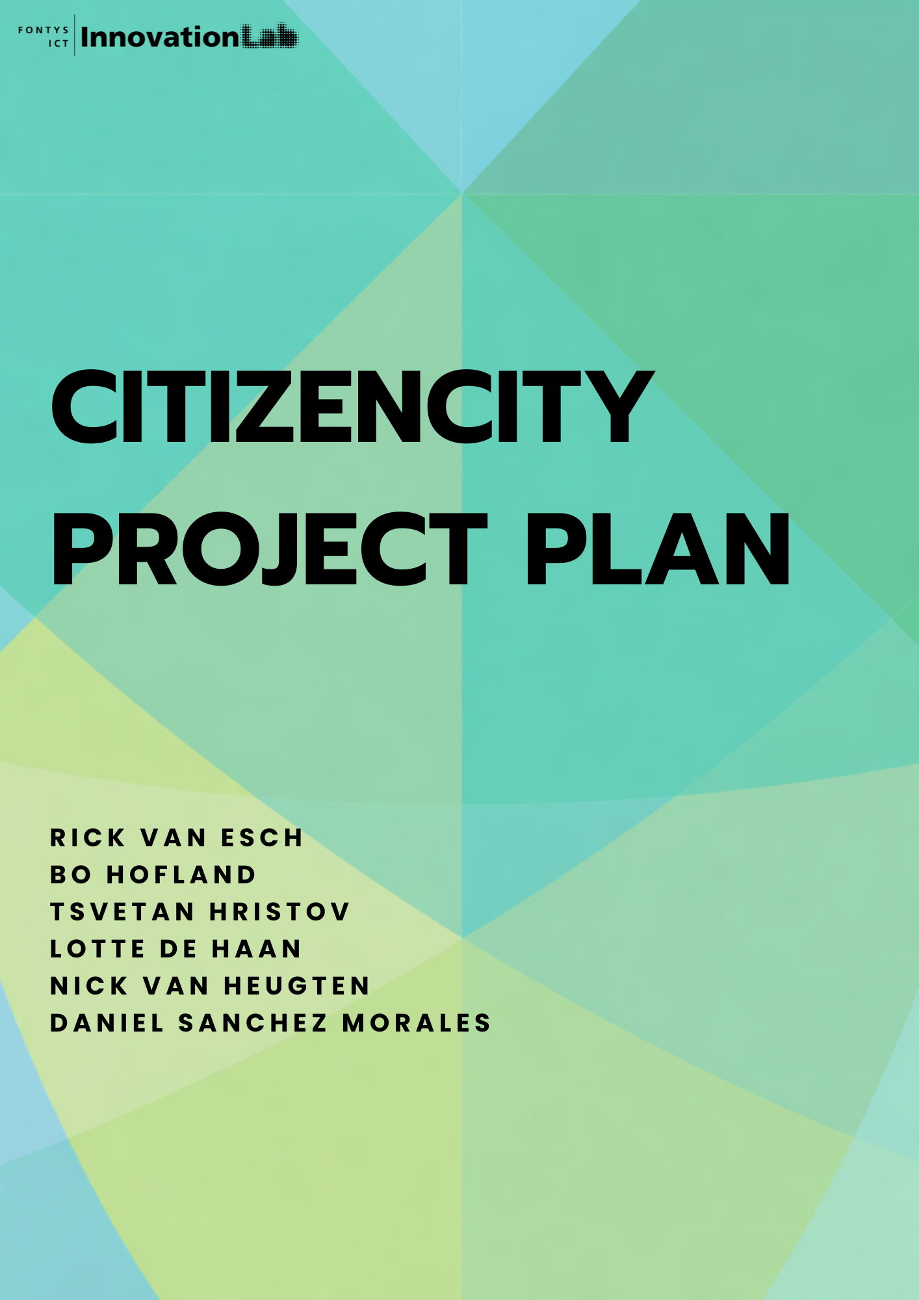
5

Version

Version | Date | Author(s) | Amendments | Status
0.1 | 23-02-2026 | Lotte de Haan | Set up document | Started
0.2 | 16-03-2026 | Nick van Heugten | Final Document | Finished

Communication

Date | 16-03-2026
Version | 0.2
Status | Complete
Author | Lotte de Haan, Daniel Sanchez Morales, Nick van Heugten, Bo Hofland, Tsvetan Hristov, Rick van Esch

Contents
1. Project Assignment 4
1.1 Context 4
1.2 Goal of the project 4
1.3 The assignment 4
1.4 Scope 5
1.5 Finished products 5
1.6 Research questions 6
2. Approach and Planning 7
2.1 Approach (Lotte) 7
2.1.1 Problem Definition Phase 7
2.1.2 Sprint Structure 7
2.1.3 Completion Phase 7
2.2 Research methods (Tsvetan) 8
2.3 Breakdown of the project (Tsvetan) 11
2.4 Time plan (Lotte) 12
3. Project Organization 13
3.1 Team members 13
3.2 Communication 14
3.3 Configuration management 14
4. Finance and Risks 15
4.1 Cost Budget 15
4.2 Risks and Fall-back Activities 15
5. Sources 17

1. Project Assignment

1.1 Context
This assignment is carried out within the Inzicht Verlicht project of the Fontys ICT InnovationLab, in collaboration with the Municipality of Eindhoven. The InnovationLab develops applied ICT solutions together with public partners, with a focus on smart city innovation and responsible data usage.
The project is part of the broader European Data Space for Smart Communities (DS4SSCC) initiative, which aims to develop a federated data space that enables secure and interoperable data sharing between cities, organizations, and research institutions across Europe. Within this framework, participating municipalities contribute pilot use cases to test and validate data space concepts, governance models, and technical standards for smart city applications.
Within this project, data is collected at the J.F. Kennedylaan intersection in Eindhoven as part of a sustainable mobility use case. The municipality monitors traffic flows and air quality to improve urban mobility and environmental performance. Earlier project phases focused on analysing and visualising this data and on establishing the technical foundation of a dataspace.
Now that the technical infrastructure has been developed, the project has entered its final phase. The current assignment focuses on defining governance structures, protocols, and procedures to ensure ethical, transparent, and structured data usage within the smart city dataspace, in alignment with the governance principles promoted by the DS4SSCC initiative.

1.2 Goal of the project

With the technical infrastructure of the Inzicht Verlicht dataspace already in place, the project focuses on making sure that data is used responsibly, transparently, and ethically. Currently, there is no clear guidance on how stakeholders should manage and monitor data usage, which could lead to misuse, privacy violations, or unclear responsibilities.

The goal of this project is to provide guidance on governance approaches, protocols, and procedures that guide stakeholders in managing and monitoring data usage. While the project focusses on the Inzicht Verlicht case in Eindhoven, the advisory report should provide outcomes that are scalable and applicable to similar smart city projects and comparable international projects.
The intended outcome is an advisory framework that provides guidance on governance, accountability, and ethical data use, identifies potential risks, and gives recommendations to support responsible management of the dataspace, both within the current project and broader smart city contexts.

1.3 The assignment
The assignment is to develop a strategic advisory report that supports policymakers and lawmakers in governing the existing dataspace within the Inzicht Verlicht project in a structured, ethical, and responsible manner.
The focus is not on technical development, but on defining governance structures that guide data sharing and management within the smart city context. The report must provide a clear and accessible framework that translates technical data operations into policy-level guidance.
The advisory report will define clear protocols and procedures for data sharing, establish good practices for ethical data governance, formulate concrete KPIs to monitor responsible data use, and clarify what constitutes high-quality and ethically sound data practices.
The final deliverable must be strategic and policy-oriented, accessible to non-technical stakeholders, actionable in practice, and focused on monitoring, evaluation, and responsible governance rather than technical implementation. The outcome should support structured decision-making and the long-term, responsible operation of the dataspace.

1.4 Scope

The project includes: | The project does not include:
1 Defining good practices for data governance within the dataspace. | 1 Modifying the technical infrastructure of the dataspace.
2 Designing protocols and procedures for ethical and responsible data usage. | 2 Implementing monitoring tools and performing technical system integration.
3 Identifying potential risks and ethical considerations. | 3 Enforcing governance in practice.
4 Suggestions for monitoring and evaluating responsible data use. | 4 Operational incident response or security management.

1.5 Finished products

The project will deliver a project plan, a research document, and an advisory report on data governance within the Inzicht Verlicht dataspace, along with supporting documentation. Intermediate outputs, such as stakeholder analyses, protocols & procedures, and risk and ethical assessments, will be documented separately and used as evidence to support the final advice and recommendations.

Product Breakdown Structure (PBS):
- Project Plan
- Research Document
  - Stakeholder Analysis
  - Legal & Ethical Analysis
  - Good Practices & Benchmarking Report
- Advice Report
  - Governance Framework Document
  - Protocols & Procedures Report
  - Business Models
  - Strategic Roadmap
- Supporting Documentation
  - Executive Summary
  - Flowcharts & Workflow Diagrams
  - Presentations & Pitch dek(s)
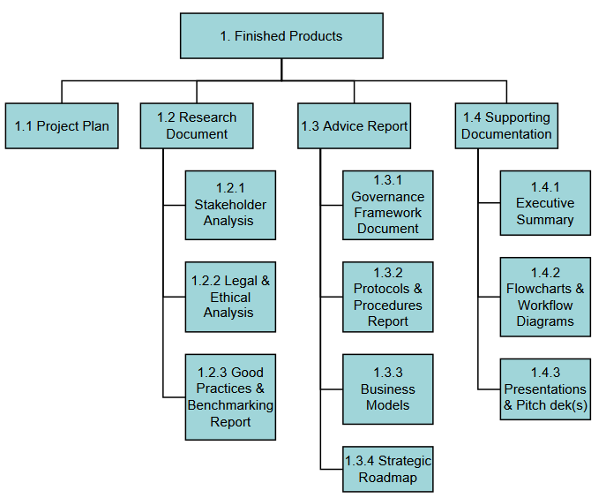

1.6 Research questions
Main Research Question:
How can data usage within the Inzicht Verlicht dataspace be governed and evaluated in a responsible, transparent, and ethical way, resulting in practical recommendations that support policymakers by the end of the project?
Sub-Questions:
- What principles and practices contribute to responsible and ethical data usage within smart city dataspaces?
- How can data usage within a dataspace be monitored and evaluated to ensure accountability and transparency?
- What legal, ethical, and organisational risks may arise from data sharing and usage, and how can these risks be mitigated?
- How can governance procedures and protocols support stakeholders and intermediaries involved in data exchange in using data responsibly while maintaining societal value and privacy protection?
- What recommendations can be provided to policymakers to support long-term and sustainable governance of the dataspace?

2. Approach and Planning

2.1 Approach
This project follows the Scrum methodology, working in iterative cycles of 3-week sprints. Scrum is chosen because it allows flexibility, continuous feedback, and incremental delivery of value.

2.1.1 Problem Definition Phase

At the start of the project, we clearly define the problem by:
- Conducting stakeholder discussions
- Formulating a clear problem statement
- Defining project goals and scope
- Identifying functional and non-functional requirements
- Creating and prioritising the Product Backlog

This ensures the team has a shared understanding before development begins.

2.1.2 Sprint Structure

Each sprint lasts two weeks and includes:
- Sprint Planning – Define the sprint goal and select backlog items.
- Weekly Stand-ups (15 minutes) – Discuss progress, plans, and blockers.
- Sprint Review – Present the working increment to stakeholders and gather feedback.
- Sprint Retrospective – Reflect on collaboration and identify improvements.

At the end of every sprint, a working product increment is delivered.

2.1.3 Completion Phase

In the final phase:
- All remaining backlog items are completed
- Final testing and validation are performed
- Documentation is finalised

This ensures the project is delivered in a structured and controlled way.

2.2 Research methods
To answer the research questions, we are going to use the D.O.T. framework, from which we will use specific strategies and methods in order to come to conclusions to the set questions.
Sub-question | Research Fields & Methods | How are the methods applied | Validation | Stepping Stones
1. What principles and practices contribute to responsible and ethical data usage within smart city dataspaces? | Library - Literature Study, Best good and bad practices  Showroom - Ethical check, guideline conformity analysis  Workshop - Brainstorm | Literature study will identify existing ethical principles, privacy guidelines, and frameworks for responsible data usage. Analysis of best good and bad practices will provide insights into already existing usages. Ethical checks and guideline conformity analysis will test whether proposed practices align with recognised standards and expectations that our stakeholders have set. Brainstorm workshops with stakeholders will explore how these principles can be applied or adapted in the specific smart city dataspace. | The results would be verified by our stakeholder where the principles and practices should align with the ones set by the stakeholder | Identification of core ethical principles, practical application examples, and evaluation criteria for responsible data usage
2. How can data usage within a dataspace be monitored and evaluated to ensure accountability and transparency? | Field - Interview, Document Analysis  Workshop - Brainstorm, Co-creation  Library – Literature Study | Interviews with stakeholders will gather insights on current monitoring practices and accountability measures (if any exist). With document analysis, we will examine existing policies, procedures and evaluation protocols, to gain ideas and inspiration on what to use for the project. Brainstorming and co-creation workshops with stakeholders will generate ideas for monitoring mechanisms and key performance indicators. Literature study will provide a theoretical background on monitoring frameworks and transparency mechanisms. | Stakeholder validation of proposed monitoring approaches and feedback during meetings | List of practical monitoring methods, accountability measures and evaluation indicators tailored to the dataspace context
3. What legal, ethical, and organisational risks may arise from data sharing and usage, and how can these risks be mitigated? | Library – Best good and bad practices, Literature study  Field – Problem analysis, Stakeholder Analysis  Workshop – Root Cause Analysis | Literature study and best good and bad practices analysis will identify already known risks that could arise when working in a collaborative data-sharing environment. Stakeholder analysis and problem analysis will map context-specific vulnerabilities (risks). Using root cause analysis, we will explore mitigation strategies collaboratively with stakeholders to reduce risks. | Stakeholder validation of identified risks and mitigation measures | Comprehensive, thorough and detailed risk analysis and proposed governance measures for risk mitigation
4. How can governance procedures and protocols support stakeholders in using data responsibly while maintaining societal value and privacy protection? | Library – Literature study  Workshop – Co-creation, Prototyping  Showroom – Peer review, Guideline conformity analysis | Literature study will provide insights into already existing governance procedures and privacy protection strategies. By having co-creation workshops and prototyping sessions (potentially with stakeholders), we will develop our own practical governance procedures and protocols or decide on what we can use from already existing ones. Peer review and guideline conformity analysis will validate whether the proposed procedures meet best practices and legal or ethical standards. | Stakeholder feedback on prototypes; guideline conformity assessments | Defined governance procedures, practical protocols and validated prototypes supporting responsible data usage
5. What recommendations can be provided to policymakers to support long-term and sustainable governance of the dataspace? | Library – Community Research  Showroom – Peer review, Guideline conformity analysis  Workshop – Business case exploration | Community research will collect insights from different smart city initiatives, policy documents, and possibly governance studies. Peer review and guideline conformity analysis will evaluate the feasibility, sustainability and alignment of recommendations with best practices and stakeholder requirements. Through business case exploration we plan to maximize the outcome of your work by analysing the most viable options or scenarios for the problem. | Stakeholder review and alignment checks with existing standards and governance models | Actionable, evidence-based policy recommendations for sustainable governance of the dataspace

2.3 Breakdown of the project

Phase | Timeframe | Description
Phase 1: Understand the project | Start: Week 2 (23/02/2026)  End: Week 6 (27/03/2026) | In this phase, we are going to work on our project plan, where we want to lay out how we plan to handle this project. On top of that, we need to get more familiar with the project, because of which we plan gather as much information as possible, from interviews with our clients, by reading available documentation provided by the said clients and find more information online (through Eindhoven’s municipality website, for example).
Phase 2: Researching | Start: Week 7 (30/03/2026)  End: Week 10 (24/04/2026) | During this phase, the main research activities are carried out. Literature studies, best-practice analyses, interviews, and workshops are used to answer the defined sub-research questions. Key topics include ethical principles, governance models, monitoring mechanisms, and legal and organisational risks. The focus is on analysing existing frameworks and identifying relevant principles that can be applied to the dataspace. Intermediate research outputs are validated with stakeholders where possible.
Phase 3: Design and development | Start: Week 12 (04/05/2026)  End: Week 16 (12/06/2026) | In this phase, the insights from the research are translated into concrete outputs. Governance structures, protocols, procedures, KPIs, and evaluation mechanisms are designed. Co-creation sessions and internal reviews are used to ensure the framework is practical, understandable, and aligned with stakeholder needs. Draft versions of the advisory report, governance framework, and supporting documents are created and iteratively improved based on feedback.
Phase 4: Finalization | Start: Week 17 (15/06/2026)  End: Week 18(30/06/2026) | The final phase focuses on completing and validating all deliverables. Feedback from stakeholders is processed, and the advisory report and supporting documentation are finalised. The project results are evaluated against the original goals and research questions. Visual materials such as summaries, roadmaps, and diagrams are finalised, and preparations for presentation and handover are made. This phase ensures the outcomes are clear, actionable, and suitable for policymakers and other non-technical stakeholders.

3. Project Organization

3.1 Team members

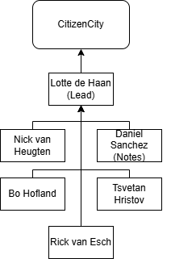
The main role distribution is regarding the meetings and communication. We are all expected to perform similar tasks within the groups. The main distribution in roles is the "Team Lead" and the “Note Taker”. The lead will be responsible for meetings and communication with stakeholders, while the note taker will be responsible for making sure meetings are well documented for either research purposes or general information and commitments.

Name + e-mail | Abbr. | Role/tasks* | Availability
Rick van Esch + r.vanesch@student.fontys.nl | RvE | Completer Finisher | Monday till Friday from 9.00 to 16.00
Nick van Heugten+ n.vanheugten@student.fontys.nl | NvH | Notulist | Monday till Friday from 9.00 to 16.00
Bo Hofland + bo.hofland@student.fontys.nl | BH | Plant | Monday till Friday from 9.00 to 16.00
Daniel Sanchez M + d.sanchezmorales@student.fontys.nl | DS | Teamworker | Monday till Friday from 9.00 to 16.00
Tsvetan Hristov + tsvetan.hristov@student.fontys.nl | TH | Resource Investigator | Monday till Friday from 9.00 to 16.00
Lotte de Haan + 510426@student.fontys.nl | LH | Teamleader | Monday till Friday from 9.00 to 16.00
Amália Oliveira De Arruda Camara + a.oliveiradearrudacamara@fontys.nl |  | Stakeholder CC | Mondays afternoon + via mail/teams.
Bart van Gennip + b.vangennip@fontys.nl |  | Stakeholder CC | t.b.a
*The roles are based on the Belbin Team Roles
(Belbin® – The Team Role Company The Nine Belbin Team Roles, z.d.)

Resource Investigator: Uses their inquistivie nature to find ideas to bring back to the team
Completer Finisher: Most effectively used at the end of tasks to polish work.
Plant: Tends to be creative and good at solving problems in unconventional ways

Communication

From the first meeting on 23-02-2026, we have set a weekly meeting plan. This will be every Monday at 14:00 if possible. When constraints occur, a rescheduling will be made.
These meetings will be held with our direct stakeholder; Amalia Oliveira De Arruda Camara. Every Thursday before 16:00, we will send notes to our stakeholders in preparation for the next meeting.

3.3 Configuration management

Since we will be mainly conducting research, we want to mainly keep track of tasks and the completion of documentation/events. Because we already have a Teams environment set up, I (Daniel) have created a Planner board where all our daily and weekly tasks will be tracked. Also, the direct file storage within that teams will be where we store all our documents. Of course, every member can choose to keep a copy of the work as backup, but this would be on their own initiative.

The Teams channel consists of the company name “ThinkData” with 4 sub-channels within it. In the channel for our project "CitizenCity", we will work and add all files related to the project.

4. Finance and Risks

4.1 Cost Budget
This project is a research and advisory project. No development costs will be made for technical implementation, since the dataspace structure in the Inzicht Verlicht case has already been set up. The focus is on governance, agreements, and policy.
We therefore do not expect major costs. Possible (limited) costs could include:
- Access to additional scientific or legal sources (if these are not available through the university)
- Use of paid collaboration or visualisation tools
- Possible travel costs for meetings with stakeholders
In principle, we will use existing university licenses and publicly available sources, such as European legislation and publicly available standards.

4.2 Risks and Fall-back Activities
Because this project combines multiple topics (governance, legislation, business models, and roadmap), we have identified risks that could affect the entire project.
Risk | Probability | Impact | Prevention | Fall-back activities
Unclear scope of the assignment | High | High | Define scope at start  Set main research question  Confirm direction with stakeholders | Re-evaluate scope after milestone  Focus on governance & compliance  Reduce additional eliments
A group member drops out | Medium | High | Clear task division with shared understanding  Central document storage (Teams)  Weekly progress meetings | Redistribute tasks  Adjust planning  Focus on core report only
The report becomes too theoretical | Medium | Medium | Define clear and measurable KPI’s  Use practical examples  Link recommendations to actions | Add visualisations  Simplify complex sections

5. Bibliography
Belbin® – The Team Role Company The nine Belbin Team Roles. (z.d.). Belbin. https://www.belbin.com/about/belbin-team-roles

